

**Course:** Skill Management and Communications Course

Communications Management Plan

**<Project's Name>**

**Prepared by:**

Date: <dd/mm/aaaa>

Communications Management Plan

# Table of Contents

# Introduction

# Description of the Communications Management Plan

## Objectives of the Communications Management Plan

## Scope of Communications Management Plan

## Key Factors for a successful Communication Management Plan

The following elements have been defined as critical success factors:

# Organizing the Communications Management Plan

## Stakeholders’ Classification

### **List of Stakeholders**

|  |  |  |
| --- | --- | --- |
|  | Stakeholders | Interests |
| *1* | Low-income neighbors | They disagree over the high cost of the work. |
| *2* | Police Corps | Support for better visibility and possible reduction of crimes. |
| *3* | Restaurant Owners | Support for being able to extend their hours of operation |
| *4* | Street vendors | Disagreeing over the monthly fee to pay to the local Government |
| *5* | Business entrepreneurs | Support for greater safety in the face of potential accidents |
| *6* | Neighbors of "Cipreses" town | They believe they should be part of the project decision making process |
| *7* | Etc… | Etc… |

### **Classify Stakeholders (Example)**

| **Stakeholders** | **Position** | **Power** | **Interest** |
| --- | --- | --- | --- |
| Police Corps | + | 4 | 3 |
| Low-income neighbors | - | 4 | 5 |
| Business entrepreneurs | + | 2 | 1 |
| Minister living in the neighborhood | + | 5 | 5 |
| Restaurant Owners | + | 3 | 1 |
| Financial Institutions | - | 3 | 4 |
| Neighbors "Cipreses" towm | - | 2 | 3 |

**Power:**  1 – Low, . . . 5 - High

**Interest:** 1 – Low, . . . 5 - High

**Position:** + In favor, - Against

### **Stakeholders Mapping Of Data (Example).**

Use the values in the previous leaderboard. The numbers correspond to the order inside the table. Other points have been added for illustration purposes.

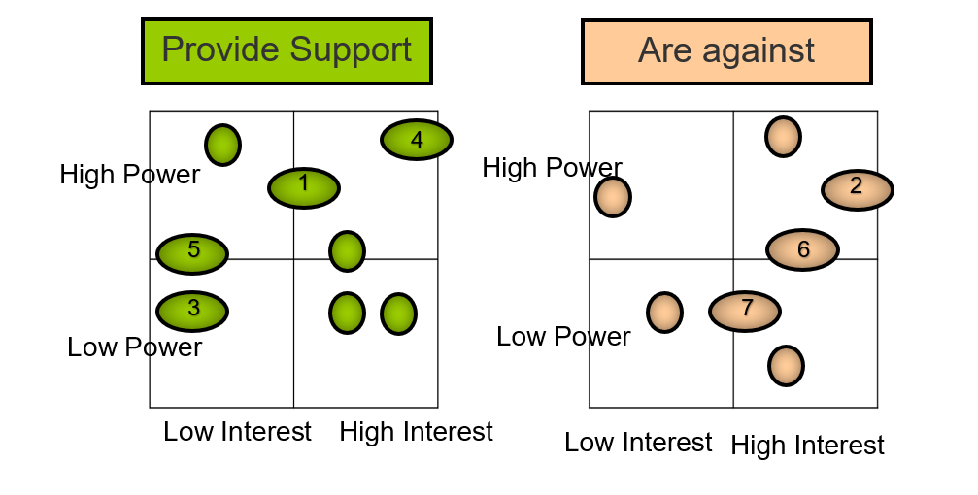

### **Define Strategies (Example).**

In this section you identify the strategies that aim at achieving the stakeholders’ management. Maintaining and increasing the interest of those who agree with the project. They should also help to win, as much as possible, the support of those who oppose or, at least lessen they negative impact.

|  |  |  |
| --- | --- | --- |
| **Stakeholder** | **Interests** | **Strategy** |
| Police Corps | Support for better visibility and possible reduction of crimes. | To play a leading role in the meetings held with the community |
| Business Entrepreneurs | Support for greater safety in the face of potential accidents | Send them special invitations to participate in meetings. Find extra benefits for them, around the project. |
| Street Vendors | Disagreeing over the monthly fee to pay to the local Government. | Report on the design of special payment plans for them, after evaluating their situation through Social Workers. |

# Organization of the Communications Management Plan

## Communications matrix.

Include the Communications Matrix (See example).

**Table xx.** XxxxXXXXXX ProjectCommunication Matrix.

|  |  |  |  |  |  |
| --- | --- | --- | --- | --- | --- |
| **Communication Type** | **Audience** | **Description/Purpose** | **Frequency** | **Owner** | **Channel** |
| Personal Communication | Project Sponsor, Project Team | Regular communication | Bi-weekly | Project Manager | Telephone calls, Email, Meetings, Web Conference |
| Reports | Project Sponsor, Project Team | Updates on project issues | Bi-weekly | Project Manager | Emails, Meetings |
|  | Project Sponsor | Updates on project finances and performance | Monthly | Project Manager | Email |
| Project announcements | Project Team | Schedule reminders | Weekly | Project Manager | Email |
| Presentations | Project Sponsor, Project Team | Completed project status update | Once | Project Manager | Meeting, Web conference |
| Reviews and Meetings | Project Team | Meetings to review project status | Monthly | Project Manager | Planning meeting |

**3.2 Communication Delivery Methods and Technologies**

Describe how the project information will be made available to the stakeholders.

**3.3 Project Reporting (Format)**

Describe the formats of weekly, biweekly, monthly reports, team performance reports, progress reports, meeting minutes, etc. (You need to provide at least 2 samples).

**3.4 Communication Standards**

Describe the standard escalation model the project will use to provide a framework for escalating communication issues

# Conclusions

# Recommendations

# Annexes

In this section, the group can add any documents that are part of Communications Management Plan; i.e. reports, templates, graphs, charts, etc. This section is not mandatory.