UNIVERSIDAD PARA LA COOPERACION INTERNACIONAL

(UCI)

A PROJECT MANAGEMENT PLAN FOR THE IMPLEMENTATION OF A SCHOOL COUNSELLING PROGRAM MODEL IN A GOVERNMENT SCHOOL

LICIA CAMILLE CASTILLO

FINAL GRADUATION PROJECT SUBMITTED IN PARTIAL FULFILLMENT OF THE REQUIREMENTS FOR THE

MASTER IN PROJECT MANAGEMENT (MPM) DEGREE

Orange Walk Town, Orange Walk, Belize

December 2024

UNIVERSIDAD PARA LA COOPERACION INTERNACIONAL

(UCI)

This Final Graduation Project was approved by the University as

partial fulfillment of the requirements to opt for the

Master in Project Management (MPM) Degree

Dr. Roger Valverde Jimenez

Full name must be written

TUTOR

Mr. JuanCamilo Delgado

Full name must be written

REVIEWER No.1

Mr. Carlos Brenes Vega

Full name must be written

REVIEWER No.2

Licia Camille Castillo

STUDENT

**DEDICATION**

To all those who have endured my constant chatter, frustrations, and my sharing of my newly acquired knowledge, I dedicate this project. Especially to my husband, Raul, my children Raul Jr., Leahan, and Breahana, thank you for understanding and supporting my need for personal advancement. To my sisters, Clarissa and Maritta, thank you for your encouragement and counsel.

For my beloved country and profession and to my fellow school counsellors, I dedicate this degree to you. Finally, for Elizabeth Goff (R.I.P.) and Dr. Denise Lenares, your past and present guidance has meant the world to me.

**ACKNOWLEDGMENTS**

Many people were instrumental during the process and finalization of this project. I am most grateful to Dr. Roger Valverde Jimenez for his constant availability, support, and guidance throughout this whole process.

To Beatriz Davis, your constant reminders and guidance have not gone unnoticed. Thank you.

To my school administrator, Mr. Julian Polanco, thank you for our continuous consultations.

To my nieces and nephew, Alyssa, Iriani, and Gian, thank you for all your interest and assistance.

To my friends, Tyronie Middleton and Richard Sierra, your assistance at clutch-time has been a life-saver.

**ABSTRACT**

The objective of this project is to establish a project management plan for the implementation of a school counselling program model in a government school. In a country where no school operates with a formal model to guide and evaluate counselling services, implementing, monitoring, and evaluating, an adapted ASCA National Model will enhance counselling program effectiveness and sustainability.

The resulting benefits of this project will not only improve student outcomes and school climate but also create a replicable model for other schools. The project management plan provides an overall guide for the successful initiation, implementation, execution, monitoring, and closure of the adapted ASCA National Model. To achieve this goal, a blend of research methodologies, including qualitative, quantitative, mixed, and applied research, is used.

Results demonstrate that through the careful and methodical implementation, monitoring, and closure of this project, the structured school counselling program model enhances counsellors’ effectiveness. This is reflected in data showing improved students’ academic, social, emotional, and career development, ultimately leading to increased attendance, higher graduation rates, and greater tertiary enrolment.

**INDEX OF CONTENTS**

INDEX OF FIGURES 7

INDEX OF CHARTS 8

ABBREVIATIONS AND ACRONYMS 10

EXECUTIVE SUMMARY 11

1 INTRODUCTION 13

1.1. Background 14

1.2. Statement of the problem 15

1.3. Purpose 17

1.4. General objective 18

1.5. Specific objectives 18

2 THEORETICAL FRAMEWORK 20

2.1 Company/Enterprise framework 20

2.2 Project Management concepts 25

2.3 Other applicable theory/concepts related to the project topic and context 44

3 METHODOLOGICAL FRAMEWORK 50

3.1 Information sources 50

3.2 Research methods 56

3.3 Tools 67

3.4 Assumptions and constraints 71

3.5 Deliverables 78

4 RESULTS 82

4.1 Develop Project Initiation Plan 82

4.2. Develop Project Management Plan 89

4.3. Develop Project Execution Plan 184

4.4 Develop Monitoring and Control Plan 207

4.5 Develop Close Project Plan 222

5 CONCLUSIONS 229

6 RECOMMENDATIONS 232

7 VALIDATION OF THE FGP IN THE FIELD OF REGENERATIVE AND SUSTAINABLE DEVELOPMENT 234

BIBLIOGRAPHY 242

APPENDICES 251

Appendix 1: FGP Charter 252

Appendix 2: FGP WBS 265

Appendix 3: FGP Schedule 266

Appendix 4: Preliminary bibliographical research 267

Appendix 5: Philologist Review Report 269

# INDEX OF FIGURES

Figure 1 *Organizational structure of Government Secondary Schools* (Source: Licia Castillo 2024) 24

Figure 2 *Project Management Process Diagram.* Source: A guide to the Project Management Body of Knowledge PMBOK Guide (Sixth Edition, p.25)………..……….. 38

Figure 3 *Life Cycle Model*. Source: Harold Kerzner. Reprinted from Kerzner, H.(2017) Project Management A Systems Approach to planning, scheduling, and controlling. 41

Figure 4 *Work Breakdown Structure* (Source: Licia C astillo 2024) 103

Figure 5 *Schedule for final project* (Source: Licia Castillo 2024) 124

Figure 6 *Interest Influence Matrix* (Source: Licia Castillo 2024)………………………. 131

Figure 7 *S Curve showing outflow of cash for project* (Source: Licia Castillo 2024)……142

Figure 8 *Probability and Impact Matrix* (Source: Licia Castillo 2024) 157

Figure 9 *Earned Value, Planned Value, and Actual Costs* (Source: Licia Castillo 2024) 214

# INDEX OF CHARTS

*Chart 1 Information Sources (Source: Licia Castillo 2024) 52*

*Chart 2 Research Methods (Source: Licia Castillo 2024) 59*

*Chart 3 Tools (Source: Licia Castillo 2024) 68*

*Chart 4 Assumptions and constraints (Source: Licia Castillo 2024) 72*

*Chart 5 Deliverables (Source: Licia Castillo 2024) 78*

*Chart 6 Stakeholders (Source: Licia Castillo 2024) 87*

*Chart 7 Tools to analyse and interpret data (Source: Licia Castillo 2024) 95*

*Chart 8 Requirements Traceability Matrix (Source: Licia Castillo 2024) 100*

*Chart 9 WBS Dictionary (Source: Licia Castillo 2024) 104*

*Chart 10 Schedule Management Process (Source: Licia Castillo 2024) 113*

*Chart 11 Activities and Estimate Activity Resources (Source: Licia Castillo 2024) 117*

*Chart 12 Estimated Durations of Activity (Source: Licia Castillo 2024) 123*

*Chart 13 Stakeholder Engagement (Source: Licia Castillo 2024) 127*

*Chart 14 Stakeholder Engagement Matrix (Source: Licia Castillo 2024) 129*

*Chart 15 Resources Allocated and Budget (Source: Licia Castillo 2024) 132*

*Chart 16 Roles and Responsibilities (Source: Licia Castillo 2024) 133*

*Chart 17 Cost Estimate (Source: Licia Castillo 2024) 136*

*Chart 18 Budget for Project (Source: Licia Castillo 2024) 138*

*Chart 19 Cash Flow Estimates (Source: Licia Castillo 2024) 140*

*Chart 20 Roles and Responsibilities(Source: Licia Castillo 2024) 143*

*Chart 21 Communication Matrix (Source: Licia Castillo 2024) 147*

*Chart 22 Roles and Responsibilities – Risk Management (Source: Licia Castillo 2024) 151*

*Chart 23 Risk Breakdown Structure (Source: Licia Castillo 2024) 152*

*Chart 24 Risk Register (Source: Licia Castillo 2024) 158*

*Chart 25 Customer Prioritization (Source: Licia Castillo 2024) 176*

*Chart 26 Requirement Prioritization for Students (Source: Licia Castillo 2024) 179*

*Chart 27 Requirements Prioritization for Ministry of Education and Chief Education Officer (Source: Licia Castillo 2024) 180*

*Chart 28 Requirements Prioritization for Teachers (Source: Licia Castillo 2024) 181*

*Chart 29 Requirements Prioritization for Parents (Source: Licia Castillo 2024) 182*

*Chart 30 Requirements Prioritization for Administration of OWTHS (Source: Licia Castillo 2024) 183*

*Chart 31 Customer Weighted Requirements Prioritization (Source: Licia Castillo 2024) 184*

*Chart 32 Change Request Form (Source: Licia Castillo 2024) 186*

*Chart 33 Lessons Learned Register (Source: Licia Castillo 2024) 187*

*Chart 34 Track Key Performance Indicators (Source: Licia Castillo 2024) 191*

*Chart 35 Quality Baseline (Source: Licia Castillo 2024) 193*

*Chart 36 Resource Calendar (Source: Licia Castillo 2024) 197*

*Chart 37 Lessons Learned Register (Source: Licia Castillo 2024) 224*

*Chart 38 Project Closure Activities (Source: Licia Castillo 2024) 225*

*Chart 39 P5 Impact Analysis – People (Source: Licia Castillo 2024) 236*

*Chart 40 P5 Impact Analysis – Planet (Source: Licia Castillo 2024) 237*

*Chart 41 P5 Impact Analysis – Prosperity (Source: Licia Castillo 2024) 238*

*Chart 42 Score Card of P5 Analysis (Source: Licia Castillo 2024) 239*

# ABBREVIATIONS AND ACRONYMS

ASC American School Counsellor Association

BSCA Belize School Counsellor Association

ETA Education and Training Act

ISCED International Standard Classification of Education

KPI Key Performance Indicators

MOE Ministry of Education

MoECST Ministry of Education, Culture, Science, and Technology

OWTHS Orange Walk Technical High School

PMBOK Project Management Body of Knowledge

PMI Project Management Institute

SIP School Improvement Plan

UNICEF United Nations Children’s Emergency Fund

WBS Work Breakdown Structure

# EXECUTIVE SUMMARY

Orange Walk Technical High School, a government school established in 1983, primarily serves a low-income student population from surrounding villages, historically struggling with high failure, dropout, and suspension rates. However, since hiring a school counsellor in 2003, the school has experienced improvement in its performance, including a significant increase in the percentage of graduates pursuing higher education. Despite being a pioneer in school counselling within the district and country, the counsellor operates without formal guidance or oversight, developing a comprehensive counselling program based on the American School Counsellor Association (ASCA) model to address students' academic, personal, social, and career needs.

The absence of a structured school counselling program can negatively affect students' academic, social, emotional, and career development, resulting in lower attendance, graduation, tertiary enrolment rates, as well as the overall school environment. Research suggests that comprehensive counselling programs improve these outcomes by addressing students' mental health needs, teaching essential life skills, and providing career guidance. While Orange Walk Technical High School has employed a counsellor for 21 years, a formal model is lacking. This project aims to address this gap by implementing a structured school counselling program, embracing recent advancements in the country's education sector, including the development of a national school counselling model and counsellor certification training.

The author, a pioneer in Belizean school counselling, co-founded the Belize School Counselor Association to advocate for the profession and improve student outcomes despite limited ministerial, legislative, and administrative support. Through persistent efforts and collaboration, they achieved significant advancements in the field, including the establishment of a standardized framework for school counsellors. This project aims to provide a structure for the implementation of this model to enhance counselling program effectiveness and sustainability while aligning with national educational goals. By monitoring implementation, counsellor performance, and student outcomes, the project seeks to create a replicable model for other schools.

The general objective of this project was to develop a project management plan to implement the adapted ASCA National Model in a government school in order to enhance the overall effectiveness and sustainability of the school's counselling services.

The specific objectives were: to establish a high-level project structure for the school counselling model in a government school by developing a plan for implementing initiation processes, including developing the project charter and identifying key stakeholders;

to create a detailed project management plan for implementing the school counselling model in a government school, which includes developing plans for scope, schedule, costs, resources, quality, communications, risks, acquisitions, and stakeholders; to propose a plan to guide the execution of the project management plan for the school counselling model in a government school; to develop a plan to implement a monitoring and control system with suitable tools and techniques to effectively track and integrate objectives and goals throughout the implementation of the school counselling model in a government school; and to define a project closure procedure for the school counselling model in a government school that encompasses evaluating the achievement of objectives and goals, documenting lessons learned, and transferring the program to the school management team.

The project management plan for the implementation of a school counselling program model in a government school benefited from a blend of research methodologies. Qualitative research offered deep insights into stakeholder perceptions, needs, and expectations related to the counselling model, monitoring system, and program evaluation, with the collected data analyzed to identify patterns and guide decision-making throughout the process. Quantitative research complemented this by providing measurable data to pinpoint stakeholder needs, track progress, assess resource utilization, and monitor deviations from the project plan. Mixed methods research then integrated both qualitative and quantitative data, delivering a comprehensive understanding of stakeholder needs and project outcomes. Applied research further assessed effectiveness, refined project components, facilitated the creation of implementation guides, supported real-world monitoring, and ensured the program aligned with its goals through continuous data collection and feedback.

This project aims to create a structured school counselling program that provides comprehensive support for students' academic, career, and personal development. The goal is to improve the effectiveness and sustainability of counselling services. This project plan outlines a structured framework for implementation, focusing on stakeholder engagement, effective communication, training, risk management, monitoring, and strong leadership.

The project involves several key objectives: establishing an advanced project structure, creating a detailed project management plan, proposing an execution plan, developing a monitoring and control system, and defining a comprehensive project closure procedure. These objectives guarantee a well-organized, effectively executed, and monitored project, leading to the desired outcomes. By addressing the specific needs of the school and its students, this project will enhance the quality of counselling services and positively impact the school community.

The Ministry of Education's support is essential for the project's success. Their involvement will ensure the program's long-term sustainability and alignment with national education goals. To maximize their impact, the Ministry should actively endorse the project charter, aligning it with broader national education policies on mental health and well-being. Additionally, they should provide access to critical data for needs assessment, allocate dedicated funding, and assist in acquiring necessary tools. The Ministry should also facilitate capacity-building workshops and training for school staff, establish a monitoring unit to oversee the project's progress, and lead the final evaluation. To ensure long-term sustainability, the government should document and share lessons learned, provide sufficient resources, and integrate the counselling model into national education policies.

# INTRODUCTION

The role of school counsellors has evolved significantly in 1990s and 2000’s. Traditionally focused on administrative tasks, school counsellors now serve as essential members of school leadership teams. Their primary responsibility is to support students' social, emotional, and academic growth. Equipped with specialized training, counsellors address challenges hindering student success through individual and group counselling, guidance lessons, and other support services. This comprehensive approach, grounded in data, ensures that all students receive support tailored to their academic, career, and personal development needs. Popov , N., & Spasenovic, V. (2020) in their comparative analysis of school counselling in 12 countries, declared that “national documents (laws, strategies, reports, regulations, instructions, advices, ministerial orders, recommendations, etc.) of all countries that school counselling is a very important position at schools that will play a more significant role in the development of education.”

UNICEF.2021b. reiterated the importance of school counsellors by stating that they play a pivotal role in enhancing student outcomes and well-being. They contribute significantly to preventing school dropout by supporting students through educational transitions and providing targeted support to at-risk students. Counsellors also offer invaluable parenting education and collaborate with child protection and health services to safeguard student welfare. Their work is essential for creating a supportive school environment and fostering student success.

The effectiveness of a school counselling program hinges on its structure, organization, and the actions of counsellors. Evidence has showed that a comprehensive and well-organized school counselling program is better able to produce positive outcomes for students. While school counsellors are crucial to program success, research also indicates a global neglect of school counselling in educational policy and funding. (UNICEF.2021b.)

The project “A project management plan for the implementation of a school counselling program model in a government school," will implement a structured and well-organized counselling program model that follows evidence-based best practices. This will ensure that the project is designed with clear objectives, a defined scope, and systematic processes. The model will encompass a wide range of services, including academic support, career guidance, social-emotional learning, and mental health services. By providing comprehensive support, the program aims to produce positive outcomes for students, aligning with evidence that such programs are more effective.

### Background

Since its inception in 1983, Orange Walk Technical High School, a government school, has maintained a population of approximately 900 students with about 55% of its students coming from the surrounding villages. The school has had a reputation for attracting students from the lower income bracket and of lesser academic ability. As a result, it was branded as being the last alternative for students seeking a high school education. The statistics had reflected a failure rate of 15% , dropout rate of 17% , and suspension rates of 20% annually. In recent years, the failure, dropout and suspension rates have decreased significantly and as a result the reputation of the school has improved. The transition rate for graduating seniors to tertiary education increased from 45% to 85%.

The improvement in performance may have coincided with the August 2003 hiring of Orange Walk Technical High School’s (OWTHS) first School Counsellor. As the district and country’s pioneer, the counsellor has had to operate in the absence of a legislative or supervisory body that guides, monitors or evaluates the work of the school counsellor. Consequently, they developed a counselling program largely based on the American School Counselor Association model.

The present school counselling program at OWTHS offers acomprehensive range of services to support students' academic, personal, social, and career development. The services encompass academic support, including counselling, monitoring, and interventions; personal and social development through skills training, emotional support, and bullying prevention; career guidance and development, including career exploration, college planning, crisis intervention and conflict resolution; preventive programs focused on personal growth, health, and life skills; family and community outreach; and coordination of school-wide programs.

### Statement of the problem

The absence of a structured school counselling program can have far-reaching negative consequences for both students and the overall school environment. Without dedicated trained school counsellors, schools may struggle to support students' academic, social, emotional, and career development. Research has indicated that a strong comprehensive school counselling program model correlate with improved academic performance, attendance, and graduation rates. School counselling interventions, a part of school counselling programs, reduce discipline problems in a significant manner (d+ = .83)( Whiston et al., 2011.) Through prevention and intervention services, counsellors can address students' mental health needs, providing essential support for emotional well-being and preventing potential crises. Furthermore, they help students develop crucial life skills, such as conflict resolution and emotional regulation, which are essential for healthy social relationships. School counselors also through career guidance initiatives guide students towards post-secondary success. Through career counselling programs, 85% of OWTHS seniors for the past two years, have enrolled in tertiary level institutions. The lack of these services can hinder students' ability to plan for their future and may contribute to lower tertiary enrolment rates.

Moreover, a lack of awareness about the positive impact of school counseling and support from Managers and school administrators, often contributes to underinvestment in these programs. Many schools also face challenges in implementing comprehensive counseling services due to insufficient funding, staffing shortages, or inadequate infrastructure. These limitations can hinder a school's ability to provide the necessary support for students' academic, social, and emotional well-being.

Although Orange Walk Technical High School (OWTHS) has employed a school counselor for 21 years, a formal school counseling model has yet to be established. Given the recent advancements in the country's education sector, including the amendment of education rules to incorporate school counselors, the development of a national school counseling model, and progress in counselor certification training, this final graduation project, " A project management plan for the implementation of a school counselling program model in a government school," is both timely and relevant. This project will provide a methodical approach to implementing such a model in a structured, organized and comprehensive manner.

### Purpose

The author of this project is a trailblazer in the field of school counselling in Belize. Alongside Elizabeth Goff, she tirelessly advocated for the profession over many years, overcoming significant challenges in a landscape lacking substantial ministerial, legislative, and administrative support. Driven by a deep passion for both their profession and Belizean students, they established the Belize School Counsellor Association (BSCA) to elevate counselling standards, foster a supportive community, and advance professional growth. Through their visionary leadership and collaborative efforts with international partners, they have catalyzed critical changes within the Ministry of Education. These advancements include the establishment of a standardized framework for school counsellors, outlining roles, responsibilities, and a clear path forward.

This purpose of this project is the implementation of the adapted ASCA National Model in a government school, which includes a structured initial setup, continuous monitoring, and comprehensive evaluation, to significantly enhance the effectiveness and sustainability of the school counselling program. Aligned with upcoming national and educational legislation, the project will ensure the counselling program supports broader educational objectives. This alignment will also advocate for increased recognition and support of school counselling within the policy framework. The project will include a monitoring component that tracks the implementation process, counsellor performance, and student outcomes. This ensures that the program remains on track and any issues are identified and addressed promptly, supporting a well-organized approach. Designed with scalability and adaptability in mind, successful program elements can be replicated and tailored for other schools.

### General objective

To develop a project management plan to implement the adapted ASCA National Model in a government school in order to enhance the overall effectiveness and sustainability of the school's counselling services.

### Specific objectives

1. To establish a high-level project structure for the school counselling model in a government school by developing a plan for implementing initiation processes, including developing the project charter and identifying key stakeholders.

2. To create a detailed project management plan for implementing the school counselling model in a government school, which includes developing plans for scope, schedule, costs, resources, quality, communications, risks, acquisitions, and stakeholders.

3. To propose a plan to guide the execution of the project management plan for the school counselling model in a government school.

4. To develop a plan to implement a monitoring and control system with suitable tools and techniques to effectively track and integrate objectives and goals throughout the implementation of the school counselling model in a government school.

5. To develop a project closure procedure for the school counselling model in a government school that encompasses evaluating the achievement of objectives and goals, documenting lessons learned, and transferring the program to the school management team.

# THEORETICAL FRAMEWORK

### Company/Enterprise framework

Secondary education in Belize corresponds to the International Standard Classification of Education (ISCED) Levels 2 and 3. There are two levels at high schools: 1) lower secondary and 2) upper secondary. Lower secondary curriculum is designed to build on foundational skills and also to provide students with some exposure to different fields. This level corresponds to ISCED level 2. Upper secondary corresponds to ISCED level 3. (Secondary education. Ministry of Education, Culture, Science and Technology, 2022). The system of education is governed by the Education and Training Act (ETA, 2010), the Education Rules 2003 and the Education (Amendment) Rules (EAR, 2012).

Secondary school typically spans ages 13-16 and lasts four years (Forms 1-4). The

curriculum is tailored for students aged 12-18, though attendance is not mandatory.

The academic year comprises at least 180 days, with a minimum of six instructional

hours per day.

Belize has three types of educational institutions: government, government-aided, and private. Government schools are fully funded by the government, while government-aided schools, owned by religious or community groups, receive government support for services or teacher salaries. Private schools are funded by individuals or groups, with some receiving small government grants.

#### Company/Enterprise background

In the year 1983 the doors of Orange Walk Technical High School (OWTHS) were opened to the Belizean public. The high school focuses on vocational education and is different than all other high schools in the Orange Walk District. It is designed develop students’ vocational skills, which is lacking in Belize. The school represents a shift in government’s educational policy by placing more emphasis on the technical, vocational and agriculture field. OWTHS is owned and fully funded by the government of Belize.

#### Mission and vision statements

Mission

“The Ministry of Education, Culture, Science and Technology (MoECST) of Belize is charged with the responsibility of ensuring that all Belizeans are given an opportunity to acquire those knowledge, skills, and attitudes required for their own personal development and for full and active participation in the development of the nation.” (Secondary education. Ministry of Education, Culture, Science and Technology, 2022).

“Orange Walk Technical High School is a co- educational government institution committed to the mission of providing our students with a learning environment where they will acquire technical/ vocational, business and academic skills, knowledge and attitudes that will prepare them to become productive and well-rounded citizens - physically, psychologically, spiritually and ethically - in a competitive and changing world.” (Orange Walk School Improvement Plan, 2015)

Vision

“The Education System of Belize will be inclusive, accessible, equitable, of high quality, technologically-driven and capable of fostering the development of good, productive citizens.” (Secondary education. Ministry of Education, Culture, Science and Technology, 2022).

Orange Walk Technical High School is committed to providing an education that transforms the lives of its students by offering an enhanced vocational education through technological developments and through values for respect, responsibility, honesty, knowledge, and civic pride. (Orange Walk School Improvement Plan, 2015)

In addition to the school’s vision statement, the school’s counselling program reads as follows “The vision of OWTHS School Counselling Program is that all students through academic success, personal-emotional growth and realizing a career aligned with their interests and abilities, will become confident leaders and positive contributing members of society practicing empathy, compassion and respect for all. The program will support all students through fostering positive partnerships with all stakeholders to assist students to achieve their fullest potential.”

#### Organizational structure

Ministry of Education schools in Belize are fully owned and funded by the Ministry, with staff employed directly by the Ministry. The Chief Education Officer, under the guidance of the Chief Executive Officer, appoints the Managing Authority, as depicted in the Organizational Structure below (Figure 1.)

District Education Centres are responsible for monitoring the quality and effectiveness of education and providing support to ensure equitable educational services, as outlined in the Education and Training Act 2010.

Government schools have managing authorities that oversee operations and collaborate with school administrators on policy development and enforcement. Each school has a Principal responsible for implementing management decisions and policies, working with the Management Authority to ensure high-quality education. The principal, along with Vice-Principals, handles the daily administration, recommends school rules and policies, provides educational leadership, guides school development, and engages with parents and the community.

Figure 1  
*Organizational structure of Government Secondary Schools*

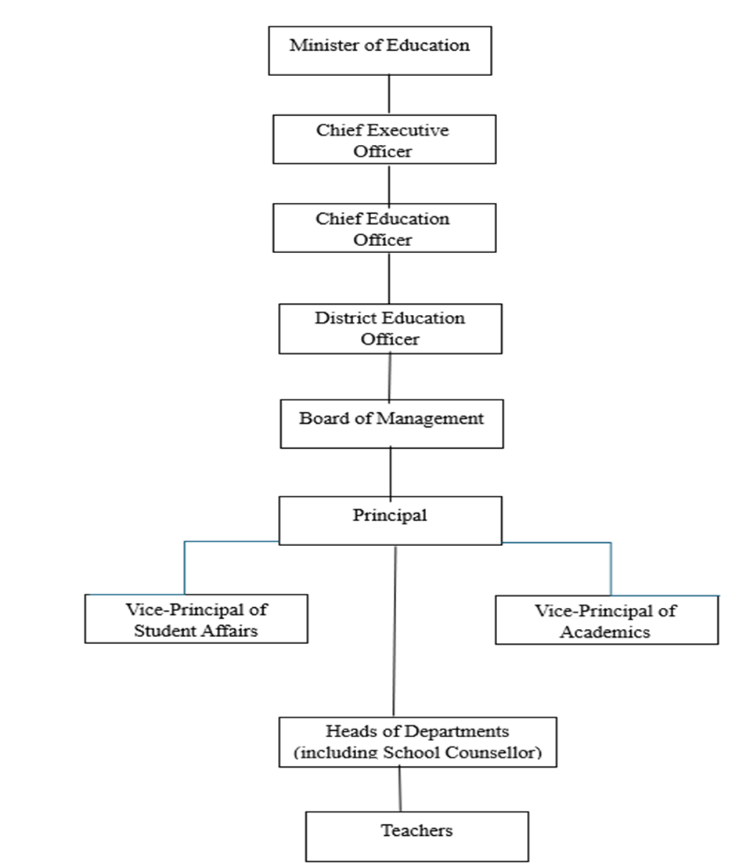

*Note.* Chart 1 showing the Organizational structure of Government Secondary Schools.

Source: Author (Licia Castillo, 2024)

#### Products offered

Orange Walk Technical High School (OWTHS) is a co-educational vocational-technical institution that emphasizes innovative education, training, and career development. Students, at level 2, are provided with core subjects that build foundational skills in Literacy and Numeracy. At upper secondary, level 3, students, guided by career counselling and exposure to various fields, choose a career path from options such as Business Science, Academic Science, Humanities, Industrial Studies, and Industrial Business.

Through a vigorous counselling program, OWTHS hopes to increase students’ academic success, personal-emotional growth and alignment of career with interests and abilities. The school strives to nurture students into confident leaders and positive contributing members of society practicing empathy, compassion and respect for all. The program fosters positive partnerships with stakeholders to help students reach their full potential.

### Project Management concepts

#### According to the PMI, “a project is defined as a temporary endeavor undertaken to create a unique product, service, or result” (PMI, 2017, p. 4). It has a defined beginning and end, specific objectives, and requirements. The unique nature of each project necessitates adapted management practices. A project is considered successful if its objectives are achieved according to the project acceptance criteria, within the agreed-upon timescale and budget.

#### Projects are undertaken at all organizational levels and can involve a single individual or a group. Project management involves applying knowledge, skills, tools, and techniques to project activities to meet project requirements.

#### For the Final Graduation Project “A project management plan for the implementation of a school counselling program model in a government school.”, these concepts form the foundation of the project methodology. The project’s success will depend on effectively applying these principles to plan, execute, and close the project while considering the specific context and requirements of the institution. If the institution has its own project management framework or specific practices, these should be integrated into the FGP methodology to ensure alignment with both academic and organizational standards.

#### Project management principles

Project management principles are fundamental guidelines that steer project managers toward successful project execution. By providing a structured approach to planning, executing, and controlling projects, these principles ensure alignment with organizational objectives and the efficient delivery of projects within scope, time, and budget constraints.

While specific principles can vary based on methodology or framework, the PMBOK 7th edition highlights core principles including:

* Stewardship
* Team Collaboration
* Stakeholder Focus
* Value Delivery
* Systems Thinking
* Leadership
* Tailoring
* Quality Focus
* Complexity Management
* Risk Optimization
* Adaptability
* Change Enablement

*Note.* Taken from the book, A Guide to the Project Management Body of Knowledge (PMBOK® Guide) (7th edition, PMI, 2021, p.23), by PMI, 2021. Copyright 2021, Project Management Institute, Inc. All rights reserved.

Key project management principles to this project include:

* **Clear Project Definition:** Establish a clear vision by defining project goals, scope, deliverables, and constraints.
* **Strong Leadership:** Effective project leadership is crucial for guiding the team and making informed decisions.
* **Stakeholder Engagement:** Identify, engage, and manage all stakeholders, fostering open communication to meet their needs and expectations.
* **Comprehensive Planning:** Develop a detailed project plan outlining timelines, resources, and milestones to guide execution.
* **Effective Communication:** Maintain open and consistent communication channels to coordinate activities, manage expectations, and resolve issues.
* **Risk Management:** Identify, assess, and mitigate potential risks to protect project success.
* **Quality Assurance:** Implement processes to ensure deliverables meet required quality standards.
* **Continuous Monitoring and Control:** Regularly track project progress against the plan and make necessary adjustments.
* **Adaptability:** Be prepared to adapt to changes and challenges that arise during the project.
* **Ethical Conduct:** Uphold high standards of integrity, transparency, and professionalism.
* **Continuous Improvement:** Foster learning and improvement by reflecting on project outcomes and processes.
* **Organizational Alignment:** Ensure the project supports broader organizational goals and strategies.

#### Project management domains

#### Project management domains are areas of focus that collectively encompass the key aspects of managing a project. These domains help project managers and teams address various facets of a project to ensure successful completion.

#### According to the PMI, a project performance domain is “a group of related activities that are critical for the effective delivery of project outcomes” (PMI, 2021, p.7). Project performance domains are interconnected areas of focus that collectively drive project success. These interdependent domains work together to achieve desired outcomes. There are eight core project performance domains and how it relates to the "Implementation of the school counselling program model in a government school, including initial setup, execution, monitoring, and evaluation."

#### Stakeholder Performance Domain: Focuses on managing relationships and expectations with all project stakeholders.

* Application: Identify key stakeholders such as school administration, teachers, parents, students, and government education officials. Engage them early to understand their needs, expectations, and concerns regarding the counselling program. Regularly communicate progress and seek feedback to ensure the program aligns with stakeholder needs and gains their support.

#### Team Performance Domain: Concentrates on building and leading high-performing project teams.

* Application: Assemble a team that includes school counsellors, teachers, administrative staff, and possibly external experts. Define roles and responsibilities clearly and promote collaboration. Regular team meetings and professional development sessions can enhance team performance and ensure everyone is working towards the common goal of implementing the counselling program.

#### Development Approach and Life Cycle Performance Domain: Addresses the selection and management of the project lifecycle model (e.g., Agile, Waterfall).

* Application: Choose an appropriate development approach (e.g., phased or iterative) for implementing the counselling program. This domain ensures that the implementation is methodical and manageable.

#### Planning Performance Domain: Involves creating and managing project plans, schedules, and budgets.

* Application: Develop a comprehensive project plan that includes the scope of the counselling program, objectives, schedule for implementation, required resources (counsellors, materials, training), budget, and risk management strategies.

#### Project Work Performance Domain: Covers the execution of project activities and tasks.

* Application: Execute the project plan by setting up the counselling program infrastructure (e.g., counselling offices, materials), conducting training for staff, and initiating the counselling services. Monitor the implementation process to ensure that it follows the plan and make adjustments as necessary to address any challenges or changes.

#### Delivery Performance Domain: Ensures the successful delivery of project outputs and outcomes.

* Application: Focus on delivering the counselling services as outlined in the project plan. Ensure that the services provided meet the quality standards and objectives set out in the planning phase. This includes regular assessments of the counselling sessions, feedback from students and staff, and adjustments to the program as needed.

#### Measurement Performance Domain: Defines metrics and measures project performance against objectives.

* Application: Establish metrics and key performance indicators (KPIs) to measure the success of the counselling program. This could include metrics like the number of students served, feedback scores from students and parents, improvements in student well-being, and academic performance. Regularly review these metrics to evaluate the program's impact and effectiveness.

#### Uncertainty Performance Domain: Focuses on identifying, assessing, and responding to project risks and uncertainties.

* Application: Identify potential risks and uncertainties, such as resistance to the program from stakeholders, staffing challenges, or unexpected costs. Develop risk mitigation strategies, such as contingency plans for staffing shortages or strategies to increase stakeholder buy-in. Regularly review risks and adjust plans as necessary to manage uncertainties effectively.

#### Predictive, adaptative and hybrid projects

Project lifecycles refer to the series of phases that a project goes through from initiation to completion. These phases help structure and guide project management processes, ensuring that the project is completed efficiently and effectively.

According to the PMBOK® Guide, seventh edition, a project life cycle is “the series of phases that a project passes through from its start to its completion” (PMBOK 7th Edition, 2021, p.33). In the context of the PMI, the approaches can be broadly categorized into predictive, adaptive, and hybrid methodologies. Each approach is suited to different types of projects based on factors like project scope, complexity, and uncertainty.

**2.2.3.1 Predictive Projects**

Predictive project management, also known as the traditional or waterfall approach, involves a linear and sequential process. The project's scope, time, and cost are determined early in the project lifecycle, and any changes are managed carefully through a formal change control process.

Certain prominent characteristics of a predictive project include a well-defined project scope and requirements, a detailed planning phase before execution begins, a single direction through clearly defined phases, and thorough documentation. This approach is best suited for projects with clear objectives, stable requirements, and a predictable environment.

**2.2.3.2 Adaptive Projects**

Adaptive project management, commonly associated with Agile methodologies, is more flexible and iterative. It is designed to accommodate changing requirements and provides iterative (small, manageable steps, allowing for regular adjustments based on feedback) deliverables throughout the project lifecycle. Collaboration and improvement are key to aligning the final product with customer needs. This approach is perfect for uncertain or complex projects where the end goal isn't clear from the start.

**2.2.3.3 Hybrid Projects**

Hybrid project management combines elements of both predictive and adaptive approaches, tailoring the methodology to suit specific project needs. Key elements like overall goals and deadlines are planned upfront, providing a solid foundation. However, other aspects, such as specific features or user interfaces, can be adapted based on feedback and changing circumstances. This combined approach allows for a structured framework while accommodating evolving needs, making it ideal for complex projects that require both predictability and responsiveness.

A hybrid lifecycle is ideal for the FGP due to its combination of predictable and evolving elements. While establishing the counseling infrastructure can be planned in advance, the development and refinement of services require flexibility. By combining predictive and adaptive approaches, we can effectively manage both the well-defined aspects of the project and the uncertainties associated with developing new services. This approach also allows for continuous improvement through stakeholder feedback and monitoring, ensuring the counseling program meets the evolving needs of the school community.

#### Project management

Project management, the administration, direction, or management of projects, is a broad field that involves coordinating resources, managing stakeholders, and applying structured methodologies to achieve specific objectives. Various authors have provided valuable and diverse perspectives into the principles and practices of project management.

Harold Kerzner:

Harold Kerzner stresses the significance of treating project management as a unified system. He emphasizes the importance of aligning project goals with organizational objectives, maintaining clear communication, and employing systematic planning and control processes to effectively manage project variables.

Kerzner’s systems approach to project management highlights the need for integration and coherence in managing projects. By looking at the whole picture, project managers can better predict problems and make sure everything works smoothly.

Dennis Lock:

Dennis Locke emphasizes the importance of precise and detailed planning, effective communication, and powerful control mechanisms. He underscores the importance of leadership and the empathic characteristics of project management, such as team dynamics and stakeholder engagement.

He believes in the holistic approach to project management emphasizing that technical skills are as important as soft skills. For successful project management, structured methodologies and effective communication and leadership provide a balanced perspective that addresses the complex nature of project management.

#### Project management knowledge areas and processes

Project Management Knowledge Areas

The PMI defines knowledge area as “an identified area of project management defined by its knowledge requirements and described in terms of its component processes, practices, inputs, out puts, tools, and techniques” (PMBOK Sixth Edition, 2017, pg. 23). Ten knowledge areas (Figure 2) cover different aspects of project management. Each knowledge area contains specific processes that guide the project from start to finish. The ten knowledge areas are explained as follows:

**2.2.5.1 Project Integration Management**

Focuses on the coordination of all project elements. It involves processes such as developing the project charter and management plan, directing project work, managing knowledge, monitoring and controlling project work, and closing the project or phase.

*Project Scope Management*

Involves defining and managing the boundaries of what is included and excluded in the project to ensure its successful completion. Key processes include planning scope management, collecting requirements, defining scope, creating a work breakdown structure (WBS), validating scope, and controlling scope.

**2.2.5.2 Project Schedule Management**

Concentrates on planning and controlling the project timeline to keep the project on schedule. Processes include planning schedule management, defining activities, sequencing activities, estimating activity durations, developing the schedule, and controlling the schedule.

**2.2.5.3 Project Cost Management**

Involves planning, estimating, budgeting, securing, managing, and controlling project costs to ensure completion within the approved budget. Key processes are planning cost management, estimating costs, determining the budget, and controlling costs.

**2.2.5.4 Project Quality Management**

Ensures that the project meets the objectives for which it was undertaken. This involves planning quality management, managing quality, and controlling quality.

**2.2.5.5 Project Resource Management**

Deals with planning, acquiring, developing, managing, and controlling the project team and physical resources. The processes include planning resource management, estimating activity resources, acquiring resources, developing the team, managing the team, and controlling resources.

**2.2.5.6 Project Communication Management**

Involves ensuring the timely and appropriate handling of project information, including planning, collecting, creating, distributing, storing, retrieving, managing, controlling, monitoring, and disposing of information.

**2.2.5.7 Project Risk Management**

Focuses on identifying, analyzing, and responding to project risks. This includes risk planning, identification, qualitative and quantitative risk analysis, risk response planning, and monitoring and controlling risks.

**2.2.5.8 Project Procurement Management**

Concerns acquiring goods and services from external sources. This knowledge area ensures that these procurements meet the project's needs and are delivered on time.

**2.2.5.9 Project Stakeholder Management**

Involves identifying all stakeholders affected by the project, analyzing their expectations and the impact on the project, and developing appropriate management strategies. This includes identifying stakeholders, planning stakeholder engagement, managing stakeholder engagement, and monitoring stakeholder engagement to ensure their needs and expectations are addressed.

Figure 2  
*Project Management Process Diagram*

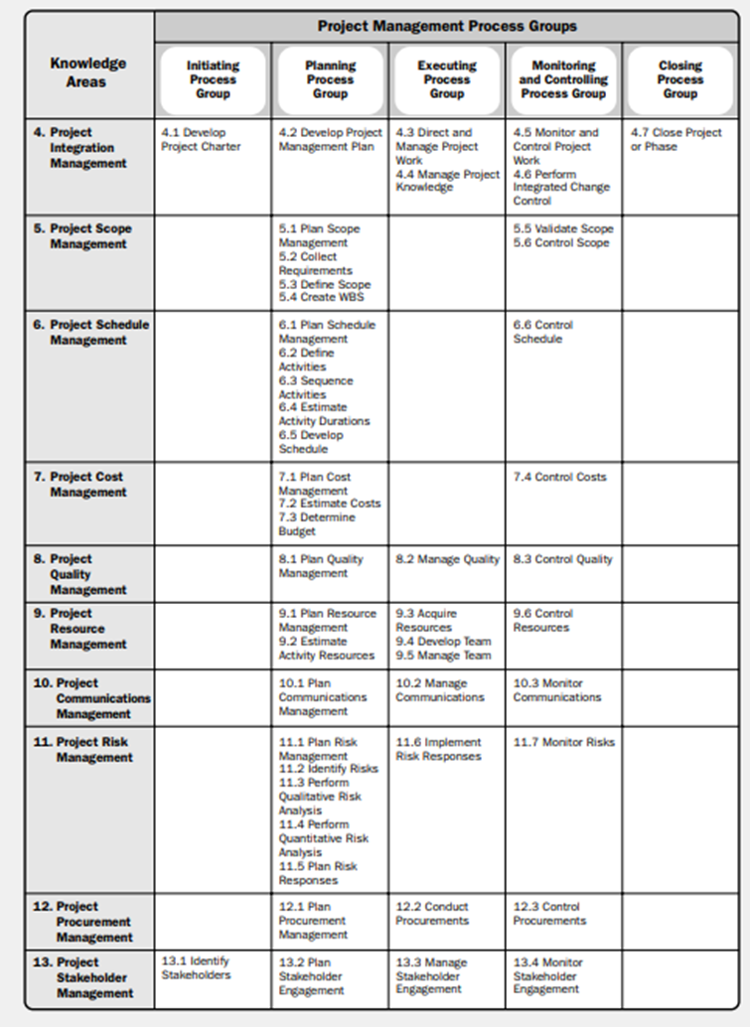

*Note*. Project Management Process groups and Knowledge Area Mapping Reprinted from A Guide to the Project Management Body of Knowledge PMBOK GUIDE (SIXTH EDITION, p.25) by Project Management Institute, Inc., 2017. All rights reserved.

Project Management Processes

According to the PMI, a Project Management Process Group is “a logical grouping of project management processes to achieve specific project objectives.” (PMBOK 6th Edition, 2017, p.23). The processes in each knowledge area are part of a broader framework that spans across five process groups. These groups represent a logical sequence of project activities:

*Initiating Process Group*

Processes that define and authorize the project or a project phase. This group includes two primary processes and outcomes: developing the project charter (outcome – project charter document) and identifying the project stakeholders (outcome – stakeholder register.)

*Planning Process Group*

During this process, the scope, objectives, and course of action required to achieve project goals are established. This process group consists of 24 processes which is designed to assist with the planning of the project in detail with the primary outcome being the project management plan.

*Executing Process Group*

Processes that complete the work defined in the project management plan to satisfy project requirements. The ten project management processes in this group focus on managing project activities and tasks to ensure efficient communication, effective risk responses, and stakeholder engagement.

*Monitoring and Controlling Process Group*

Processes that track, review, and regulate the progress and performance of the project and identify any areas where changes to the plan are required.

*Closing Process Group*

Processes that finalize all project activities to formally close the project or a project phase. This process involves confirming that the customer has accepted all final phases or project deliverables. It also includes completing and storing documentation and addressing any remaining tasks or unresolved aspects of the project or phase.

#### Project life cycle

Harold Kerzner:

Harold Kerzner defines the project life cycle as a series of phases that a project progresses through from initiation to completion as shown in Figure 3. He emphasizes that these phases are structured to help manage and control the project, these phases are conceptual, planning, testing, implementation, and closure. Kerzner highlights that each phase culminates in a deliverable or a milestone that must be completed before moving on to the next phase.

The initial phase focuses on evaluating the concept, assessing potential risks and their impact on project timelines, costs, and performance, and determining the project's feasibility. The subsequent phase refines the initial concept, establishes concrete resource requirements, and sets realistic project goals. Essential documentation is also created. For projects involving competitive bidding, this phase includes deciding whether to participate and developing the bid proposal. The third phase focuses on testing and refining the project to ensure it's ready for launch. All necessary documentation is finalized. The fourth phase involves integrating the project's outcome into the organization's operations. For products, this includes introducing the product to the market and managing its lifecycle. The final phase concludes the project by wrapping up activities and reassigning resources. This is similar to the end of a product's life when a company focuses on new opportunities

Figure 3  
*Life-cycle model*

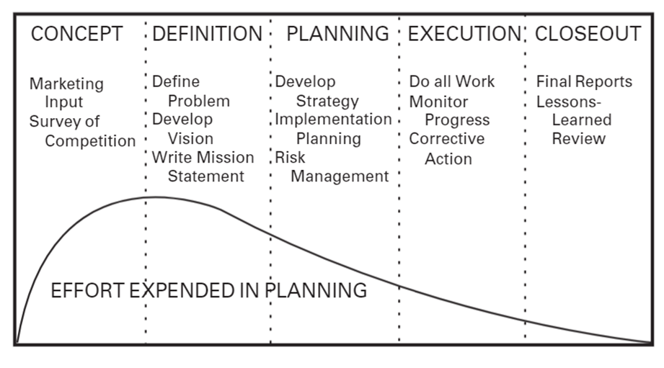

*Note.* Figure 3 shows the series of phases that a project progresses through as explained by Harold Kerzner. Reprinted from Kerzner, H. (2017). Project Management A Systems Approach to planning, scheduling, and controlling.

Dennis Lock:

Dennis Lock describes the project life cycle as a sequence of distinct phases that are often sequential but can overlap, depending on the project management approach. He asserts that these phases are established to facilitate control and monitoring of the project’s progression. The typical phases identified by Lock include feasibility, definition, execution, and closure. He notes that the specific nature and number of phases may vary based on the project's industry and complexity.

James P. Lewis:

James P. Lewis characterizes the project life cycle as a series of stages that define the path from the beginning to the end of a project. He outlines these stages as initiation, planning, execution, and closure. According to Lewis, the project life cycle provides a framework for managing the project, allowing for orderly progression and decision-making at critical points. He emphasizes the importance of each phase in delivering the project objectives and meeting stakeholder expectations. These definitions reflect the authors' views on the structured progression of a project, highlighting the importance of phases in facilitating effective management and control.

Kerzner's project management model can be effectively applied to the project " A project management plan for the implementation of a school counselling program model in a government school." By breaking down the project into distinct phases—initiation, planning, execution, monitoring and control, and closure—the model provides a structured approach. This framework ensures that the project is well-defined, planned, executed, monitored, and evaluated, ultimately leading to successful implementation of the counseling program. The life cycles of most projects at OWTHS follow the basic pattern of initiation, planning, execution, monitoring and control, and closure.

#### 2.2.7 Company strategy, portfolios, programs and projects

The Project Management Institute (PMI) outlines rooted definitions and frameworks for business strategy, portfolio, programs, and projects. These elements are interconnected and together help organizations plan and execute the strategic vision, ensuring that all efforts are aligned towards achieving desired outcomes. This alignment enhances the organization's ability to respond to market opportunities and threats, manage resources effectively, and achieve long-term sustainability and success.

The Project Management Institute (PMI) defines the key concepts as follows:

Business Strategy: A high-level roadmap outlining an organization's goals, actions, and resource allocation to achieve its objectives. It provides direction and focus.

Portfolio: A collection of projects and programs aligned with the overall strategy. It helps prioritize investments and optimize resource use.

Programs: A group of related projects working together to achieve specific strategic goals. They offer better control and efficiency than managing individual projects separately.

Projects: Temporary undertakings with defined start and end dates, aiming to create a unique product or service. They are crucial for implementing strategic initiatives.

By aligning business strategy, portfolios, programs, and projects, schools can operate more effectively and efficiently and improve student outcomes, ensuring that all educational and operational activities are aligned with the school's mission and strategic goals. The integration of these elements leads to better decision-making, resource allocation, and the achievement of key educational outcomes, ultimately leading to improved student success and institutional growth.

A clear business strategy, a School Improvement Plan (SIP), outlines a school’s long-term goals and resource allocation to achieve them, such as improving student outcomes. A portfolio of academic programs, extracurricular activities, and initiatives supports the school’s overall mission. Programs address specific educational needs, like personal social development programs. Projects are time-bound initiatives to implement specific goals, such as career and life skills development projects.

### Other applicable theory/concepts related to the project topic and context

**2.3.1 Current situation of the problem or opportunity in study**

According to Smith-Augustine (2012), in Belize “there is no common job description or standardized framework for the practice of school counselling.” She further explains, “Without a standardized structure for delivery of counselling services, school counsellors’ roles and responsibilities are determined by the school administration and/or the knowledge and preferences of the individual school counsellor.” Not much has changed nationally since this research was conducted in 2012.

In other countries without formalized structures for counselling practice, the roles and responsibilities of school counsellors vary widely. For example, in Turkey, where the Ministry of National Education does not clearly define these roles, school counsellors, known as guidance teachers, do not teach and are often expected to assist with administrative functions in the school. This lack of clarity has led to confusion and misunderstandings among school personnel (Stockton and Gũneri, 2011).

In Canada, Keats and Laitsch (2010) note that school counsellors often provide discipline and administrative support in addition to traditional counselling roles. This ambiguity in counsellors’ roles has contributed to system overload and increased stress, complicating the professional knowledge requirements and capacities of practitioners. Since 2010, there has been some progress toward a more nationalized counselling professional identity and parameters of practice. However, as of 2017, the professional identity is still in a developmental stage due to the variation in responsibilities and training (Kushner, 2017).

Improvements

Smith-Augustine and Wagner (2012) stated that Belize's educational landscape is primed for significant growth due to the proactive efforts of school counsellors. These professionals have been instrumental in advocating for a standardized counselling model. Their work will ensure that any future regulatory framework or national model for school counselling in Belize prioritizes education, training, professional identity, and standardized practices.

The Belize Education Sector Plan 2021-2025 recognizes a critical need for psychosocial support in schools. To address this, the Ministry of Education, Culture, Science, and Technology (MoECST) has assigned at least one counsellor to every secondary school. Counsellors provide individual and group counselling, teach life skills, and organize school-wide events. Beyond this, the ministry is funding the Belize School Counsellor Association to develop a standardized school counselling model, with the assistance of U.S. experts.

The drafted Belize national model is adapted from the ASCA National Model: A Framework for School Counselling Program. The following research shows support for the efficacy of this model. A study done by Wilkerson, K., Pérusse, R., & Hughes, A. (2013), stated that research consistently shows that elementary schools with robust, data-driven counselling programs achieve higher academic performance compared to schools without such initiatives. In addition, Goodman-Scott, et.al. (2018) stated that research consistently demonstrates that comprehensive, data-driven school counselling programs positively impact student learning and behavior outcomes.

**2.3.2 ASCA National Model**

The ASCA National Model: A Framework for School Counselling Programs, 4th Edition (2019), provides a comprehensive blueprint for school counsellors to design, implement, and assess counselling programs. It emphasizes a data-driven, student-centered approach to help students achieve academic, career, and social/emotional development and growth. It emphasizes a systematic approach to counselling that integrates these components and principles into a cohesive program.

**2.3.2.1 Core Components of the model:**

Foundation: Defines the program's purpose, aligning it with school goals and emphasizing student outcomes.

Management: Organizes and oversees the counselling program, using data to guide planning and resource allocation.

Delivery: Outlines direct and indirect services to students, including counselling, classroom guidance, and collaboration.

Accountability: Measures program effectiveness demonstrates impact on students, and informs continuous improvement.

**2.3.2.2 Key Principles of the model:**

Data-Driven: Uses data to inform decision-making and measure outcomes.

Collaborative: Works closely with teachers, administrators, parents, and the community.

Comprehensive: Addresses students' academic, career, and social-emotional needs.

Student-Centered: Prioritizes student success and well-being.

Professional: Adheres to ethical standards and engages in ongoing professional development.

Important to note that while this model has been used informally by several school counsellors in Belize, it has never undergone a formal project implementation, including project initiation, monitoring, and evaluation phases.

**2.3.3 Previous research done for the topic in study**

Recent developments in Belize, as part of the Belize Education Sector Plan 2021-2025, include the Ministry of Education, Culture, Science, and Technology assigning counselors to every secondary school and funding efforts to develop a standardized school counseling model, inspired by the ASCA National Model.

The ASCA National Model, supported by research (Wilkerson et al., 2013; Goodman-Scott et al., 2018), has shown that comprehensive, data-driven counseling programs positively impact student academic performance and behavior. This model emphasizes a systematic, data-driven approach that includes components such as foundation, management, delivery, and accountability, ensuring that counseling programs are aligned with school goals and focused on student outcomes.

The ASCA model provides a proven framework for the "Implementation of the school counselling program model in a government school, including initial setup, monitoring, and evaluation." Research on its effectiveness demonstrates potential benefits for student outcomes. The existing advocacy efforts from counselors and the Ministry of Education (MOE) create a favorable environment for implementation. While the ASCA model has been used informally, a formal project requires phases like initiation, monitoring, and evaluation.

**2.3.4 Other theory related to the topic in study**

In her article, Sokolova, V. (2024, July 5), highlights the growing importance of lifelong learning and how educational institutions need to adapt to increasing demands by effectively managing educational projects. Project management in education involves leading teams to achieve goals within constraints like scope, budget, and time. While these practices are common in business, they are also crucial for educational institutions to manage complex projects.

She cites certain key challenges in Educational Project Management such as improper planning, inability to adapt quickly, lack of human resources, budget constraints, changing requirements, and difficulty in measuring success.

The article suggests that detailed planning, support for staff, efficient resource management, and establishing procedures for adapting to changes are essential strategies for overcoming these challenges. Utilizing project management software and techniques can enhance tracking and controlling projects, ensuring they are completed successfully despite the inherent challenges in the educational sector.

# METHODOLOGICAL FRAMEWORK

A methodology framework is a structured approach that guides the planning, execution, and analysis of a research project, study, or inquiry. It is the set of principles, tools and practices that guide the process of developing or implementing a system, product, or solution and achieving the research objectives. This blueprint for how research will be conducted, ensures consistency, reliability, and validity throughout the study.

### Information sources

“Information can come from virtually anywhere — media, blogs, personal experiences, books, journal and magazine articles, expert opinions, encyclopedias, and web pages — and the type of information you need will change depending on the question you are trying to answer.” Libguides: Information Literacy Guide: Types of Information Sources," 2021. The source from which we get our information are called information sources. Information sources provide us with information on current developments in different fields, offer answers for specific inquiries, clarifies uncertainties, and provides comprehensive overviews or historical information. Two such sources of information are primary and secondary sources.

#### Primary sources: Interviews, Observations, Surveys, Questionnaires, Existing Data

According to the University of Wisconsin Stevens Point LibGuide, primary sources are firsthand accounts of research or events, including original scholarly research results, raw data, testimonies, speeches, historical objects, or other evidence that provide unique and original information about a person or event. ("Libguides: Primary, Secondary, and Tertiary Sources of Information in the Sciences," 2023). These sources that hold original information have either been published recorded or reported, are more current and contain the most recent information available.

For this project " A project management plan for the implementation of a school counselling program model in a government school " several primary sources of information are necessary and will be employed (Chart 1.) These include interviews with key stakeholders such as school administrators, counsellors, teachers, students, and parents to gather perspectives on the program's planning, implementation, and impact. Direct observations of counselling sessions, activities, and the overall school environment provide first hand insights into program delivery and its effects. Program documentation, including setup materials, monitoring reports, and evaluation tools, offers necessary records of the program's development and progress. Surveys and questionnaires administered to students, teachers, and parents measure changes in attitudes, behaviors, and satisfaction. School records, such as student behavior data, student academic performance data and referral information, can be analyzed to identify potential correlations with the counselling program. Meeting notes and memos document the decision-making processes and program development.

#### Secondary sources: Literature reviews, Case Studies, Existing documentations

“A document concerning a particular subject of inquiry which is derived from or based on the study and analysis of the primary source of information is called the secondary source of information.” Information sources and services 2013 pp.9. A secondary source is not evidenced and is at least one step removed from the original event. It offers analysis and interpretation of primary sources.

The secondary sources used for the project "A project management plan for the implementation of a school counselling program model in a government school" (Chart 1) will include literature reviews on existing research on school counselling programs, case studies detailing successful implementations, and relevant policy documents. Evaluation studies and theoretical frameworks provide a foundation for program design and assessment. Practical guidance can be found in best practice guides, while educational statistics and reports offer data on student needs and program outcomes. Historical analyses provide context, and professional journals offer current trends and practices.

Chart 1

Information sources

| **Objectives** | **Information sources** | |
| --- | --- | --- |
| **Primary** | **Secondary** |
| 1. To establish a high-level project structure for the school counselling model in a government school by developing a plan for implementing initiation processes, including developing the project charter and identifying key stakeholders. | **Interviews and Surveys:**  School Administrators – surveys to understand perspectives on the need for the school counselling model.  Counselors and Teachers – focus groups to learn about the current challenges and expectations for a structured model.  Students and Parents - surveys to understand the emotional, social, and academic challenges students face and what support parents expect from a school counselling program.  Government Officials/ Education Department Representatives – use interviews to understand the policies, expectations, and compliance requirements for implementing a government-endorsed counselling model.  ASCA Experts – consult with experts on how to align the counselling model with best practices and standards.  **Existing Documentation:**  School Reports and Records  Policy Documents - review records on student performance, attendance, behavioral issues, and current interventions to identify areas where counselling services can improve.  **Observations:**  School Environment | **Academic Literature:**  Research Articles and Journals - on school counselling models and their impact on student outcomes.  Books on Educational Counseling - on counselling techniques, school-based interventions, and developmental psychology to ensure the model is student-centered and holistic.  **Government Publications**  **Guidelines and Frameworks:** Official documents on school counseling standards and best practices.  **Statistical Reports -** analyze local or national statistics on student mental health, behavioral issues, and academic performance to inform the specific needs addressed by the counselling model.  **PMI and Other Project Management Bodies**: The PMBOK® Guide, Sixth and Seventh Editions and Project Management Textbooks |
| 1. To create a detailed project management plan for implementing the school counselling model in a government school, which includes developing plans for scope, schedule, costs, resources, quality, communications, risks, acquisitions, and stakeholders. | **Interviews and Surveys:**  School Administrators and Principals - interview to define the project scope by identifying the specific needs the counselling model will address.  Counsellors and Teachers - focus groups to understand the specific training needs  Project Management Experts – consultations to assist in creating detailed schedules, cost estimates, and risk management strategies that are tailored to the school environment.  **Existing Documentation:**  School Reports and Records  Budgets and Financial Statements - analyze data to define the project’s scope, identifying the specific areas the counselling model will address.  Policy Documents  **Observations:**  School Environment - conduct on-site observations to assess the physical environment and available resources, such as counselling rooms or student support areas. | **Academic Literature:**  Research Articles and Journals - review academic research on the effectiveness of various school counseling models to inform the quality management plan.  **Government Publications:**  Statistical Reports - analyze statistical reports on student mental health, absenteeism, and academic performance to help define the scope and objectives of the counselling model.  **Best Practices and Case Studies:**  Reports from Other Schools  **PMI (Project Management Institute) Publications**: The PMBOK® Guide, Sixth and Seventh Editions and Project Management Textbooks |
| 3. To propose a plan to guide the execution of the project management plan for the school counselling model in a government school. | **Interviews and Surveys:**  School Administrators and Principals - interview administrators to discuss the timeline for implementing counselling services, defining roles, and identifying key milestones such as training, launch dates, and monitoring processes.  Counsellors and Teachers - surveys and interviews with counsellors to gather feedback on how they would prefer to execute the plan, including methods of training, engagement, and coordination.  Government Officials - interview to ensure the execution plan aligns with legal, policy, and budgetary requirements.  Project Management Experts - consultation in project management to gain insights on how to effectively track and manage project execution,  **Existing Documentation:**  School Reports and Records - Analyze past reports on student issues, counsellor usage, and feedback from teachers to identify key areas that need addressing during the execution phase.  Budgets - review the budget to ensure that resources are properly allocated for each phase of execution, such as training, materials, and monitoring. | **Academic Literature:**  Research Articles and Journals - review literature on effective school counselling practices to guide the sequence of execution.  **Government Publications:**  Guidelines and Frameworks:  Statistical Reports  **Best Practices and Case Studies:**  Reports from Other Schools - analyze case studies from other schools that have successfully implemented similar counselling programs.  **PMI (Project Management Institute) Publications**: The PMBOK® Guide, Sixth and Seventh Editions and Project Management Textbooks |
| 4. To develop a plan to implement a monitoring and control system with suitable tools and techniques to effectively track and integrate objectives and goals throughout the implementation of the school counselling model in a government school. | **Interviews and Surveys:**  Counsellors and Teachers - survey which metrics they find most relevant for monitoring student progress and the practicality of various tracking tools.  Students and Parents - gather input on what they consider successful outcomes of the counselling program.  Government Officials/ Education Department Representatives - interview to understand what reporting frameworks are required at the government level.  **Existing Documentation:**  School Records - data for tracking student progress.  **Observations:**  Classroom and Counselling Observations - to monitor how well the program is being implemented. | **Academic Literature:**  Research Articles and Journals - to identify best practices for tracking and monitoring student outcomes in counselling programs.    **Government Publications:**  Statistical Reports - on school performance or mental health trends to set context-specific goals and objectives.  **Best Practices and Case Studies:**  Reports from Other Schools - to identify which tracking and monitoring systems are working best.  **PMI (Project Management Institute) Publications**: The PMBOK® Guide, Sixth and Seventh Editions and Project Management Textbooks |
| **Objectives** | **Information sources** | |
| **Primary** | **Secondary** |
| 5. To define a project closure procedure for the school counselling model in a government school that encompasses evaluating the achievement of objectives and goals, documenting lessons learned, and transferring the program to the school management team. | **Interviews and Surveys:**  School Administrators and Principals - to assess whether the objectives of the school counselling model have been achieved.  Counsellors and Teachers - to gather their input on the effectiveness of the counselling model.  Students and Parents – surveys and focus groups to understand their perception of the program’s impact.  **Existing Documentation:**  School Reports/Records - to analyze whether the counselling program achieved its intended outcomes.  Project Documentation – project management plan to assess the program's success. | **Government Publications:**  Guidelines and Frameworks - to ensure compliance during project closure.  **Best Practices and Case Studies:**  Reports from Other Schools  **PMI (Project Management Institute) Publications**: The PMBOK® Guide, Sixth and Seventh Editions and Project Management Textbooks |

*Note.* Chart 1 shows Information Sources used to gather information for the project "A project management plan for the implementation of a school counselling program model in a government school."

Source: Author (Licia Castillo, 2024)

### Research methods

Research methods are the strategies, processes or techniques utilized in the collection of data or evidence for analysis in order to uncover new information or create better understanding of a topic. LibGuides at University of Newcastle Library. (2024). Research methods provide structured step-by-step ways to investigate and understand phenomena, learn about things, find answers, or test ideas.

Four types of research methods can aid this FGP in meeting its objectives: Qualitative, Quantitative, Mixed Methods, and Applied Research.

**3.2.1 Qualitative Research Method**

Qualitative research methods are utilized for gathering non-numerical data. It is used to determine the underlying reasons, views, or meanings from study participants or subjects. Bouchrika, I. (2024)

Qualitative research methods can provide valuable insights into the implementation and impact of a school counselling program model. By conducting interviews with teachers, students and parents during the initial setup, researchers can gain a deep understanding of the school's culture, identify specific needs, and assess available resources. Ongoing monitoring through focus groups and observations allows for exploration of the program's influence on student well-being and relationships. Finally, in-depth interviews with counsellors, students, and parents during the evaluation phase can provide rich feedback on the program's effectiveness, strengths, and areas for improvement.

**3.2.2 Quantitative Research Method**

Quantitative research methods are used for gathering information via numerical data. This type is used to measure behavior, personal views, preferences, and other variables. Quantitative studies are in a more structured format, while the variables used are predetermined. Bouchrika, I. (2024)

Quantitative research provides numerical data to inform the implementation and evaluation of a school counselling program model. By analyzing student demographics, academic performance, and disciplinary records during the initial setup, researchers can identify specific student populations in need of support. Monitoring program utilization rates, attendance figures, and counsellor caseloads offers quantitative data on program reach and impact. Finally, pre- and post-intervention assessments of student behavior, academic performance, and mental health provide measurable outcomes to evaluate the program's effectiveness.

**3.2.3 Mixed Methods Research**

This approach allows for a balance of numerical data and in-depth insights by helping to explain statistical results in greater detail, as qualitative data can shed light on the underlying reasons behind quantitative patterns. Integration of these methods can occur at various stages of the research process, from data collection to analysis and presentation. This methodology is also valuable for tracking the process of programs or interventions, providing insights into implementation and outcomes. Finally, mixed methods can be used to examine patient-centered outcomes and stakeholder engagement, fostering a deeper understanding of the impact of interventions from multiple perspectives.

Mixed methods research offers a comprehensive approach to understanding and evaluating a school counselling program model. By combining qualitative and quantitative data, researchers can gain a deeper understanding of the program's impact. During the initial setup, this approach helps identify specific needs and tailor the program accordingly. Throughout implementation, monitoring both quantitative measures (like attendance rates) and qualitative feedback provides a holistic view of program progress. Finally, integrating quantitative outcomes with qualitative insights during evaluation offers a rich understanding of the program's overall effectiveness and areas for improvement.

**3.2.4 Applied Research Method**

Applied research is a practical problem-solving approach that uses scientific methods. By focusing on expanding knowledge, applied research aims to find solutions to real-world issues. It involves systematic investigation, collaboration, and the application of research methods to generate actionable insights. By bridging the gap between theory and practice, applied research drives innovation and improves products, services, and processes across various fields.

Applied research is directly focused on solving practical problems within a specific context. In the case of implementing a school counselling program, applied research involves developing and implementing solutions that address the school's unique counselling needs. It also entails using research findings to make informed decisions about program adjustments, resource allocation, and overall effectiveness. By continuously evaluating and refining the program based on research evidence, applied research ensures that the program remains relevant, effective, and responsive to the changing needs of students.

Chart 2

*Research methods*

| **Objectives** | **Research methods** | | |  |
| --- | --- | --- | --- | --- |
| Qualitative | Quantitative | Mixed | Applied |
| 1. To establish a high-level project structure for the school counselling model in a government school by developing a plan for implementing initiation processes, including developing the project charter and identifying key stakeholders. | **Conduct Interviews and Focus Groups:** Organize a series of interviews with school administrators, teachers, counsellors, and key government officials and hold focus groups with a small number of parents and students.  Examples:  a. *A structured interview guide with questions such as "What are the most pressing mental health needs of the school community?" and "What role do you see the counselling model playing in addressing these needs?"*  *b.Focus group discussion prompts and a facilitator guide.* | **Surveys and Questionnaires:** Distribute surveys to a larger population of students, parents, and teachers to quantify their needs and expectations for the counselling model.  Example: *Online or paper-based surveys with multiple-choice, Likert scale, and open-ended questions.*  **Statistical Analysis:** Analyze the survey data to identify common themes and trends that can inform the project charter and stakeholder identification.  Example: *Software such as Microsoft Excel, or Google Sheets for quantitative analysis.*  **Baseline Metrics:** Establish baseline metrics for key performance indicators (KPIs) related to the counselling model's outcomes.  Example: *a* *baseline data collection form or spreadsheet that records initial values of key metrics before project implementation.* | **Integrate Qualitative and Quantitative Data:** Combine insights from the interviews and focus groups (qualitative data) with the survey results (quantitative data) to gain a well-rounded understanding.  Example: *A matrix or chart in Excel or Google Sheets that displays the integrated findings.* | **Develop Practical Solutions:** Design and implement practical strategies for the initiation phase of the project, including the creation of the project charter and stakeholder identification processes.  Example: *A matrix or chart in Excel or Google Sheets that displays the integrated findings.*  **Pilot Testing:** Conduct pilot tests of the initial project structure and processes in a small group or a single school to identify potential issues and refine the approach.  Example: *A checklist with specific criteria for evaluating the pilot test.*  **Evaluate Effectiveness:** Assess the effectiveness of the implemented initiation processes and make necessary adjustments to ensure they meet the project's goals and stakeholder needs.  Example: *Evaluation rubric or checklist for assessing the success of the initiation processes.* |
| 2. To create a detailed project management plan for implementing the school counselling model in a government school, which includes developing plans for scope, schedule, costs, resources, quality, communications, risks, acquisitions, and stakeholders. | **Interviews and Focus Groups:**  Conduct interviews and focus groups with teachers, administrators, students, parents, and community members to gather insights into their expectations and needs for the counselling model.  Brainstorming sessions and expert interviews to gather qualitative data on potential risks and challenges. | **Surveys and Questionnaires:** Distribute surveys to gather data on the availability of resources, estimated costs, and timelines from various departments and stakeholders.  Example*:*  *a. Online or paper-based surveys with questions on resource availability, cost estimations, and timelines.*  *b.* *A stakeholder communication survey with both multiple-choice and open-ended questions to identify communication needs.*  **Statistical Analysis:** Use statistical tools to analyze data on resource availability, utilization rates, and acquisition costs.  **Baseline Metrics:** Quantitative data can be used to set measurable quality targets and monitor communication reach and effectiveness.  Example: *Baseline data collection forms for measuring key indicators related to service quality and stakeholder engagement.* | **Comprehensive Needs Assessment:** Combine qualitative data from interviews with quantitative survey data to create a holistic understanding of stakeholder needs and resource requirements.  Example: *Needs assessment report template that integrates both qualitative and quantitative findings.* | **Practical Solutions:** Develop practical strategies for defining the project scope, creating a schedule, estimating costs, and allocating resources based on applied research findings.  Example:  *a. Cost estimation worksheet with breakdowns of resource needs and projected costs.*  *b. Resource allocation matrix or chart (Excel or MS Project).*  **Pilot Testing:** Conduct pilot tests of the counselling model in a small setting to evaluate quality standards, communication effectiveness, and stakeholder engagement.  Example: *Pilot test checklist or evaluation form with specific criteria such as "clarity of communication," "adequacy of resources," and "stakeholder involvement."*  **Problem Solving:** Use applied research to identify and address practical challenges related to risk management and acquisitions. Develop and implement strategies to mitigate risks and streamline procurement processes based on empirical evidence.  Example: *Risk management plan template, including sections for risk identification, analysis, response planning, and monitoring.* |
| 3. To propose a plan to guide the execution of the project management plan for the school counselling model in a government school. | **Interviews and Focus Groups:**  Conduct interviews and focus groups with teachers, administrators, students, parents, and other key stakeholders to gather insights into their expectations and needs for the counselling model.  **Content Analysis:** Review and analyze documents, reports, and other qualitative data sources related to past counselling initiatives or school mental health policies to extract themes and lessons learned. | **Surveys and Questionnaires:** Distribute well-structured surveys to students, teachers, and parents to collect data on current mental health issues, counselling needs, and attitudes toward counselling services.  Example*: Likert scale (e.g., 1-5 scale from ‘strongly disagree’ to ‘strongly agree’), multiple-choice, or short answers.*  **Statistical Analysis:** Analyze quantitative data such as student performance, attendance rates, disciplinary incidents, and other relevant metrics to establish baselines and measure the impact of the counselling model.  Example*: School management system-generated reports that track these metrics over time, allowing for quantitative analysis of trends.* | **Sequential Explanatory Design:** Begin with quantitative data collection (e.g., surveys) to identify general trends and patterns, followed by qualitative methods (e.g., interviews or focus groups) to explore the findings in greater depth. | **Program Evaluation:** Conduct formative **evaluations** during early implementation and summative evaluations at the end of the project to assess the effectiveness of the counselling model throughout its implementation. Use this data to make adjustments and improvements.  **Needs Assessment:** Perform a needs assessment to identify gaps in current counselling services and determine the specific requirements for the new model.  **Implementation Science:** Use implementation science frameworks to guide the introduction of the counselling model, focusing on strategies that enhance the adoption, integration, and sustainability of the model in the school setting. |

| Objectives | **Research methods** | | | |
| --- | --- | --- | --- | --- |
| Qualitative | Quantitative | Mixed | Applied |
| 4.To develop a plan to implement a monitoring and control system with suitable tools and techniques to effectively track and integrate objectives and goals throughout the implementation of the school counselling model in a government school. | **Interviews and Focus Groups:** Conduct interviews and focus groups with teachers, counsellors, administrators, students, and parents to understand their needs and expectations for the monitoring and control system. | **Surveys and Questionnaires:** Distribute surveys to gather data on the specific needs, preferences, and expectations of a larger population of stakeholders.  Examples: *checklists or* *Survey using likert scale (e.g., 1-5 scale from ‘strongly disagree’ to ‘strongly agree’), multiple-choice, or short answers.*  **Statistical Analysis:** Use statistical analysis to identify common trends and requirements that can inform the design of the monitoring and control system.  **Performance Metrics:** Establish baseline metrics and key performance indicators (KPIs) to measure the effectiveness of the monitoring and control system.  Example: *Standardized log or database where counsellors enter details such as session date, duration, student issues discussed, and action steps*.  **Data Collection:** Use quantitative tools to collect and analyze data on the system's performance, such as usage rates, response times, and error rates. | **Comprehensive Needs Assessment:** Integrate qualitative insights from interviews with quantitative survey data to develop a robust and well-rounded monitoring and control system.  **Triangulation:** Collect both qualitative and quantitative data to monitor the system's implementation, ensuring that findings from different data sources corroborate each other. | **Best Practices:** Use applied research to identify and implement best practices for system design and development.  **Pilot Testing:** Conduct pilot tests of the system in a small setting to evaluate its effectiveness and identify any issues or challenges.  **Problem Solving:** Use applied research to address practical challenges and make necessary adjustments during the implementation phase. |
| 5.To develop a project closure procedure for the school counselling model in a government school that encompasses evaluating the achievement of objectives and goals, documenting lessons learned, and transferring the program to the school management team. | **Interviews and Focus Groups:** Conduct interviews and focus groups with teachers, counsellors, administrators, students, and parents to gather qualitative feedback on whether the counselling program met its objectives and goals.  Example: *Interview procedures with tailored questions for each stakeholder* *group*.  **Narrative Inquiry:** Collect personal stories and experiences from project team members and stakeholders to capture valuable lessons learned.  **Stakeholder Meetings:** Facilitate meetings with the school management team to discuss qualitative findings, ensuring they understand the nuances and context behind the data.  **Training Sessions:** Conduct qualitative assessments of training sessions to ensure the school management team is prepared to take over the program effectively. | **Surveys and Questionnaires:** Distribute surveys to students, parents, and staff to collect quantitative data on the program’s outcomes, such as improvements in student well-being, academic performance, and attendance.  Example: *Online or paper-based surveys with multiple-choice, Likert scale, and open-ended questions.*  **Performance Metrics:** Use quantitative data on project performance (e.g., number of counselling sessions, attendance rates, improvement metrics) to document what was achieved.  Example: *Excel-based tracking sheets or database tools for collecting and monitoring KPI data.*  **Follow-Up Surveys:** Use follow-up surveys to assess the management team’s confidence and competence in handling the program after the transfer. | **Integrated Evaluation:** Combine quantitative survey results with qualitative feedback from interviews to create a holistic evaluation of the program’s success.  **Comprehensive Reports:** Prepare reports that integrate quantitative performance metrics with qualitative narratives to provide a complete picture of lessons learned.  **Sequential Explanatory Design:** Use quantitative data to identify key areas of interest and follow up with qualitative methods to explain and contextualize those findings.  **Continuous Feedback Loop:** Implement a feedback loop that combines quantitative assessments and qualitative interviews to continuously improve the transfer process.  Example: *Online feedback forms or physical suggestion boxes for continuous data collection*. | **Real-World Data Collection:** Collect data from actual program implementation to assess the achievement of objectives and goals in a practical context.  **Case Studies:** Develop case studies based on real-world experiences to document lessons learned in a practical and actionable format.  **Example:** *Case study templates that guide the documentation of practical experiences and lessons learned.*  **Applied Analysis:** Use applied research methods to analyze what worked well and what didn’t, providing concrete recommendations for future projects.  Example: *SWOT analysis tools and applied research templates for practical program evaluation.*  **Implementation Guides:** Create detailed implementation guides based on applied research findings to assist the school management team in taking over the program.  **Pilot Testing:** Conduct pilot tests of the transfer process to identify and address any practical challenges, ensuring a smooth transition using feedback forms. |

*Note.* Chart 2 shows the Research Methods used to collect information for the project "Implementation of the school counselling program model in a government school, including initial setup, monitoring, and evaluation."

Source: Author (Licia Castillo, 2024)

### Tools: Microsoft Project (Asana, Gantt Chart), Microsoft Team/Zoom, Microsoft Excel, Google Drive/Dropbox, Stakeholder Analysis Matrix, Google Docs/Microsoft Word/Adobe Acrobat

A study by Patanakul, P., Iewwongcharoen, B., & Milosevic, D. (2010) indicates that project management tools and techniques contribute to project success measures in every phase of the project lifecycle. Additionally, according to Mishra, A., & Mishra, D. (2013), numerous project management tools are being developed to automate the management of individual or groups of projects throughout their lifecycle.

A project management tool is a software application or platform essential for modern business success. Specifically designed to assist individuals or teams in managing their projects, these tools aid project managers in efficiently planning, executing, monitoring, and completing tasks. Tailored to the business's needs and goals, they offer various functionalities to support different project management processes.

The following tools, as indicated in Chart 3, will be used for the project “A project management plan for the implementation of a school counselling program model in a government school.": Microsoft Project (Asana, Gantt Chart), Microsoft Team/Zoom, Microsoft Excel, Google Drive/Dropbox, Stakeholder Analysis Matrix, Google Docs/Microsoft Word/Adobe Acrobat.

Chart 3

##### *Tools*

| **Objectives** | **Tools** |
| --- | --- |
| 1. To establish a high-level project structure for the school counselling model in a government school by developing a plan for implementing initiation processes, including developing the project charter and identifying key stakeholders. | **Microsoft Project (Asana)** to manage project documents, schedule tasks, allocate resources, and track project progress.  **Microsoft Teams/Zoom** to facilitate communication and collaboration among project team members and stakeholders.  **Google Drive/ Dropbox** to store and manage project documents such as the project charter, stakeholder lists, and communication plans.  **Stakeholder analysis matrix** to identify and analyze stakeholder influence, interest, and impact on the project.  **Risk registers in Microsoft Project** to identify potential risks during the initiation phase and plan appropriate mitigation strategies. |
| 2.To create a detailed project management plan for implementing the school counselling model in a government school, which includes developing plans for scope, schedule, costs, resources, quality, communications, risks, acquisitions, and stakeholders. | **Microsoft Project** to define and document the project scope, create the Work Breakdown Structure (WBS), and manage scope changes. Allocate and manage resources, track resource availability and utilization, and resolve resource conflicts  **Gantt Chart** to develop a detailed project schedule.  **Microsoft Excel** to estimate costs, create a project budget, and track actual costs against the budget, to develop quality management plans, define quality metrics, and track quality performance, to identify risks, perform qualitative and quantitative risk analysis, and develop risk response plans  **Microsoft Teams/Zoom** to develop a communications plan, set up communication channels, and track communication activities. |
| 3. To propose a plan to guide the execution of the project management plan for the school counselling model in a government school. | **Microsoft Project:** For creating detailed project schedules, task dependencies, and Gantt charts. It helps in tracking progress against the plan.  **Microsoft Teams / Slack:** For real-time communication and collaboration among project team members, school staff, and other stakeholders.  **Gantt Charts:** For visualizing the project timeline, task durations, and dependencies.  **Kanban Boards:** To visualize and manage the flow of tasks during the implementation phase, ensuring a clear view of what is in progress, completed, or needs attention. |
| 4.To develop a plan to implement a monitoring and control system with suitable tools and techniques to effectively track and integrate objectives and goals throughout the implementation of the school counselling model in a government school. | **Gantt Chart** to track project progress against the planned schedule and performance baselines using dashboards and progress charts.  **Excel** to identify, assess, and monitor project risks, and track the effectiveness of risk responses, to develop quality control charts, perform inspections, and ensure project deliverables meet quality standards.  **Microsoft Teams/ Zoom** to facilitate regular communication and reporting among project stakeholders. |
| 5.To define a project closure procedure for the school counselling model in a government school that encompasses evaluating the achievement of objectives and goals, documenting lessons learned, and transferring the program to the school management team. | **Asana** to finalize project tasks, ensure all deliverables are completed, and close out project files.  **Excel** to assess project performance against objectives and goals  **Microsoft Word** to document lessons learned, create knowledge repositories, and ensure that lessons are accessible for future projects.  **Google Workspace** to store and manage project documentation, including lessons learned and project closure reports.  **Microsoft Teams** to facilitate the transition of the program to the school management team, ensure proper handover of responsibilities, and manage communication.  **Google Docs/Microsoft Word/Adobe Acrobat** to prepare and finalize closure documents, including the final project report and closure checklist. |

*Note.* Chart 3 shows Tools used for the project " A project management plan for the implementation of a school counselling program model in a government school."

Source: Author (Licia Castillo, 2024)

### Assumptions and constraints

Assumptions and constraints are two critical aspects of project management that are identified and documented during project initiation. Effective management of these factors can significantly impact a project's outcome and success.

“An assumption is a factor that is considered to be true, real, or certain, without proof or demonstration.” (Project Management Institute, 2021, pp. 185) Project managers base these assumptions or beliefs based on previous experience or analysis of available information. The uncertainty of assumptions can affect the strategy and the outcome of the project because it can increase the probability of project risks.

“A constraint is a factor that limits the options for managing a project, program, portfolio, or process.” (Project Management Institute, 2021, pp. 185) Project constraints affect the quality and the outcome of the project by restricting or dictating the actions of the project team. The three most common types of limitations are cost, schedule, resources.

For the final graduation project " A project management plan for the implementation of a school counselling program model in a government school" to be a success I must consider the following assumptions and constraints (Chart 4) that need to be identified and managed:

Assumptions: stakeholder availability and willingness and readiness to support and assist the Project, Ministry of Education buy-in, continuous availability of technology (internet and tools), involvement of qualified and training personnel, easily accessible data collecting instruments and accurate data collection, sufficient resource availability and effective communication with all stakeholders.

Constraints: Time, Budget and scope constraints, Ministry of Education Rules and regulations, stakeholder resistance, limited and inexperienced human resource, communication barriers, uncontrollable external factors (hurricanes), technological limitations, lack of continuity and sustainability.

##### 

Chart 4

##### *Assumptions and constraints*

| **Objectives** | **Assumptions** | **Constraints** |
| --- | --- | --- |
|
|  |
| 1. To establish a high-level project structure for the school counselling model in a government school by developing a plan for implementing initiation processes, including developing the project charter and identifying key stakeholders. | **Stakeholder Availability and Willingness**: It is assumed that key stakeholders (such as school administrators, teachers, counsellors, and government officials) will be available and willing to participate in the project’s initiation processes.  **Access to Information**: It is assumed that all necessary information required to develop the project charter and identify stakeholders will be accessible and accurate.  **Government Support**: It is assumed that the government (Ministry of Education) will support the project and provide any necessary approvals or resources.  **Resource Availability**: It is assumed that the resources (personnel, materials, tools) needed to establish the project structure will be available as planned.  **School Readiness**: It is assumed that the school is ready to engage in the project, including the initial setup, without significant disruptions to its regular activities.  **Standard Procedures**: It is assumed that the standard project management procedures and tools will be sufficient for this project’s needs. | **Time Constraints**: The project may have a fixed timeline, particularly for the initiation phase, which could be influenced by the academic calendar.  **Regulatory Constraints**: The project must comply with government Education Rules and regulations and policies, which could impact the process of developing the project charter and identifying stakeholders.  **Scope Constraints**: The project scope may be limited to the initiation processes only, without extending into detailed planning or execution at this stage.  **Stakeholder Influence**: The identification and involvement of stakeholders may be constrained by political or administrative hierarchies within the government school system.  **Resource Constraints**: Limited availability of qualified personnel to lead the project initiation processes could be a constraint. |
| 2.To create a detailed project management plan for implementing the school counselling model in a government school, which includes developing plans for scope, schedule, costs, resources, quality, communications, risks, acquisitions, and stakeholders. | **Stakeholder Engagement**: It is assumed that all key stakeholders (e.g., school administration, teachers, counsellors, students, and parents) will actively participate in the planning process and provide timely inputs.  **Government and Regulatory Support**: It is assumed that the project will receive ongoing support from the Ministry of Education, including adherence to regulatory requirements and provision of necessary approvals.  **Technology Access**: It is assumed that the necessary technology tools (e.g., project management software, communication tools) will be available and functional to support planning activities.  **School Cooperation**: It is assumed that the school will cooperate fully with the project team, allowing for the smooth development and implementation of the plan without significant disruptions to regular school activities.  **External Factors**: It is assumed that external factors such as political stability, economic conditions, and societal support will remain favorable throughout the planning and implementation phases. | **Time Constraints**: The project must be completed within a specific timeframe, often dictated by the academic calendar, which may limit the time available for detailed planning.  **Scope Constraints**: The scope of the project is limited to the implementation of the school counselling model, and any scope creep must be carefully managed to avoid impacting other project elements.  **Resource Constraints**: Limited availability of qualified personnel, could constrain the planning process, potentially delaying the project or requiring adjustments to the plan.  **Communication Barriers**: Potential communication barriers among stakeholders, such as language differences, distance or technological limitations, could impact the effectiveness of communication plans.  **Risk Factors**: The project must account for potential risks, such as changes in government policy or unexpected disruptions (e.g., hurricanes), which could constrain the planning and implementation processes. |
| 3. To propose a plan to guide the execution of the project management plan for the school counselling model in a government school, | **Stakeholder Support:** It is assumed that there will be ongoing support and cooperation from key stakeholders, including school administration, teachers, parents, and the education department.  **Funding:** Adequate funding will be provided throughout the project, including for unexpected expenses, ensuring that financial constraints do not hinder the implementation.  **Compliance with Policies:** The project assumes that the counselling model will comply with existing government policies and regulations related to student welfare and mental health services.  **Timely Decision-Making:** Assumes that decisions by the school administration and project team will be made promptly to avoid delays in project execution.  **Training and Professional Development:** Assumes that necessary training and professional development for counsellors and other staff will be completed on time and will effectively prepare them for their roles.  **Technology Access:** Assumes that necessary technology (e.g., software for monitoring and reporting, communication tools) will be accessible and functional throughout the project.  **Student Participation:** Assumes that students will be willing to participate in the counselling sessions and related activities, and that their participation will be sufficient for evaluating the program’s impact.  **No Major Disruptions:** Assumes that there will be no major disruptions (e.g., strikes, natural disasters, significant policy changes) that would severely impact the project timeline or execution. | **Time Constraints:** There may be strict deadlines for implementing the counselling model, such as the school year schedule, which can limit flexibility in the project timeline.  **Resource Availability:** Limited availability of qualified counsellors, training providers, or physical space for counselling sessions can be a constraint.  **Resistance to Change:** There may be resistance from staff, students, or parents to the new counselling model, impacting the pace and effectiveness of execution.  **Data Privacy and Confidentiality:** Legal and ethical requirements to protect student privacy and confidentiality could limit data collection and sharing, affecting monitoring and evaluation processes.  **Communication Barriers:** Potential communication barriers among stakeholders, such as language differences, limited access to communication tools, or differing levels of engagement, could hinder project execution.  **School Calendar and Schedule:** The project must align with the school’s academic calendar, limiting the timing of implementation phases, especially during exams or holiday periods. |
| 4.To develop a plan to implement a monitoring and control system with suitable tools and techniques to effectively track and integrate objectives and goals throughout the implementation of the school counselling model in a government school. | **Availability of Monitoring Tools**: It is assumed that suitable monitoring and control tools (software, data collection systems, etc.) are available, accessible, and compatible with the school's existing infrastructure.  **Stakeholder Engagement**: It is assumed that stakeholders, including school staff and administrators, will actively participate in the monitoring process, providing necessary data and feedback.  **Support from School Administration**: It is assumed that the school administration will support the implementation and ongoing use of the monitoring and control system, including providing the necessary resources and permissions.  **Alignment with Project Goals**: It is assumed that the monitoring and control system will align with the overall project goals and objectives, allowing for seamless tracking and integration.  **Technology Infrastructure**: It is assumed that the school has the necessary technology infrastructure (e.g., internet connectivity, computer systems) to support the monitoring and control system. | **Time Constraints**: The monitoring and control system must be developed and implemented within a specific timeframe, which may be limited by the overall project schedule or the academic calendar.  **Resource Constraints**: There may be limited availability to assist qualified personnel to develop, implement, and maintain the monitoring and control system, potentially impacting the effectiveness of the system.  **System Complexity**: The complexity of the monitoring and control system must be managed to ensure that it is user-friendly for school staff and does not require extensive technical knowledge to operate. |
| 5.To define a project closure procedure for the school counselling model in a government school that encompasses evaluating the achievement of objectives and goals, documenting lessons learned, and transferring the program to the school management team. | **Completion of Project Objectives**: It is assumed that the project has successfully met most of its objectives and goals, and that the school counselling model has been effectively implemented.  **Stakeholder Participation**: It is assumed that all key stakeholders, including school administrators, counsellors, and government representatives, will actively participate in the closure process, including evaluations and documentation.  **Availability of Data**: It is assumed that sufficient and accurate data will be available to evaluate the project’s success, including information on the achievement of objectives and goals.  **Commitment to Documentation**: It is assumed that the project team is committed to thoroughly documenting lessons learned and best practices to inform future projects.  **School Management’s Readiness**: It is assumed that the school management team (includes the school counsellor) is ready and willing to take over the program, with the necessary resources and training to continue its operation.  **Regulatory Compliance**: It is assumed that the project closure process will comply with all relevant governmental and educational regulations.  **Resource Availability**: It is assumed that the necessary resources (personnel, time, and tools) are available to conduct the closure activities effectively. | **Time Constraints**: The project closure must be completed within a specific timeframe, which may be limited by the end of the academic year or other administrative deadlines.  **Quality Requirements**: The project must meet specific quality standards in its closure, including thorough evaluation and accurate documentation, which could constrain the process if resources are limited.  **Data Security and Privacy**: The closure process must ensure that all data, particularly sensitive student information, is handled securely and in compliance with privacy regulations, potentially constraining the documentation and transfer processes. |

*Note.* Chart 4 shows Assumptions and Constraints based on the 7 objectives of the project “A project management plan for the implementation of a school counselling program model in a government school."

Source: Author (Licia Castillo 2024)

### Deliverables

According to the PMI (2021), a deliverable refers to the interim or final product, service, or result from a project. Project deliverables are the tangible or intangible outcomes or outputs produced by completing specific project activities. They represent completed work and are essential for measuring project progress and success. Defined within the project scope, they serve as benchmarks for evaluating the quality and completeness of work performed, ensuring project requirements are met and stakeholder expectations are fulfilled. Chart 5 describes the deliverables what will be produced for this project.

Chart 5

##### *Deliverables*

| **Objectives** | **Deliverables** |
| --- | --- |
|
|  |
| 1. To establish a high-level project structure for the school counselling model in a government school by developing a plan for implementing initiation processes, including developing the project charter and identifying key stakeholders. | **Project Charter:** document will outline the project’s purpose, objectives, scope, and high-level requirements and include the project’s vision, mission, goals, success criteria, key stakeholders, and initial risk assessment.  **Stakeholder Register:** Document will include a comprehensive list of all stakeholders involved in or affected by the project.  **High-Level Project Structure:** Document will include a framework that outlines the overall organization of the project, including major deliverables, milestones, and phases.  **Initial Risk Assessment:** Document will include an early identification of potential risks and issues that could impact the project.  **Communication Plan:** Document will include a plan that outlines how communication will be managed throughout the project.  **Project Organization Chart:** Document will include a visual representation of the project's organizational structure.  **Preliminary Budget Estimate:** Document will include an initial estimation of the project budget required for the high-level project structure.  **Project Kick-off Meeting Agenda:** Document will include an agenda for the initial project kick-off meeting. |
| 2. To create a detailed project management plan for implementing the school counselling model in a government school, which includes developing plans for scope, schedule, costs, resources, quality, communications, risks, acquisitions, and stakeholders. | **Project Management Plan Document**: A comprehensive document that integrates all subsidiary plans into a single plan for managing the project.  **Scope Management Plan Document**: A detailed plan that outlines how the project scope will be defined, validated, and controlled.  **Work Breakdown Structure (WBS) Document**: A hierarchical decomposition of the total scope of work to accomplish the project objectives.  **Schedule Management Plan Document**: A plan that outlines how the project schedule will be developed, managed, and controlled.  **Project Schedule Document**: A detailed timeline of project activities.  **Cost Management Plan Document**: A plan that outlines how project costs will be estimated, budgeted, managed, and controlled.  **Resource Management Plan Document**: A plan that details how project resources (both human and material) will be acquired, allocated, managed, and released.  **Communications Management Plan Document**: A plan that outlines how project information will be communicated to stakeholders.  **Risk Management Plan Document**: A plan that identifies potential risks and outlines strategies for risk management.  **Stakeholder Engagement Plan Document**: A plan that outlines how stakeholders will be engaged throughout the project. |
| 3. To propose a plan to guide the execution of the project management plan for the school counselling model in a government school | **Project Management Plan:** Project Charter, Scope Statement, Work Breakdown Structure (WBS), Schedule Plan, Resource Plan  **Implementation Schedule:** A detailed timeline for the execution phase, including all major tasks and activities.  **Training and Capacity Building:** Training Workshops: Conducting workshops for school staff and counsellors to ensure they are equipped with the skills and knowledge required for the counselling program and Training Materials: Development and distribution of training manuals, guides, and other resources to support the training sessions.  **Stakeholder Engagement and Communication:** Stakeholder Engagement Activities: Execution of activities to engage parents, students, teachers, and school administrators, ensuring their support and involvement in the counselling program and Communication Updates: Regular communication materials (e.g., newsletters, emails, meetings) to keep stakeholders informed about the implementation progress. |
| 4. To develop a plan to implement a monitoring and control system with suitable tools and techniques to effectively track and integrate objectives and goals throughout the implementation of the school counselling model in a government school. | **Monitoring and Control Plan:** Document will include a comprehensive plan that outlines how the project’s progress and performance will be monitored and controlled.  **Key Performance Indicators (KPIs):** Document will include a list of measurable values that will be used to assess the effectiveness of the project in meeting its objectives.  **Progress Reporting Templates:** Document will include a standardized templates for reporting project progress to stakeholders.  **Risk Register Updates:** Document will include a regularly updated risk register reflecting new risks identified during the monitoring phase, as well as the status of previously identified risks.  **Quality Control Checklists** Document: Checklists used to ensure that project deliverables meet the required quality standards  **Status Review Meeting Agendas and Minutes** Document: Agendas and minutes for regular status review meetings held to discuss project progress and performance  **Lessons Learned Register:** Document will include a register documenting lessons learned during the monitoring and control phase. |
| 5. To define a project closure procedure for the school counselling model in a government school that encompasses evaluating the achievement of objectives and goals, documenting lessons learned, and transferring the program to the school management team. | **Final Project Report:** Document will include a detailed report summarizing the entire project, including its achievements, challenges, and final outcomes.  **Objectives and Goals Evaluation Report:** Document will include a report that evaluates the extent to which the project objectives and goals have been achieved.  **Lessons Learned Document:** Document will include a document capturing the lessons learned throughout the project lifecycle.  **Final Stakeholder Meeting and Handover Agenda:** Document will include the agenda for the final meeting with stakeholders, focused on project closure and handover.  **Formal Acceptance Sign-Off**: A formal sign-off document confirming that all project deliverables have been completed and accepted by the client or key stakeholders.  **Handover Package Document**: A package containing all the necessary documentation and materials for transferring the program to the school management team.  **Post-Implementation Review Document**: A review conducted after the project’s implementation to assess its long-term impact and success.  **Transition Plan:** Document will include a detailed plan for transitioning the project’s outcomes and responsibilities to the school management team. |

*Note.* Chart 5 shows Deliverables based on the 7 specific objectives of the project " A project management plan for the implementation of a school counselling program model in a government school."

Source: Author (Licia Castillo, 2024)

# RESULTS

The purpose of the final graduation project is to implement a school counselling program model in a government school, including initial setup, monitoring, and evaluation. The development of this project using project management methodology is necessary for assessing the project's success, measuring performance, identifying lessons learned, informing future decisions, ensuring accountability, evaluating methodologies, refining risk management, promoting continuous improvement, ensuring compliance, and addressing stakeholder satisfaction. This chapter offers valuable insights into the project's execution, facilitating learning and improvement for future projects.

# 4.1 Develop Project Initiation Plan

This is the first stage of the project's life cycle, where the project will be defined and its processes and activities outlined. The project's vision, goals, main objectives, and stakeholders will be established and defined. Two key processes within this process group will be included: the development of the project charter and the identification of the project stakeholders.

**4.1.1 Develop Project Charter**

According to the PMBOK (2017), a Project Charter is “the process of developing a document that formally authorizes the existence of a project and provides the project manager with the authority to apply organizational resources to project activities.” The following Project Charter shown in Chart 6, outlines the scope, objectives and expectations of the project, serving as a roadmap for the entire project lifecycle. The project charter is vital because it ensures that this project is well-defined, authorized, and aligned with the needs and goals of the government school. To facilitate project success, it provides direction, sets clear expectations, and facilitates communication among stakeholders.

|  |  |  |  |
| --- | --- | --- | --- |
| **PROJECT CHARTER** | | | |
| **DATE** | **PROJECT NAME** | | |
| September 8, 2024 | A project management plan for the implementation of a school counselling program model in a government school. | | |
| **PROJECT LIFE CYCLE** | Hybrid | | |
| **KNOWLEDGE AREA** | **PROCESS GROUP** | | |
| ● Project integration management  ● Project scope management  ● Project schedule management  ● Project cost management  ● Project quality management  ● Project resource management  ● Project communication management  ● Project risk management  ● Project procurement management  ● Project stakeholder management | * Project Initiation * Project Planning * Project Execution * Project Monitoring * Project Closure | | |
| **Application area** | Education | | |
| **Tentative start date** | **Tentative completion date** | | **Duration**  **(months)** |
| August 4, 2025 | June 20, 2026 | 46 weeks | |
| **Project Objective (general and specific)** | | | |
| General objective  To develop a project management plan to implement the adapted ASCA National Model in a government school in order to enhance the overall effectiveness and sustainability of the school's counselling services.  Specific objectives  1. To establish a high-level project structure for the school counselling model in a government school by developing a plan for implementing initiation processes, including developing the project charter and identifying key stakeholders.  2. To create a detailed project management plan for implementing the school counselling model in a government school, which includes developing plans for scope, schedule, costs, resources, quality, communications, risks, acquisitions, and stakeholders.  3. To propose a plan to guide the execution of the project management plan for the school counselling model in a government school.  4. To develop a plan to implement a monitoring and control system with suitable tools and techniques to effectively track and integrate objectives and goals throughout the implementation of the school counselling model in a government school.  5. To define a project closure procedure for the school counselling model in a government school that encompasses evaluating the achievement of objectives and goals, documenting lessons learned, and transferring the program to the school management team. | | | |
| **Justification or Purpose of the Project (Contribution and expected results)** | | | |
| No common job description or standardized framework for the practice of school counselling exists. In the absence of a national program, a standardized structure for the delivery of counselling services, the delivery of services depends on the interpretation of each school’s administration and the vision, preference, and knowledge of the school counsellor. This lack of structured guidance may hinder the utilization of a school counsellor’s skills and mission.  Implementing the school counselling program model using program management methodology will ensure that the project is well-organized, efficient, effective, and sustainable. The school counselling program will be transformed to become more structured, strategic, and impactful. This approach not only will improve service delivery but also ensure that the programs are responsive to the needs of the school community, providing a strong support system for students' academic, emotional, and social development. | | | |
|  | | | |

|  |
| --- |
| **Description of the product or service that the project will generate- Final Deliverables of the project** |
| Final deliverable will be:  1. a Comprehensive School Counselling Program that includes: Program Implementation Plan, Project Management Artifacts, Evaluation Outcomes, Stakeholder Management Plan and Sustainability Plan.   1. School Counsellor/s who is/are trained. 2. Stakeholders (staff, students and parents) who are trained on the program model. |

|  |
| --- |
| **Assumptions** |
| 1. Stakeholder Engagement: Active participation from all stakeholders throughout the project. 2. Resource Availability: Adequate funding and resources. 3. Government Support: Ongoing support and adherence to regulations. 4. Information and Technology Access: Availability of tools and systems. 5. School Readiness: Willingness to cooperate and support the project. 6. External Stability: Favorable external conditions. 7. Training and Development: Sufficient training for staff. 8. Student Participation: Active student involvement. 9. No Major Disruptions: Absence of significant internal disruptions. |

|  |
| --- |
| **Restrictions** |
| 1. Time Restrictions: Limited flexibility due to academic calendar. 2. Scope Restrictions: Potential limitations on project scope and activities. 3. Resource Restrictions: Limited availability of specialized personnel. 4. Communication Barriers: Language differences, technology access, and engagement challenges. 5. Quality and Compliance Requirements: Adherence to quality standards and data privacy regulations. 6. External Factors: Potential risks and disruptions from external factors. |

|  |
| --- |
| **Preliminary risk identification** |
| • Delays due to academic calendar  • Insufficient resources  • Lack of qualified personnel.  • Resistance to change  • Communication breakdowns  • Economic or political instability |

|  |  |  |
| --- | --- | --- |
| **General resources and budget** | | |
| **Deliverable** | **Name of the resource** | **Estimated Total Cost USD** |
| Needs Assessment and Data Collection | Materials, Incentives, Travel allowance | $250.00 |
| Training and Professional Development | Venue, food, Materials | $1,500.00 |
| Program Launch | Venue, food, materials, travel allowance | $400.00 |
| Data Analysis | Allowance for Expert | $200.00 |
| Evaluation Reports | Allowance for Expert | $200.00 |
| Project Closure | Venue, food, materials, travel allowance | $1,500.00 |
|  |  | $4,050.00USD |

|  |  |
| --- | --- |
| **Milestone Name** | **End Date** |
|  |  |
| Project Initiation and Charter Approval | August 9, 2025 |
| Needs Assessment and Data Collection | August 30, 2025 |
| Program Foundation Development | September 20, 2025 |
| Resource Allocation and Planning | October 4, 2025 |
| Establish Program Management Plans | October 18, 2025 |
| Training and Professional Development | November 1, 2025 |
| Program Launch | November 15, 2025 |
| Initial Monitoring Setup | November 29, 2025 |
| First Monitoring Review and Adjustment | January 10, 2026 |
| Mid-Point Evaluation and Stakeholder Feedback | March 7, 2026 |
| Program Audit and Compliance Check | April 5, 2026 |
| Final Monitoring and Data Analysis | May 2, 2026 |
| Evaluation Report and Recommendations | May 16, 2026 |
| Sustainability and Handover Plan Development | June 13, 2026 |
| Project Closure and Stakeholder Presentation | June 20, 2026 |

|  |  |
| --- | --- |
| **Stakeholders** | |
| Ministry of Education  School Counsellor  Chief Education Officer  Project Manager  District Education Officer  Administration of OWTHS  Board of Managers of OWTHS  Parents  Students  Teachers and Staff of OWTHS | |
| **Name of Project Manager:** | Licia Castillo |
| **Name of Person Authorizing:** | Mrs. Yolanda Gongora, Chief Education Officer |

**4.1.2 Identify Project Distinct Stakeholders**

Identifying and engaging stakeholders is crucial for the success of implementing any school counselling program. Understanding the needs, expectations, and contributions, will ensure that the program is designed, implemented, and sustained effectively. This involves fostering collaboration, effective communication, and addressing potential risks to gain support and buy-in from key stakeholders. Ultimately, this process will lead to a more sustainable and impactful program that meets the needs of students and the broader school community.

Chart 6 outlines the list of stakeholders, their involvement in the project, their role, interest, and influence on the project, as well as their responsibilities to the project."

Chart 6

*Stakeholders*

| Stakeholder | Project Role | Internal/  External | Interest | Influence | Description |
| --- | --- | --- | --- | --- | --- |
| Ministry of Education | Project Sponsor | External | Medium | High | Primary –  authority responsible for country’s education |
| School Counsellor | Project Team | Internal | High | High | Primary –  Key facilitator of the counselling services |
| Chief Education Officer | Project Owner | External | Medium | High | Secondary – person responsible for country’s education |
| Licia Castillo | Project Manger | Internal | High | High | Direct role in managing and delivering the project |
| District Education Officer | Project Partner | External | Medium | Medium | Secondary –  authority responsible for district’s education |
| Board of Managers of OWTHS | Project Partner | Internal | Medium | High | Secondary – governance and oversight |
| Administration of OWTHS | Project Team | Internal | High | High | Primary –  Oversees the overall functioning of the school and the program |
| Parents | Parents | Internal | Medium | Low | Secondary –  Supporters of students’ well-being |
| Students | End User | Internal | High | Low | Primary - beneficiary of the project |
| Teachers and Staff of OWTHS | Project Team | Internal | High | Medium | Primary –  Daily facilitators of the students’ education |
| Community resources | Project Partner | External | Low | Low | Indirect – supporters and partners |

Source: Author (Licia Castillo, 2024)

# 4.2. Develop Project Management Plan

During this second phase of the project lifecycle, “the total scope of the effort, define and refine the objectives and develop the course of action required to attain these objectives” (PMBOK 2016) will be established.

**4.2.1 Plan Project Scope Management**

Defining the scope of a project is essential for setting clear boundaries and expectations. It outlines what the project will and will not include, providing a detailed description of the work required to achieve the project's objectives.

“Define Scope is the process of developing a detailed description of the project and product” PMBOK (2017). The scope sets clear boundaries and expectations, outlining what the project will and will not include. It provides a detailed description of the work that will be required to achieve the project’s objectives. Defining the scope for this school counselling program project guarantees a focused, structured approach to its implementation, helps manage stakeholder expectations, guides resource allocation, and provides a foundation for monitoring, evaluation, and change management.

|  |  |
| --- | --- |
| Project Name | A project management plan for the implementation of a school counselling program model in a government school. |
| Date | September 8, 2024 |
| Project Justification | |
| No common job description or standardized framework for the practice of school counselling exists. In the absence of a national program, a standardized structure for the delivery of counselling services, the delivery of services depends on the interpretation of each school’s administration and the vision, preference, and knowledge of the school counsellor. This lack of structured guidance may hinder the utilization of a school counsellor’s skills and mission.  Implementing the school counselling program model using program management methodology will ensure that the project is well-organized, efficient, effective, and sustainable. The school counselling program will be transformed to become more structured, strategic, and impactful. This approach not only will improve service delivery but also ensure that the programs are responsive to the needs of the school community, providing a strong support system for students' academic, emotional, and social development. | |
| Project Objectives | |
| To develop a project management plan to implement the adapted ASCA National Model in a government school in order to enhance the overall effectiveness and sustainability of the school's counselling services.  Specific objectives  1. To establish a high-level project structure for the school counselling model in a government school by developing a plan for implementing initiation processes, including developing the project charter and identifying key stakeholders.  2. To create a detailed project management plan for implementing the school counselling model in a government school, which includes developing plans for scope, schedule, costs, resources, quality, communications, risks, acquisitions, and stakeholders.  3. To propose a plan to guide the execution of the project management plan for the school counselling model in a government school.  4. To develop a plan to implement a monitoring and control system with suitable tools and techniques to effectively track and integrate objectives and goals throughout the implementation of the school counselling model in a government school.  5. To define a project closure procedure for the school counselling model in a government school that encompasses evaluating the achievement of objectives and goals, documenting lessons learned, and transferring the program to the school management team. | |
| Deliverables | Persons Responsible |
| 1. Comprehensive School Counselling Program that includes: Program Implementation Plan, Project Management Artifacts, Evaluation Outcomes, Stakeholder Management Plan and Sustainability Plan.  2.School Counsellor/s who is/are qualified and trained.  3.Stakeholders (staff, students and parents) who are trained on the program model. | 1.Project Manager  2.School Counsellor  3.Project Management Team  4.School Administration  5.Expert Trainers |
| Project Scope Definition | |
| The project scope involves implementing the adapted ASCA National Model in a government school to enhance the effectiveness and sustainability of the school's counselling services through structured phases of setup, monitoring, and evaluation. The project will establish a structure by initiating processes such as developing a project charter and identifying key stakeholders The plan will be executed to implement the school counselling model, followed by the development and implementation of a monitoring and control system to track and integrate objectives and goals. The project will conclude with a closure procedure that evaluates the achievement of the objectives, documents lessons learned, and ensures the transfer of the program to the School Counselling Management team for continued sustainability. | |
| Expected Results | |
| A well-defined project charter and a clear identification of key stakeholders, providing a strong foundation for the implementation of the adapted ASCA National Model in the government school.  Successful execution of the adapted ASCA National Model, with the school counselling program fully operational, delivering structured counselling services to students.  A system for tracking and integrating objectives and goals, ensuring that the counselling program is consistently aligned with the intended outcomes and can be adjusted as needed based on ongoing evaluation.  Improved effectiveness of the school's counselling services, demonstrated by increased student engagement, positive feedback, and measurable impact on student well-being and academic success.  A thorough evaluation of the project's success in meeting its objectives, including documentation of lessons learned, which will inform future initiatives and improvements.  A smooth transfer of the counselling program to the School Counselling Management team, equipped with the knowledge, resources, and processes needed to sustain and further develop the program independently. | |
| Assumptions | |
| 1.Stakeholder Engagement: Active participation from all stakeholders throughout the project.  2.Resource Availability: Adequate funding and resources.  3.Government Support: Ongoing support and adherence to regulations.  4.Information and Technology Access: Availability of tools and systems.  5.School Readiness: Willingness to cooperate and support the project.  6.External Stability: Favorable external conditions.  7.Communication and Decision-Making: Effective communication and timely decisions.  8.Training and Development: Sufficient training for staff.  9.Student Participation: Active student involvement.  10.No Major Disruptions: Absence of significant disruptions. | |
| Inclusions | |
| 1. Activities related to the initiation phase, including creating the project charter and identifying key stakeholders involved in the implementation of the counselling program. 2. All tasks and processes necessary to set up and execute the school counselling model, including the recruitment and training of counsellors, establishing counselling spaces, and scheduling sessions. 3. Developing comprehensive plans for managing scope, schedule, costs, resources, quality, communications, risks, acquisitions, and stakeholder engagement. 4. Establishing tools, techniques, and processes to track progress, integrate objectives, and ensure the counselling program meets its goals throughout the implementation phase. 5. Conducting an evaluation of the counselling program’s effectiveness, documenting lessons learned, and implementing a structured closure process, including the handover of the program to the School Counselling Management team for ongoing sustainability. 6. Producing all necessary documentation, including progress reports, evaluation reports, and the final project closure report, to support transparency and accountability throughout the project lifecycle. | |
| Exclusions | |
| 1. The project will not include the rollout of the adapted ASCA National Model to other schools or districts; it focuses solely on the designated government school. 2. Counselling services or interventions not aligned with the adapted ASCA National Model are excluded, such as specific mental health treatments or services requiring external mental health professionals. 3. Significant structural renovations or extensive infrastructure upgrades of school facilities outside of what is necessary to establish the counselling spaces are not included. | |
| Acceptance Criteria | |
| A well developed and approved, comprehensive project charter that is shared with all key identified stakeholders.  The adapted ASCA National Model is fully implemented in the school as per the project plan, with established counselling activities and services operational.  All counsellors and staff are adequately trained on the model and demonstrate understanding and compliance with the program's guidelines.  A monitoring and control system is in place, utilizing suitable tools and techniques to track the progress of the counselling program.  The counselling services enhance the overall effectiveness and sustainability of the school’s counselling program, demonstrated by measurable improvements in student engagement, satisfaction, and support outcomes.  A formal evaluation of the counselling program's implementation is completed, showing that all objectives have been met or exceeded.  The program is successfully transferred to the School Counselling Management team, with all necessary resources, documentation, and training provided to ensure continued operation and sustainability.  A formal project closure procedure is completed, including a final review meeting with stakeholders to confirm acceptance of all deliverables and project outcomes. | |

**4.2.1.1 Conduct Needs Assessment**

**Collecting, analyzing and interpreting data is essential for designing a well-defined project scope.** By accurately understanding stakeholder needs, identifying project boundaries, and providing realistic estimates, data analysis ensures that the scope is aligned with project objectives and potential risks are mitigated. This ultimately leads to a more achievable and successful project.

School counsellors will utilize the data to identify and plan school counselling programs that align with the mission of schools. To identify the most pressing counselling needs within a school and assess attitudes toward counselling, several types of needs assessments can be used. These assessments as illustrated in Chart 7, collect relevant data from students, staff, parents, and other stakeholders to inform the design and implementation of an effective school counselling program. Needs assessments lay the foundation for an action plan aimed at bridging the gap between the current situation and the desired outcome. They also provide the rationale to advocate for school counselling services, and ensure the effective use of available resources in future action plans.

Often, combining various typesof these needs assessments is the most effective way to gather comprehensive data. For example, surveys can be used to gather quantitative data, interviews, and focus groups provide in-depth insights, and school records for objective trends can provide a holistic understanding of the school community counselling needs and attitudes toward counselling.

**4.2.1.2 Analyse and Interpret data**

Analyzing data is a process of looking for patterns in data and interpreting data is a process of trying to explain the patterns that were discovered. The results are used to determine the most pressing counselling needs within a school and attitudes toward counselling, this involves breaking down the collected information to identify key patterns, then making sense of these patterns in the context of the school's environment. This process includes organizing data, identifying key variables, conducting quantitative and qualitative analysis, visualizing data, and interpreting findings to determine the most pressing needs and explore attitudes toward counselling.

Chart 7

*Tools to analyse and interpret data*

| **Needs Assessments** | **Purpose** | **Method** | **Analyse and Interpret Data** |
| --- | --- | --- | --- |
| **Surveys and Questionnaires** | Gather quantitative and qualitative data from a large group. | Develop surveys (Likert Scale) and questionnaires with questions tailored to different stakeholder groups (students, teachers, parents, administrators) to collect information about their perceptions of the school's counselling needs and attitudes toward counselling services. | **Quantitative Analysis**: For close-ended questions (e.g., Likert scale), use statistical analysis (mean, median, mode) to identify patterns in responses.  **Qualitative Analysis**: For open-ended questions, perform thematic analysis by categorizing responses into themes to identify prevalent concerns or attitudes. |
| **Interviews** | Collect in-depth qualitative information and explore complex issues. | Conduct one-on-one or small group interviews with students, teachers, parents, and school staff to explore their views on the types of support needed and their attitudes toward counselling. | **Thematic Analysis**: Transcribe interview data and code the text into key themes or patterns related to students’ needs and attitudes. Highlight frequent issues or areas of concern.  **Frequency Analysis**: Count the number of times specific needs or attitudes are mentioned to gauge their prevalence. |
| **Observation** | Collect objective data on student behavior and interactions within the school environment. | Observe classrooms, cafeterias, and other school settings to identify signs of that may indicate a need for attention. | **Behavioral Analysis**: Review observation notes for behavioral patterns that indicate potential counselling needs.  **Categorization**: Categorize observed behaviors into themes to determine the focus areas for consideration. |
| **School Records and Data Analysis** | Use existing data to identify trends that may indicate counselling needs. | Review school records, such as attendance rates, disciplinary records, academic performance, and health office visits, to identify patterns (e.g., high absenteeism, frequent behavioral issues) that suggest a need for counselling services. | **Descriptive Statistics**: Use data such as attendance, disciplinary records, and academic performance to identify students or groups exhibiting  patterns indicative of specific needs.  **Trend Analysis**: Examine records over time to detect trends that may point to emerging issues within the school community.  **Comparative Analysis**: Compare data across different student demographics (age, gender, socioeconomic status) to determine if certain groups have unique counselling needs. |
| **Needs Assessment Forms/Checklists** | Quickly assess specific areas of concern within the student population. | Develop a checklist or form that students, teachers, and parents can complete to indicate areas where they believe support is needed (e.g., stress management, conflict resolution, academic support). | **Frequency Analysis**: Tally the number of times specific needs are checked off to identify the most commonly reported issues.  **Ranking and Prioritization**: If the form includes a ranking component, aggregate the rankings to identify the most critical needs.  **Categorization**: Group related needs into categories (e.g., academic, social, emotional) to streamline the focus for intervention strategies. |

Source: Author (Licia Castillo, 2024)

**4.2.1.3 Outline key components of the counselling model**

The model to be implemented in this project comprises of four components: Define, Manage, Deliver and Assess. This set of comprehensive guidelines helps the school counsellor develop, implement, and improve the school counselling services. It is tailored to the individual school’s mission and vision statements. The model emphasizes a data-driven approach to assist students in social and emotional development, achieving academically and in career decision-making.

**4.2.1.3.1 Define Component**

Define component establishes student and counsellor professional standards that a counselling program should follow.

*Student Standards* outlines the ASCA Mindsets & Behaviors for Student Success, which define the knowledge, skills, and attitudes that students need for success in academics, career readiness, and social/emotional development.

*Professional Standards* guides counselors in professional conduct and ethical behavior through the ASCA Ethical Standards for School Counselors and ASCA School Counselor Professional Standards & Competencies.

**4.2.1.3.2 Manage Component**

Manage Component is the program focus and planning tools used to gather data and adjust the program to meet the needs of the students and the school in a data-driven application.

Program Focus:

*Beliefs, Vision Statement and Mission Statement*

Program Planning:

*Annual Agreement* is a formal document that outlines the goals, responsibilities, and strategies of the counseling program for the school year.

*Advisory Council* is a group of stakeholders (students, parents, teachers, administrators) who review and provide input on the counseling program.

*Use-of-Time Assessment* ensures that school counselors spend most of their time on activities that directly benefit students.

*Action Plans* are detailed plans for delivering counseling curriculum, small group, and closing-the-gap activities.

*Calendars* establishes the schedule for implementing counseling activities throughout the year (annual and weekly calendars).

**4.2.1.3.3 Deliver Component**

Deliver Component includes the activities and direct and indirect services which help students develop the ASCA Mindsets & Behaviors for Student Success and improve their achievement, attendance and discipline.

Direct Services: Interactions with students that include:

*School Counseling Core Curriculum*: Structured lessons designed to help students attain desired competencies in academic, career, and social/emotional development.

*Individual Student Planning*: Activities that help students set and achieve academic, career, and personal/social goals.

*Responsive Services:* Addressing immediate student needs, including individual and group counseling, crisis intervention, consultation, and referrals.

Indirect Services: Collaboration and consultation with parents, teachers, administrators, and community organizations to support student success.

**4.2.1.3.4 Assess Component**

Assess Componentfocuses on the evaluation and improvement of the school counselling program to ensure its effectiveness.

Program Assessment

*School Counseling Program Assessment*

*Annual Results Reports*

School Counselor Assessment and Appraisal

*ASCA School Counselor Professional Standards & Competencies Assessment*

*School Counselor Performance Appraisal Template*

**4.2.2 Develop Plan Scope Management**

**4.2.2.1 Collect Requirements**

Collecting requirements sets the foundation for the project's scope, guides planning and execution establishes a monitoring and evaluation framework, and helps ensure that the final deliverables meet stakeholder needs. By defining clear, detailed requirements, the project team can prevent misunderstandings, manage changes, reduce risks, and improve overall project outcomes, most importantly, increasing the likelihood of customer and user satisfaction.

For this project, collecting requirements is essential in tailoring the project to the specific needs of the school community (Chart 8.) By considering the diverse needs of stakeholders and potential challenges, the project team can design a program that effe

ctively supports student well-being and academic success.

Chart 8

*Requirements Traceability Matrix*

|  |  |  |  |  |  |
| --- | --- | --- | --- | --- | --- |
| **Requirement ID** | **Requirement Description** | **Source** | **Design/Implementation** | **Test Cases** | **Deliverables** |
| R1 | Identify and define the counselling program model | Ministry of Education | Program Model Document | Review Program Model Documentation | Defined Counselling Program Model |
| R2 | Set up a dedicated counselling space | School Administration | Room Setup Plan | Check Room Setup and Facilities | Functional Counselling Room |
| R3 | Recruit qualified counsellor/s | School Administration/Human Services Commission (MOE) | Recruitment Plan | Verify Credentials of Recruited Counsellors | List of Qualified Counsellors |
| R4 | Train staff and other stakeholders on the program model | Project Manager | Training Modules and Sessions | Evaluate Training Effectiveness | Trained Staff |
| **Requirement ID** | **Requirement Description** | **Source** | **Design/Implementation** | **Test Cases** | **Deliverables** |
| R5 | Develop initial program delivery | Project Manager and Project Management Team | Schedule Plan | Review with Stakeholders | Initial Counselling Schedule |
| R6 | Set up data collection tools for monitoring | Project Management Team | Data Collection Plan | Test Data Collection Process | Monitoring Tools and Templates |
| R7 | Conduct initial counselling activities | Counsellor/s | Session Implementation Plan | Observe and Review Activities | Initial Counselling Activities |
| R8 | Monitor student engagement and participation | School Counselling Team | Monitoring Plan | Review Participation Data | Participation Logs |
| R9 | Evaluate the effectiveness of initial activities | External Evaluators | Evaluation Criteria and Tools | Conduct Surveys and Feedback Sessions | Initial Evaluation Report |
| R10 | Provide recommendations based on evaluation findings | Project Management Team | Feedback Mechanism | Collect Feedback from Stakeholders | Recommendations Document |
| R11 | Adjust counselling program based on feedback and evaluation | Project Management Team | Improvement Action Plan | Verify Adjustments Implementation | Updated Program Model and Action Plan |
| R12 | Ensure compliance with school policies and legal requirements | Legal Advisor | Compliance Checklist | Compliance Audit | Compliance Report |
| **Requirement ID** | **Requirement Description** | **Source** | **Design/Implementation** | **Test Cases** | **Deliverables** |
| R13 | Document all processes and findings | Project Management Team | Documentation Plan | Review Documentation Completeness | Project Documentation |

Source: Author (Licia Castillo, 2024)

**4.2.2.2 Work Breakdown Structure**

TheWork Breakdown Structure (WBS) is a fundamental project management tool that provides a clear, hierarchical view of the tasks and activities needed to complete the project. By decomposing the project into smaller, more manageable components it helps to define and organize the total scope of the project and allows for more detailed planning.

Using a Work Breakdown Structure (WBS) for the project "A project management plan for the implementation of a school counselling program model in a government school" is central for organizing and managing the project's diverse components effectively.

WBS as illustrated in Figure 4, is vital for this counselling program project as it provides a structured way to define the scope, organize activities, assign responsibilities, monitor progress, and manage resources. It ensures that all aspects of the program, from initial setup to monitoring and evaluation, are covered systematically, leading to a more effective and successful implementation.

Figure 4  
*Work Breakdown Structure*

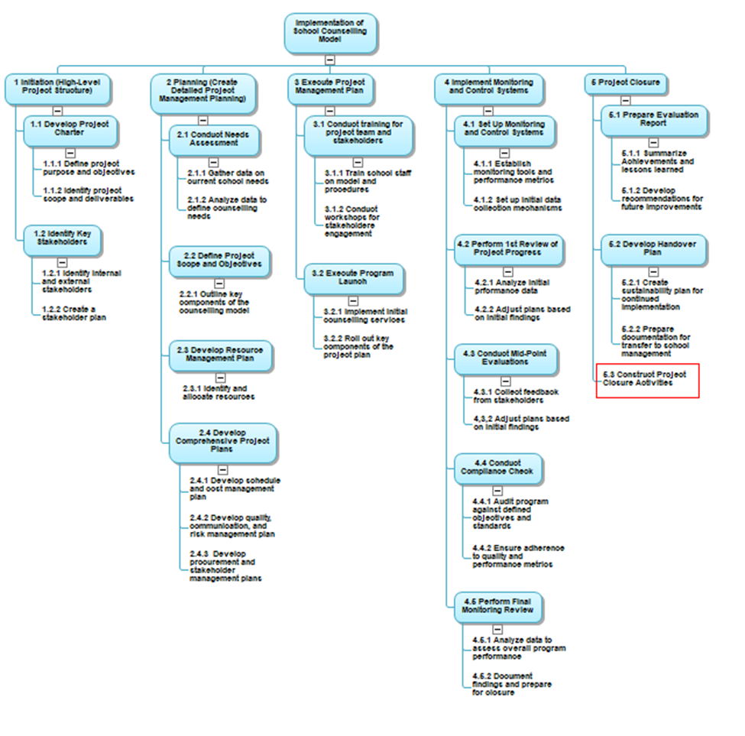

Source: Author (Licia Castillo, 2024)

**4.2.2.3 WBS Dictionary**

According to the PMBOK Guide, WBS Dictionary is “A document that provides detailed deliverable, activity, and scheduling information about each component in the work breakdown structure.” WBS Dictionary provides detailed information needed to plan, manage and execute each work package in the WBS.

The WBS dictionary in Chart 9 provides a comprehensive overview of the school counselling program project, defining the project's goals, deliverables, roles, and schedule. This detailed information facilitates smooth collaboration and effective execution.

Chart 9

*WBS Dictionary*

|  |  |  |  |  |
| --- | --- | --- | --- | --- |
| Project: A project management plan for the implementation of a school counselling program model in a government school. | | | | |
| WBS ID | Description of Work | Individual Responsible | Schedule | |
| Start Date | End Date |
| 1.0 Project Initiation and Charter Approval | | | | |
| 1.1 Develop Project Charter | | | | |
| 1.1.1 Define project purpose and objectives | Develop a clear statement outlining the main reasons for developing a plan for implementing the school counselling model. | Project Manager | August 1, 2025 | August 15, 2025 |
| 1.1.2 Identify project scope and deliverables | Clearly define the boundaries of the project, including what will be covered and what will not be included. | Project Manager |
| 1.1.3 Define project roles and responsibilities | Identify all team members involved in the project, including school counsellors, teachers, school administrators, and external partners. Document their roles, specific responsibilities, and decision-making authority. | Project Manager, School Counsellor/s, School Administrator |
| 1.2 Identify Key Stakeholders | | | | |
| 1.2.1 Identify internal and external stakeholders | Create a comprehensive list of stakeholders, categorizing them into internal and external and assess each stakeholder's influence and interest. | Project Manager, School Counsellor/s | August 16, 2025 | August 29, 2025 |
| 1.2.2 Create a stakeholder engagement plan | Develop a detailed plan outlining how to involve stakeholders throughout the project. | Project Manager, School Counsellor/s |
| 2.0 Create Detailed Project Management Plan | | | | |
| 2.1 Conduct Needs Assessment | | | | |
| 2.1.1 Gather data on current school needs | Conduct needs assessment with students, parents, and staff. | Project Manager, School Counsellor/s, School Administrator | August 30, 2025 | September 19, 2025 |
| 2.1.2 Analyze data to define counselling needs | Analyze the collected data to determine the most pressing counselling needs within the school and attitudes toward counselling. | Project Manager, School Counsellor/s, School Administrator, Data Analysis Specialist |
| 2.2 Define Program Scope and Objectives | | | | |
| 2.2.1 Outline key components of the counselling model | Develop the school counselling program foundation, including vision, mission, goals, and essential elements of the counselling model. | Project Manager, School Counsellor/s | September 20, 2025 | October 3, 2025 |
| 2.3 Develop Resource Management Plan | | | | |
| 2.3.1 Identify and allocate resources required for the project | List all required resources, including school counsellors, training materials, software tools, and budget. | Project Manager, School Counsellor/s, School Administrator | October 4, 2025 | October 17, 2025 |

|  |  |  |  |  |
| --- | --- | --- | --- | --- |
| 2.4 Develop Comprehensive Project Plans | | | | |
| 2.4.1 Develop scope, schedule, and cost management plans | Define the project's work scope, create a timeline with milestones and deadlines, and develop a budget that includes cost estimates for all planned activities and resources. | Project Manager | October 18, 2025 | October 31, 2025 |
| 2.4.2 Develop quality, communications, and risk management plans | Develop a communication strategy to keep stakeholders informed and engaged. Identify potential risks and develop mitigation strategies. | Project Manager, School Counsellor/s, |
| 2.4.3 Develop procurement and stakeholder management plans | Outline how the project will engage and manage stakeholders, including communication methods, feedback channels, and involvement in decision-making processes. | Project Manager, School Counsellor/s, School Administrator |

|  |  |  |  |  |
| --- | --- | --- | --- | --- |
| 3.0 Develop a plan to guide Execute Project Management Plan | | | | |
| 3.1 Plan Training for Project Team and Stakeholders | | | | |
| 3.1.1 Develop a plan to guide the execution of training for school staff on counselling model and procedures. | Develop a plan for the training sessions for counsellors and key staff on the counselling model's components, processes, and their responsibilities in supporting the program. | Project Manager, School Counsellor/s, School Administrator, Specialists | November 1, 2025 | November 14, 2025 |
| 3.1.2 Develop a plan to guide the execution of workshops for stakeholder engagement. | Develop a plan to guide the implementation of workshops for internal and external stakeholders to raise awareness about the program, encourage support, and provide an opportunity for input and feedback. | Project Manager, School Counsellor/s, School Administrator |

|  |  |  |  |  |
| --- | --- | --- | --- | --- |
| 3.2 Plan the Execution of the Program Launch | | | | |
| 3.2.1 Plan the execution of initial counselling services | Outline a plan to offer individual and small group services, using trained school counselors and established procedures as outlined in the model. | Project Manager, School Counsellor/s, School Administrator | November 15, 2025 | November 28, 2025 |
| 3.2.2 Plan the execution of the Roll out of key components of the project plan | Guide the implementation of other program elements and whole school services ensuring they align with the project's objectives. | Project Manager, School Counsellor/s, |
| 4.0 Develop a Plan to Implement Monitoring and Control System | | | | |
| 4.1 Set Up Monitoring and Control Systems | | | | |
| 4.1.1 Establish monitoring tools and performance metrics | Develop tools and metrics to monitor the program's implementation and assess its effectiveness in meeting the defined objectives. | Project Manager, School Counsellor/s | November 29, 2025 | January 9, 2026 |
| 4.1.2 Set up initial data collection mechanisms | Create processes for collecting data on student participation, satisfaction, outcomes, and other relevant metrics to measure the program's impact. | Project Manager, School Counsellor/s, Data Specialist |
| 4.2 Perform First Review of Project Progress | | | | |
| 4.2.1 Analyze initial performance data | Review initial data to assess the program's early impact, determine if it is meeting its objectives, and identify areas for improvement. | Project Manager, School Counsellor/s, Data Specialist | January 10, 2026 | March 6, 2026 |
| 4.2.2 Adjust plans based on initial findings | Modify the project plan, resource allocation, or program components based on the data analysis to optimize outcomes. | Project Manager, School Counsellor/s, School Administrator |
| 4.3 Conduct Mid-Point Evaluation | | | | |
| 4.3.1 Collect feedback from stakeholders | Gather input from students, staff, parents, and other stakeholders to evaluate the program's effectiveness and identify areas for enhancement. | Project Manager, School Counsellor/s, School Administrator | March 7, 2026 | April 4, 2026 |
| 4.3.2 Adjust project execution as needed | Modify the project execution plan based on feedback and data analysis to improve program outcomes. | Project Manager, School Counsellor/s, School Administrator |
| 4.4 Conduct Compliance Check | | | | |
| 4.4.1 Audit program against defined objectives and standards | Conduct an internal audit to verify adherence to objectives, quality standards, and regulatory requirements. | Project Manager, School Counsellor/s, Data Specialist | April 5, 2026 | May 1, 2026 |
| 4.4.2 Ensure adherence to quality and performance metrics | Check that the program meets quality and performance standards, implementing corrective actions if necessary. | Project Manager, School Counsellor/s, school administrator |
| 4.5 Perform Final Monitoring Review | | | | |
| 4.5.1 Analyze data to assess overall program performance | Review all collected data to evaluate the program's effectiveness, impact on students, and achievement of objectives. | Project Manager, School Counsellor/s, School Administrator | May 2, 2026 | May 15, 2026 |
| 4.5.2 Document findings and prepare for closure | Compile final evaluation findings, lessons learned, and recommendations, preparing for the project's formal closure. | Project Manager, School Counsellor/s, |

|  |  |  |  |  |
| --- | --- | --- | --- | --- |
| 5.0 Project Closure | | | | |
| 5.1 Prepare Evaluation Report | | | | |
| 5.1.1 Summarize achievements and lessons learned | Summarize the project's achievements and lessons learned. | Project Manager, School Counsellor/s | May 16, 2026 | June 12, 2026 |
| 5.1.2 Develop recommendations for future improvements | Outline recommendations for future improvements | Project Manager, School Counsellor/s |
| 5.2 Develop Handover Plan | | | | |
| 5.2.1 Create sustainability plan for continued implementation | Outline procedures to ensure yearly implementation of model. | Project Manager, School Counsellor/s | June 13, 2026 | June 19, 2026 |
| 5.2.2 Prepare documentation for transfer to school management | Compile all documentation used during the implementation of the project. | Project Manager |
| 5.3 Conduct Project Closure Activities | | | | |
| 5.3.1 Finalize all project documentation | Finalize all project documentation | Project Manager | June 20, 2026 | June 26, 2026 |
| 5.3.2 Present outcomes to stakeholders | Meeting with representation from all stakeholders to share project outcome, conclusions and recommendations.  . | Project Manager, School Counsellor/s, School Administrator |
| 5.3.3 Officially close the project | Meeting with internal stakeholders to officially close project | Project Manager, School Counsellor/s, School Administrator | June 27, 2026 | June 27, 2026 |

Source: Author (Licia Castillo, 2024)

**4.2.3 Develop Plan Schedule Management**

Developing the **project schedule** for the project “A project management plan for the implementation of a school counselling program model in a government school” requires a structured approach to guarantee that all tasks are completed within a defined timeframe.

**4.2.3.1 Plan Schedule Management**

Chart 10, outlines a synopsis of Schedule Management Process including the tools, techniques, inputs and outputs that may be used for this project.

Chart 10

*Schedule Management Process*

| **Project Schedule Management Processes** | **Input** | **Tools & Techniques** | **Outputs** |
| --- | --- | --- | --- |
| **Plan Schedule Management**  This process involves establishing the procedures, documentation, and policies to plan, develop, manage, and control the project schedule. | Project Charter, Project Management Plan (especially the scope management plan), Enterprise Environmental Factors (school academic calendar, government policies) | Expert Judgment, Data Analysis, Meetings (to gather input from key stakeholders like school administration, teachers, etc.) | Schedule Management Plan (defines how scheduling will be conducted, monitored, and controlled) |
| **Define Activities**  This process breaks down the work packages from the **Work Breakdown Structure (WBS)** into specific activities required to complete the project. | Scope Management Plan, Scope Baseline, Enterprise Environmental Factors (e.g., standard operating procedures in schools) | Decomposition (breaking down work packages into activities), planning activities in greater detail as the project progresses, Expert Judgment | Activity List (a detailed list of all activities to be performed)  Activity Attributes (additional details like the duration, resources, or constraints of each activity)  Milestone List (key dates like program setup, monitoring milestones, evaluation deadlines) |
| **Sequence Activities**  This process determines the order in which the activities will be carried out, considering dependencies | Schedule Management Plan, Activity List, Milestone List, Project Scope Statement, Environmental Factors (e.g., standard operating procedures in schools) | Leads and Lags (to manage time gaps between activities) | Project Schedule Network Diagrams (visual representation of the order of activities and dependencies)  Updated Project Documents (activity lists, milestones, etc.) |
| **Estimate Activity Durations**  This process involves estimating how long each activity will take, considering the resources and conditions under which it will be performed. | Scope Baseline, Activity List and Activity Attributes, Resource Requirements, Historical Data (from similar school programs), Risk Register, Environmental Factors (e.g., standard operating procedures in schools) | Expert Judgment (from school counselors, administrators, or project managers experienced in educational settings), Analogous Estimating (using historical data from similar projects), Parametric Estimating (based on known parameters, e.g., time per student for counselling), Three-Point Estimating (optimistic, pessimistic, and most likely estimates) | Duration Estimates (for each activity), Basis of Estimates (explanation of the methods used), Project Documents Updates |
| **Develop Schedule**  This process integrates the estimated activity durations, resource availability, and dependencies into a project schedule, creating a baseline for monitoring. | Schedule Management Plan, Activity List, Activity Attributes, and Duration Estimates, Resource Calendar (availability of counsellors, teachers, and other resources), Project Scope Statement | Critical Path Method (CPM) (to identify the longest sequence of dependent activities), Resource Optimization (ensuring resources are used efficiently), Schedule Compression (fast-tracking or crashing to shorten the project timeline), software tools to manage and update the schedule | Project Schedule (in formats like Gantt charts or network diagrams), Schedule Baseline (approved version of the schedule against which performance will be measured), Schedule Data (detailed information about each activity and milestone), Project Calendars (identifying working days and holidays for the school project) |
| **Control Schedule**  This process monitors the status of the project to ensure that the schedule is being adhered to, or to identify necessary changes to stay on track. | Schedule Management Plan, Project Schedule, Work Performance Data (actual vs. planned progress), Project Calendars | Critical Path Method (to assess the impact of delays on the overall schedule), Schedule Compression (fast-tracking or crashing if delays occur), Project Management Software (to track progress and update the schedule) | Work Performance Information (insight into the current status and any delays), Change Requests (if there’s a need to revise the schedule baseline), Project Management Plan Updates |

Source: Author (Licia Castillo, 2024)

**4.2.3.2 Define** **Activities and Estimate Activity Resources**

An activity is a specific type and amount of work that must be performed to complete a project. Each activity involves a specific, measurable, and time-bound task that results in defined outputs. Activities are the building blocks of a project schedule, representing the tasks or actions that must be undertaken to accomplish the project's goals and deliverables. Chart 11 outlines the specific activities and tasks that will be undertaken in this project.

Estimate Activity Resources determines the resources that the project will need to perform each activity in a project. Chart 8 identifies the human resources, technologies, materials and equipment that will be needed to perform the activities identified in the project. Since this project is pioneering, the pool of experts in Belize is limited. None the less, the project manager will rely on the experiences of other school counsellors and international experts (Dr. Lenares and Dr. Perryman.) Breaking down each activity into smaller tasks and estimating the resources that will be needed for each task will allow the Project Manager to plan accordingly.

Chart 11

*Activities and Estimate Activity Resources*

|  |  |  |  |  |  |
| --- | --- | --- | --- | --- | --- |
| Activity ID | Activity Name | Sub Task | Activities | Description of Work | Activity Resources |
| 1.0 | Project Initiation and Charter Approval | 1.1 Develop Project Charter | 1.1.1Define project purpose and objectives | Develop a clear statement outlining the goals and intended outcomes of the school counselling project. | Project manager, school leadership (member of administration, member of board, ministry representative), subject matter experts (education and counselling), Meeting room and virtual setup |
| 1.1.2Identify project scope and deliverables | Establish the boundaries of the project by defining what the project will and will not cover. | Project manager, subject matter experts, Project documentation tools |
| 1.1.3Define project roles and responsibilities | Clearly assign roles and responsibilities for the project team. | Project manager |
| 1.2 Identify Key Stakeholders | 1.2.1 Identify internal and external stakeholders | Identify all individuals, groups, and organizations that will be impacted by or have an interest in the project. | Project manager, school leadership |
| 1.2.2 Create a stakeholder engagement plan | Develop strategies to engage with identified stakeholders throughout the project. | Project manager, communications specialist, Communication tools |

|  |  |  |  |  |  |
| --- | --- | --- | --- | --- | --- |
| Activity ID | Activity Name | Sub Task | Activities | Description of Work | Activity Resources |
| 2.0 | Create Detailed Project Management Plan | 2.1 Conduct Needs Assessment | 2.1.1 Gather data on current school needs | Conduct surveys, interviews, and assessments to collect data on the school’s current counselling and mental health needs. | Data collection team, school counsellors, school staff, Surveys, forms, digital data collection tools |
| 2.1.2 Analyze data to define counselling needs | Define the major elements of the counselling model, such as the services to be provided, the role of counsellors, intervention strategies, and how the program will be integrated into the school environment. | Data analysts, counsellors, Data analysis software |
| 2.2 Define Program Scope and Objectives | 2.2.1 Outline key components of the counselling model | Identify the necessary human, financial, and material resources required for successful implementation. | Counselling experts, educational specialists |
| 2.3 Develop Resource Management Plan | 2.3.1 Identify and allocate resources required for the project | Identify the necessary human, financial, and material resources required for successful implementation. | Project Manager, school management team, school counsellors |
| 2.4 Develop Comprehensive Project Plans | 2.4.1 Develop scope, schedule, and cost management plans | Develop detailed plans that define the project scope, a schedule outlining major tasks and milestones, and a cost management plan. | Project Manager, school management team, school counsellors |
| 2.4.2 Develop quality, communications, and risk management plans | Create a quality management plan to ensure the project deliverables meet predefined standards. Develop a communication plan to ensure timely and effective dissemination of information to stakeholders. Create a risk management plan to identify potential risks and outline mitigation strategies. | Project Manager, school management team, school counsellors |
| 2.4.3 Develop procurement and stakeholder management plans | Define the process for acquiring goods, services, and resources. Create a stakeholder management plan. | Project Manager, school management team, school counsellors |

|  |  |  |  |  |  |
| --- | --- | --- | --- | --- | --- |
| Activity ID | Activity Name | Sub Task | Activities | Description of Work | Activity Resources |
| 3.0 | Develop a Plan to execute the Project Management Plan | 3.1 Plan Training for Project Team and Stakeholders | 3.1.1 Develop a plan for the execution of training for school staff on counselling model and procedures | Organize the delivering of training sessions for teachers, counsellors, and school administrators. | Trainers, counsellors, school staff, Training materials (manuals, presentations), equipment (projectors) |
| 3.1.2 Develop a plan for the execution of workshops for stakeholder engagement | Facilitate the conducting of workshops with key stakeholders, including parents, teachers, and external partners. | Workshop facilitators, project manager, Venue, presentation materials, communication tools |
| 3.2 Plan the execution of the Program Launch | 3.2.1 Plan the execution of initial counselling services | Outline a plan to deliver counselling services based on the defined model, ensuring that key resources (staff, space, materials) are in place. | Counsellors, school staff, Counselling space, equipment (desks, chairs), documentation tools |
| 3.2.2 Plan the execution of roll out of key components of the project plan | Guide the gradual implementation of the core aspects of the project, such as creating counselling schedules, offering group or one-on-one sessions, and launching additional components of the model (e.g., peer counselling, mental health awareness campaigns). | Project team, school staff |

|  |  |  |  |  |  |
| --- | --- | --- | --- | --- | --- |
| Activity ID | Activity Name | Sub Task | Activities | Description of Work | Activity Resources |
| 4.0 | Implement Monitoring and Control System | 4.1 Set Up Monitoring and Control Systems | 4.1.1 Establish monitoring tools and performance metrics | Set up tools such as tracking software or spreadsheets and define key performance indicators (KPIs.) | Monitoring and evaluation (M&E) specialists, project manager, Performance tracking software |
|  | 4.1.2 Set up initial data collection mechanisms | Develop methods for collecting data to assess the success of the counselling program (e.g., surveys, attendance records, session evaluations) and set up processes to ensure accurate and timely data collection. | Project manager, Data collection team |
| 4.2 Perform First Review of Project Progress | 4.2.1 Analyze initial performance data | Review the data collected. | Data analysts, Data analysis software |
| 4.2.2 Adjust plans based on initial findings | Make adjustments to the project plan as needed. | Project manager, Project team, analysts |
| 4.3 Conduct Mid-Point Evaluation | 4.3.1 Collect feedback from stakeholders | Gather feedback from key stakeholders (students, staff, parents.) | Project manager, Stakeholder engagement team, Feedback forms, survey tools, meetings |
| 4.3.2 Adjust project execution as needed | Make necessary changes to the implementation of the project. | Auditors, project manager, Audit checklist, documentation |
| 4.4 Conduct Compliance Check | 4.4.1 Audit program against defined objectives and standards | Conduct an audit. | Project manager, school leadership team, ministry personnel |
| 4.4.2 Ensure adherence to quality and performance metrics | Continuously monitor and enforce quality and performance standards throughout the project. | Project manager, school leadership team, ministry personnel |
| 4.5 Perform Final Monitoring Review | 4.5.1 Analyze data to assess overall program performance | Conduct a thorough analysis of the data collected throughout the project. | Data analysts, project manager |
| 4.5.2 Document findings and prepare for closure | Compile all project data, lessons learned, and outcomes into a final project report. | Project manager, school counsellor |
| Activity ID | Activity Name | Sub Task | Activities | Description of Work | Activity Resources |
| 5.0 | Project Closure | 5.1 Prepare Evaluation Report | 5.1.1 Summarize achievements and lessons learned | Prepare a summary of the project’s accomplishments, including key outcomes, lessons learned, and best practices. | Project manager, project team, school counsellor, Reporting tools, meeting space |
| 5.1.2 Develop recommendations for future improvements | Create a set of recommendations for enhancing similar projects in the future. | Project manager, project team, school counsellor |
| 5.2 Develop Handover Plan | 5.2.1 Create sustainability plan for continued implementation | Develop a long-term plan. | Project manager, project team, school counsellor, school leadership team |
|  | 5.2.2 Prepare documentation for transfer to school management | Organize and prepare all project documentation, such as reports, procedures, and tools, to be handed over to the school management team. | Project manager, school counsellor |
| 5.3 Conduct Project Closure Activities | 5.3.1 Finalize all project documentation | Ensure all documentation is complete, including final reports, project records, and financial summaries. | Project manager, school counsellor, Project team, administrative staff |
|  | 5.3.2 Present outcomes to stakeholders | Organize a final presentation or meeting to share the project’s outcomes with key stakeholders. | Project manager, school counsellor, administrative staff |
|  | 5.3.3 Officially close the project | Complete all final tasks, such as closing contracts, finalizing payments, and conducting a project closure meeting. | Project manager, stakeholders |

Source: Author (Licia Castillo, 2024)

**4.2.3.3** **Estimate Activity Durations**

Estimating activity duration is the process of determining the amount of time required to complete each task in a project. This estimation is necessary for ensuring that resources are allocated efficiently and for developing an accurate project schedule to guarantee that the project will be completed on time and within budget (Chart 12.) Expert judgement, analogous estimating, and three-point estimation will be used to determine the estimated time for each activity. Experts in the field who have knowledge of the time in it takes to perform the activities in the Belizean context will be included in the estimation. Counsellors who have implemented various portions of the model will be included to determine the expected duration of each activity. A triangulation of three time estimates (an optimistic, a pessimistic, and a ‘most likely’ estimate) will be used to estimate a range.

Chart 12

*Estimated Durations of Activity*

|  |  |  |
| --- | --- | --- |
| WBS Code | Task Name | Duration (Days) |
| 1.0 | Project Initiation and Charter Approval |  |
| 1.1 | Develop Project Charter |  |
| 1.1.1 | Define project purpose and objectives | 4 |
| 1.1.2 | Identify project scope and deliverables | 4 |
| 1.1.3 | Define project roles and responsibilities | 3 |
| 1.2 | Identify Key Stakeholders |  |
| 1.2.1 | Identify internal and external stakeholders | 5 |
| 1.2.2 | Create a stakeholder engagement plan | 5 |
| 2.0 | Create Detailed Project Management Plan |  |
| 2.1 | Conduct Needs Assessment |  |
| 2.1.1 | Gather data on current school needs | 10 |
| 2.1.2 | Analyze data to define counselling needs | 5 |
| 2.2 | Define Program Scope and Objectives |  |
| 2.2.1 | Outline key components of the counselling model | 10 |
| 2.3 | Develop Resource Management Plan |  |
| 2.3.1 | Identify and allocate resources required for the project | 10 |
| 2.4 | Develop Comprehensive Project Plans |  |
| 2.4.1 | Develop scope, schedule, and cost management plans | 3 |
| 2.4.2 | Develop quality, communications, and risk management plans | 3 |
| 2.4.3 | Develop procurement and stakeholder management plans | 4 |
| 3.0 | Execute Project Management Plan (Execution) |  |
| 3.1 | Conduct Training for Project Team and Stakeholders |  |
| 3.1.1 | Train school staff on counselling model and procedures | 8 |
| 3.1.2 | Conduct workshops for stakeholder engagement | 2 |
| 3.2 | Execute the Program Launch |  |
| 3.2.1 | Implement initial counselling services | 5 |
| 3.2.2 | Roll out key components of the project plan | 5 |
| 4.0 | Implement Monitoring and Control System |  |
| 4.1 | Set Up Monitoring and Control Systems |  |
| 4.1.1 | Establish monitoring tools and performance metrics | 10 |
| 4.1.2 | Set up initial data collection mechanisms | 20 |
| 4.2 | Perform First Review of Project Progress |  |
| 4.2.1 | Analyze initial performance data | 10 |
| 4.2.2 | Adjust plans based on initial findings | 30 |
| 4.3 | Conduct Mid-Point Evaluation |  |
| 4.3.1 | Collect feedback from stakeholders | 5 |
| 4.3.2 | Adjust project execution as needed | 15 |
| 4.4 | Conduct Compliance Check |  |
| 4.4.1 | Audit program against defined objectives and standards | 15 |
| 4.4.2 | Ensure adherence to quality and performance metrics | 5 |
| 4.5 | Perform Final Monitoring Review |  |
| 4.5.1 | Analyze data to assess overall program performance | 8 |
| 4.5.2 | Document findings and prepare for closure | 2 |
|  | Project Closure |  |
| 5.1 | Prepare Evaluation Report |  |
| 5.1.1 | Summarize achievements and lessons learned | 10 |
| 5.1.2 | Develop recommendations for future improvements | 10 |
| 5.2 | Develop Handover Plan |  |
| 5.2.1 | Create sustainability plan for continued implementation | 3 |
| 5.2.2 | Prepare documentation for transfer to school management | 2 |
| 5.3 | Conduct Project Closure Activities |  |
| 5.3.1 | Finalize all project documentation | 2 |
| 5.3.2 | Present outcomes to stakeholders | 3 |
| 5.3.3 | Officially close the project | 1 |

Source: Author (Licia Castillo, 2024)

**4.2.3.4 Develop Schedule**

Sequenced activities determine the order in which the activities will be carried out, whereby the primary goal is to outline a logical flow of work that facilitates the efficient execution of the project. It helps in identifying dependencies among tasks, which can affect their start and finish times. The schedule is aligned with the project scope and timeline, including key milestones, and dependencies between tasks as shown in Figure 5.

**Figure 5**  
*Schedule for project*

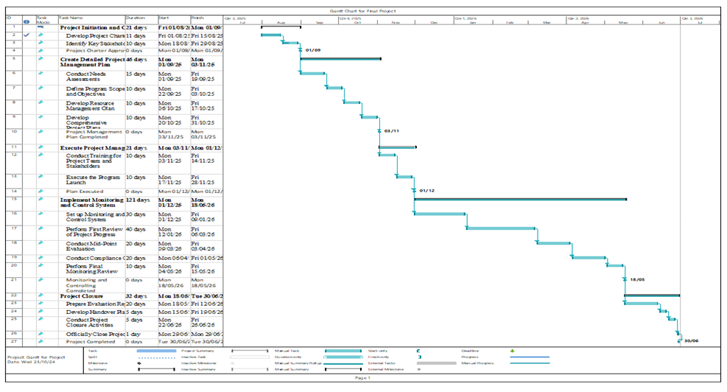

Source: Author (Licia Castillo, 2024)

**4.2.4 Develop Stakeholder Engagement Plan**

The stakeholder engagement plan is necessary for ensuring the successful implementation of the school counselling program model in a government school. By identifying and analysing the stakeholders’ influence and involvement, the impact they can have on this project will be discerned. By involving key stakeholders effectively, their support can be gained, their concerns addressed, and their expectations aligned with the project’s goals.

Early engagement with these stakeholders will guarantee that everyone understands the program’s objectives, scope, and intended outcomes, fostering a sense of ownership. By involving the government and school administration, all necessary resources like budget, space, and staff can be secured. The input of teachers, students, and parents will assist in designing counselling services that meet the specific needs of the community. During the monitoring phase, stakeholders will stay informed about the progress, milestones, and any challenges encountered during the program’s implementation and provide real-time feedback.

Based on the information gathered, the engagement strategy is designed, as seen in

Chart 13

*Stakeholder Engagement*

|  |  |  |  |  |  |
| --- | --- | --- | --- | --- | --- |
| **Stakeholder** | **Project Role** | **Internal/External** | **Interest** | **Influence** | **Engagement Strategy** |
| Ministry of Education | Project Sponsor | External | Low | High | Provide periodic progress reports, invite them to high-level meetings, and consult on critical decisions |
| School Counsellor | Project Team | Internal | High | High | Involve in regular team meetings, actively seek their input, and ensure they are kept updated on every phase of the project. |
| Chief Education Officer | Project Sponsor | External | Low | High | Schedule periodic check-ins, keep them satisfied by addressing their concerns, and inform them about project milestones |
| Licia Castillo | Project Manger | Internal | High | High | Lead decision-making processes, ensure continuous updates, and make sure all stakeholders are aligned through her direction. |

| **Stakeholder** | **Project Role** | **Internal/External** | **Interest** | **Influence** | **Engagement Strategy** |
| --- | --- | --- | --- | --- | --- |
| District Education Officer | Project Partner | External | Low | Low | Provide infrequent updates, maintain a relationship without over-communicating. |
| Board of Managers of OWTHS | Project Partner | Internal | Low | High | Regular high-level briefings, consultation on major decisions, and involving them in strategic aspects of the project. |
| Administration of OWTHS | Project Team | Internal | High | High | Frequent and detailed updates, involvement in key decision-making, and leading communication with other internal stakeholders like teachers and staff. |
| Parents | Parents | Internal | Low | Low | Provide occasional updates through newsletters or parent-teacher meetings. |
| Students | End User | Internal | High | Low | Regular updates on program benefits, create avenues for feedback (e.g., surveys or student meetings), and ensure they feel heard. |
| Teachers and Staff of OWTHS | Project Team | Internal | High | High | Involve in project meetings, actively seek their input, and ensure they receive training and resources to implement the program effectively. |
| Community resources | Project Partner | External | Low | Low | Occasional updates and engagement if necessary for specific project activities. |

Source: Author (Licia Castillo, 2024)

**4.2.4.1 Stakeholder Analysis**

In the planning process, the stakeholder engagement assessment matrix is a framework used to evaluate and document each relevant stakeholder’s level of engagement in the project. This current level of engagement is then compared with the desired level of engagement. This will help in identifying the potential gaps and level of attention needed for each stakeholder, guiding the engagement strategies.

Chart 14 illustrates the current and desired level of engagement of the stakeholders in this project.

Chart 14

*Stakeholder Engagement Matrix*

| Stakeholder | Unaware | Resistant | Neutral | Supportive | Leading |
| --- | --- | --- | --- | --- | --- |
| Ministry of Education |  |  | C |  | D |
| School Counsellor |  |  |  |  | C, D |
| Chief Education Officer |  |  | C |  | D |
| Project Manager |  |  |  |  | C, D |
| District Education Officer | C |  |  |  | D |
| Board of Managers of OWTHS | C |  |  | D |  |
| Administration of OWTHS |  |  |  | C | D |
| Parents | C |  |  | D |  |
| Students |  |  |  | C, D |  |
| Teachers and Staff of OWTHS |  | C | C | D |  |
| Community resources | C |  |  | D |  |

Source: Author (Licia Castillo, 2024)

**4.2.4.2 Stakeholder Influence/Interest**

By assessing each stakeholders’ interest and influence, the power dynamics with this project can be better understood. Interest indicates stakeholders’ likely concerns, and Influence indicates their ability resist your recommendation or change.

Some of the stakeholders have the power to block or advance and some may be interested and others may not care, this is illustrated in Figure 6. Engagement strategies can be tailored accordingly with each group.

Figure 6  
*Interest Influence Matrix*

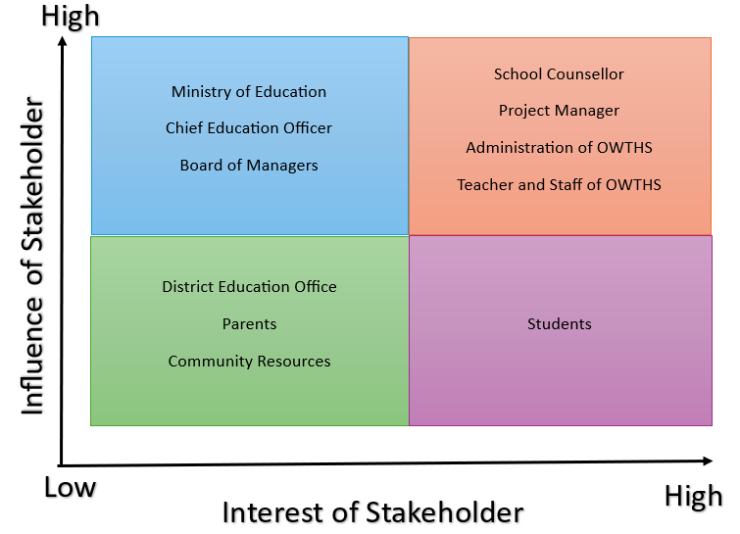

Source: Author (Licia Castillo, 2024)

**4.2.5 Develop Resource Management Plan**

Developing a **resource management plan** for the project “A project management plan for the implementation of a school counselling program model in a government school” is necessary for organizing, allocating, and managing the resources needed for its success. The resource management plan ensures that human, financial, physical, and material resources are available at the right time and used efficiently.

**4.2.5.1 Estimate Activity Resources**

Based on factors like the school’s size, the student population, and the scale of the program, the required resources and budget for the “A project management plan for the implementation of a school counselling program model in a government school” will vary.

The breakdown in Chart 15 illustrates all aspects of the project—staffing to materials, that will be needed to adequately and efficiently managed, monitored, and evaluated.

Chart 15

*Resources allocated and Budget*

|  |  |  |
| --- | --- | --- |
| Resource | Allocation and Source | Budget |
| Human | Project Manager  Data Analyst  Project Team  School Counsellor  Administrators  Teachers  Trainer | $21,200 USD |
| Facilities | Secured, Air-conditioned office  Secured storage area  Training Area | $1000USD |
| Equipment | Computer, printer, shredder, Smart TV | $2,500USD |
| Software Tools | MS Project, MS Teams, Asana, Google forms, Survey Monkey, Zoom, Canva | $500USD |
| Training Materials | Work Books, Training manuals, materials for presentations | $800USD |
| Data gathering materials | Surveys, Questionnaires | $500USD |
| Miscellaneous Costs | Travel, stipend, materials, food for training, software, etc. | $2,400USD |

Source: Author (Licia Castillo, 2024)

**4.2.5.2 Roles and Responsibilities**

Each member of the project brings to the team their own unique set of skills and expertise. By assigning the roles, what specific positions and functions they will engage in and the responsibilities, the duties and tasks assigned to each specific role, the team as shown in Chart 16, will be able to work more efficiently and effectively.

Chart 16

*Roles and Responsibilities*

| Human Resource | Role | Responsibility |
| --- | --- | --- |
| Project Manager | Oversees the entire project, ensuring that it stays on track, within scope, budget, and time. | Define project goals and objectives,  Develop the project plan, schedule, and budget, Coordinate communication between all stakeholders,  Monitor progress and address risks or issues, Ensure resource allocation and adherence to timelines, Conduct regular meetings and reporting, Oversee the evaluation of the program’s success. |
| School Principal | School leadership and liaison between the project and school administration. | Approve and support the implementation of the project  Coordinate with the teaching staff, counsellors, and administrative team  Ensure the project aligns with the school’s vision and policies.  Facilitate access to school resources (space, staff, etc.).  Provide input and feedback on the project’s impact on students.  Serve as a key decision-maker in all school-related aspects of the project. |
| Counsellor(s) | Deliver the counselling services to students as part of the program. | Provide individual and group counselling sessions.  Assess student needs and develop personalized action plans.  Maintain confidential student records and track progress.  Liaise with teachers, parents, and administration on student needs.  Develop strategies, activities, and materials for ensuring student achievement and success.  Participate in program evaluation by reporting student outcomes and feedback. |
| Teachers | Facilitate student engagement and support the counselling program | Identify and refer students who may need counselling.  Support the counsellor in reinforcing coping strategies and well-being practices in class.  Provide feedback on student progress or any behavioral changes.  Work with project manager, counsellor, and school principal to ensure smooth implementation. |
| Administrative Staff | Provide data, logistical and clerical support for the project. | Handle documentation, records, and reporting for the project.  Communicate with parents, teachers, and students regarding program details.  Manage the distribution of materials and resources for the counselling program.  Support the project manager with administrative duties, such as meeting coordination and report generation. |
| Subject matter experts | Provide specialized knowledge and expertise in areas critical to the counselling program | Assist in designing the evaluation metrics for program success.  Offer training and guidance to counsellors, teachers, and other staff.  Provide insight into the latest research and trends in school counselling. |
| Trainers | Deliver training to project stakeholders (counsellors, teachers, and staff) on program tools, processes, and methodologies. | Train counsellors on program delivery methods, data collection, and reporting.  Provide professional development sessions for teachers on issues related to students  Offer ongoing mentorship and support to counsellors and school staff.  Evaluate the effectiveness of the training and adjust as needed. |
| Data Analyst | Collect, analyze, and interpret data related to the program’s implementation and impact. | Develop data collection tools and processes for tracking student outcomes.  Analyze trends in student well-being, attendance, behavior, and performance.  Provide insights and reports on the effectiveness of the counselling program.  Work closely with the evaluation team to ensure that data is aligned with project objectives.  Help in the creation of reports that guide decision-making for program improvements. |
| IT Support Team | Ensure the technical infrastructure and tools necessary for the project are in place and functional. | Set up and maintain technology platforms for data collection, management and communication.  Provide technical support for counsellors, teachers, and administrators using digital tools.  Ensure the privacy and security of student data stored electronically.  Troubleshoot any technology issues that arise during program implementation.  Assist with online reporting, video conferencing, or virtual counselling setups, if needed. |

Source: Author (Licia Castillo, 2024)

**4.2.6 Develop Cost Plan Management**

According to PMBOK 2017, Plan Cost Management is the process of defining how the project costs will be estimated, budgeted, managed, monitored, and controlled. A cost management plan is a method of strategizing that will guide and direct the budget and ensure that this project stays within the approved financial limits. The plan includes estimation of cost and budget determination.

**4.2.6.1 Estimate Costs**

The estimated total cost of resources, both direct and indirect, necessary to complete this project has been calculated. As this is a pioneering venture, the majority of the cost estimations are based on historical knowledge and expert judgment. Chart 17 provides a detailed breakdown of the various cost categories, descriptions, and corresponding estimated amounts.

Chart 17

*Cost Estimate*

| **Categories** | **Name** | **Description** | **Cost** |
| --- | --- | --- | --- |
| Labor Costs | Project Manager | External personnel leading project | $15,500BZE |
| Counsellor  Administrative Staff  Teachers  Support Staff  IT Specialist | Stipend for involvement in project | $500 (yearly)BZE  $1500BZE  $750BZE  $100BZE |
| Trainer (Subject Matter Expert) | Fees charged per session for Professional development for counsellors and teachers | $950BZE |
| Data Analyst | Fees for charged per document | $1000BZE |
| Training Costs | Facilities | Rental of location for team members separate from school | $200BZE |
| Training Materials | Work Books, Training manuals, materials for presentations, activity tools | $800BZE |
| Other | Food, rentals | $400BZE |
| Equipment | Office supplies, counselling resources, computers, projectors, and educational materials, Smart tv, shredder | Needed to facilitate delivery of project | $2,500BZE |
| Data Gathering, Communication Tools | Software tools | Tools, software, or resources required to gather needs information, for the assessment of the project, for communication with stakeholders  (MS Project, MS Teams, Asana, Google forms, Survey Monkey, Zoom, Canva) | $500.00BZE |
| Materials (hardcopy) | Surveys, Questionnaires | $500BZE |
| Travel | Transportation for project manager, counsellors, trainers, and project team | Transportation to districts to meet with stakeholders, stipend for trainers | $1000BZE |
| Facilities and Infrastructure | Rental or improvement of space | Space on campus may need to be improved or additional room be outfitted to accommodate Project Manager, | $800BZE |
| Miscellaneous Costs | unforeseen expenses | communication, internet, or additional project support, closing activities | $1000BZE |
|  |  | Total Cost Estimate | $28,900BZE |

Source: Author (Licia Castillo, 2024)

**4.2.6.2 Determine Budget**

The budget (Chart 18) is a detailed plan of how much will be spend during this project and is derived from the approved estimated. Most of the budget will be utilized during the planning and execution phases where the procurement of materials, facilities and equipment, and the training of stakeholders will happen. During the monitoring, evaluation and closing phases, costs will be incurred for data collection, evaluation tools, report generation, and closing activities.

Chart 18

*Budget for project*

|  |  |  |
| --- | --- | --- |
| **Categories** | **Description** | **Cost** |
| Labor Costs |  | $15,500BZE |
| Stipend for involvement in project | $500 (yearly)BZE  $1500BZE  $750BZE  $100BZE |
| Fees charged per session for Professional development for counsellors and teachers | $950BZE |
| Fees for charged per document | $1000BZE |
| Training Costs | Rental of location for team members separate from school | $200BZE |
| Work Books, Training manuals, materials for presentations, activity tools | $800BZE |
| Food, rentals | $400BZE |
| Equipment | Needed to facilitate delivery of project | $2,500BZE |
| Data Gathering, Communication Tools | Tools, software, or resources required to gather needs information, for the assessment of the project, for communication with stakeholders  (MS Project, MS Teams, Asana, Google forms, Survey Monkey, Zoom, Canva) | $500.00BZE |
| Surveys, Questionnaires | $500BZE |
| Travel | Transportation to districts to meet with stakeholders, stipend for trainers | $1000BZE |
| Facilities and Infrastructure | Space on campus may need to be improved or additional room be outfitted to accommodate Project Manager, | $800BZE |
| Miscellaneous Costs | communication, internet, or additional project support, closing activities | $1000BZE |
| Total Cost Estimate | | $28,900BZE |
| **Cost Estimate** | | $28,900BZE |
| Contingency Reserve (5%) | | $1,445BZE |
| **Cost Baseline** | | $30,345BZE |
| Management Reserve (3%) | | $910.35BZE |
| **Total Project Budget** | | $31,255.35BZE |

Source: Author (Licia Castillo, 2024)

**4.2.6.3 Cash Flow Estimate**

A cash flow estimate for implementing a school counselling program model in a government school involves projecting the outflow of cash (Figure 7) over the projected ten months. The time frame for the cash flow estimate will be monthly. This estimate will cover key financial aspects, including developing plan for project initiation, execution, monitoring, and closure. Specific costs are associated with each project phase (Chart 19.) This will include expenses related to project charter development, stakeholder engagement, resource management, training and evaluations, monitoring and control, and closure procedures. These costs will include salaries, stipends, hiring consultants, administrative expenses, stakeholder meetings, communication materials, travel, equipment procurement, software, trainer fees, venue costs, participant incentives, monitoring tools, periodic assessments, audit costs, documentation, final reports, and program transfer.

It is expected that potential sources of cash inflow for this project will be allocated from government funding and grants from other NGOs.

Chart 19

*Cash Flow Estimates*

|  |  |  |  |  |  |  |  |  |  |  |  |
| --- | --- | --- | --- | --- | --- | --- | --- | --- | --- | --- | --- |
| Activities | Aug | Sept | Oct | Nov | Dec | Jan | Feb | March | April | May | June |
| Project Manager | 1,500 | 1,500 | 1,500 | 1,500 | 1,500 | 1,500 | 1,500 | 1,500 | 1,500 | 1,500 | 2,000 |
| Equipment | 2,000 |  |  |  |  |  |  |  |  |  |  |
| facilities, infrastructure | 800 |  |  |  |  |  |  |  |  |  |  |
| Conduct Needs Assessment |  | 200 |  |  |  |  |  |  |  |  |  |
| Develop Resource Management Plan and Comprehensive Project Plans |  |  | 500 |  |  |  |  |  |  |  |  |
| Plan Training for Project Team and Stakeholders |  |  |  | 1,200 |  |  |  |  |  |  |  |
| Plan the Execution of the Program Launch |  |  |  | 1450 |  |  |  |  |  |  |  |
| Set Up Monitoring and Control Systems |  |  |  |  | 250 |  |  |  |  |  |  |
|  |  |  |  |  |  |  |  |  |  |  |  |
| Activities | Aug | Sept | Oct | Nov | Dec | Jan | Feb | March | April | May | June |
| Perform First Review of Project Progress |  |  |  |  |  |  | 300 |  |  |  |  |
| Conduct Mid-Point Evaluation |  |  |  |  |  |  |  | 450 |  |  |  |
| Conduct Compliance Check |  |  |  |  |  |  |  |  | 850 |  |  |
| Prepare Evaluation Report |  |  |  |  |  |  |  |  |  | 450 |  |
| Conduct Project Closure Activities |  |  |  |  |  |  |  |  |  |  | 5,550 |

Source: Author (Licia Castillo, 2024)

Figure 7  
*S Curve showing outflow of cash for project*

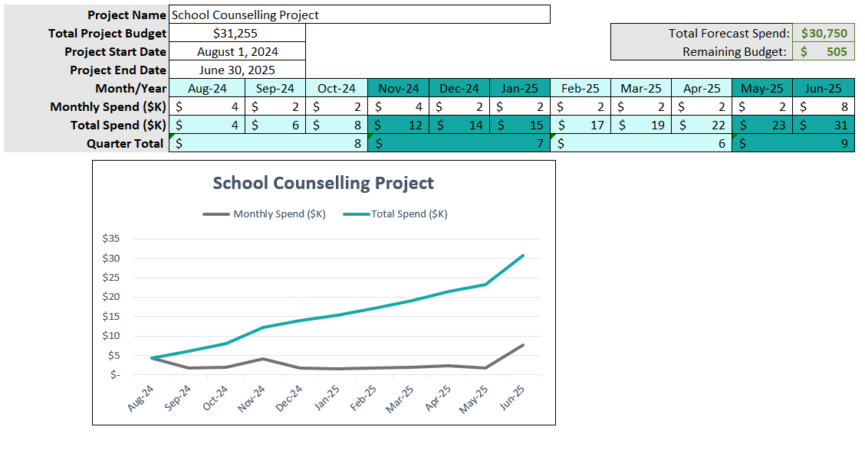

Source: Author (Licia Castillo, 2024)

**4.2.7 Plan Procurement Management**

The implementation of a school counselling program in a government school requires careful planning and resource allocation to ensure its success. A procurement management plan is essential to guide the acquisition of necessary goods and services, align stakeholders, and optimize resource utilization. These procurement methods and preferences are tailored to the specific needs of the school. They ensure a balance between cost-efficiency, quality, compliance, and timely delivery of goods and services necessary for the program’s success. Chart 20 identifies the different people working on the project and all stakeholders who will be affected by the project.

Chart 20

*Roles & Responsibilities*

|  |  |  |
| --- | --- | --- |
| **Name** | **Role or Title** | **Responsibilities** |
| Licia Castillo | Project Manager | Oversees the entire procurement process, ensuring all needs are met on time and within budget, selects trainers, conducts market research and price comparisons for equipment and materials |
| Julian Polanco | Project Sponsor/School Administrator | Provides approvals for procurement decisions, particularly for larger purchases, signs purchase orders |
| Not yet determined | School Counsellor | Assist with the location of venue, equipment, materials |
| Iram Peralta | Bursar | Prepares purchase orders, tracks and receives equipment and materials |

Source: Author (Licia Castillo, 2024)

Specific Procurement Methods and Preferences

Specific procurement methods are necessary for implementing the school counselling project because it assists in controlling the costs, ensuring that if the resources need to be purchased it will be done so at the best possible price. Procurement strategies ensure that necessary materials, services, and resources are available on time and are of high-quality and experienced. The following procurement methods and preferences will be used to ensure efficiency, compliance, and cost-effectiveness:

Recycling vs Buying: Equipment like projectors or computers if not available at the school or not in good working condition will need to be purchased.

Direct Purchase: Smaller, straightforward purchases such as office supplies, stationery, counselling activity materials, and catering, direct purchasing will occur. This will be sourced from local vendors to support community and reduce delivery time.

Prequalification of Suppliers: a prequalification process will be used for selecting key suppliers of essential services. This involves evaluating potential vendors in advance based on relevant certifications. Only suppliers with proven experience in delivering education-related or counselling-specific resources will be prequalified.

Competitive Bidding: significant purchases like equipment (e.g., computers, projectors, office furniture) or external services (e.g., training providers), competitive bidding will be used. This process will involve soliciting bids from a minimum of three prequalified bids for comparison, cost effectiveness, quality, and delivery timelines.

**4.2.8 Develop Communications Management Plan**

According to PMBOK 2017, Plan Communications Management is the process of developing an appropriate approach and plan for project communications activities based on the information needs of each stakeholder or group, available organizational assets and the needs of the project. Planning communication management ensures that the right information is efficiently shared with the right people on a timely basis, leading to better coordination, stakeholder engagement, and effective project execution. For a sensitive project like a school counselling program, clear and structured communication is necessary to achieving its intended goals and ensuring its success.

**4.2.8.1 Communication Methods**

Efficient and effective communication in this project is vital for success. Interactive communication where two or more groups will be exchanging information in real time and push communication where information will be distributed are the foundation of this plan. Each communication method serves a distinct purpose, and selecting the appropriate method for each stakeholder and scenario helps in maintaining alignment, collaboration, and transparency.

* Meetings are crucial for building rapport, especially with key stakeholders like project sponsors (e.g., Ministry of Education, Chief Education Officer) and partners (e.g., school administration, community resources). It allows for direct interaction, addressing concerns in real-time, and fostering collaboration.
* Email is important for sending detailed, structured information that can be reviewed by stakeholders at their convenience. This is particularly important for documentation, progress reports, and updates that don’t require immediate feedback.
* Formal reports will provide a thorough analysis of the project’s progress, including financial status, key achievements, and risks. These will be essential for decision-making by high-level stakeholders like project sponsors (e.g., Ministry of Education).
* Capacity Building Workshops will equipping teachers, staff, and the school counsellor with the knowledge and tools needed to implement and sustain the counselling program. Interactive sessions will help clarify expectations and improve the team’s readiness.
* Phone calls or video conferences will allow for quick resolution of urgent issues or last-minute changes that require immediate attention. This method will be especially useful when geographic distance makes face-to-face meetings difficult.
* Flyers will be effective for communicating with a larger group of stakeholders, such as parents, students, and community members, who may not require frequent updates but need to stay informed about the program’s outcomes and benefits.
* Surveys will help in collecting feedback from students, parents, teachers, and counsellors, ensuring that the program is effective and meeting the needs of its beneficiaries. This is vital for the monitoring and evaluation phase.
* For internal project teams, instant messaging platforms (e.g., WhatsApp) will facilitate quick communication, especially when immediate responses or clarifications are needed. This is useful for day-to-day operations and coordination.

**4.2.8.2 Communication Matrix**

The communication matrix (Chart 21) defines the key communication needs of each stakeholder, including what information they require, the frequency of updates, the communication method, and the person responsible. Here’s an outline of the communication matrix for your project. The Frequency of communication will vary based on the stage of the project. Different Communication Methods including formal reports, emails, face-to-face meetings, or phone calls, tailored to the needs, preferences and availability of the stakeholder will be utilized. The project manager plays a central role in ensuring that communication is flowing smoothly, but team members like the school administrators, school counsellor and data analyst also share responsibilities for specific stakeholders.

Chart 21

*Communication Matrix*

|  |  |  |  |  |  |
| --- | --- | --- | --- | --- | --- |
| **Stakeholder** | **Project Role** | **Communication Needs** | **Communication Channels** | **Communication Frequency** | **Person responsible** |
| Ministry of Education | Project Sponsor | Project status updates, budget reports | Monthly or milestone-based | Formal reports, high-level meetings (virtual or face to face) | Project Manager (Licia Castillo) |
| School Counsellor | Project Team | Program materials, operational updates, feedback | Weekly | Team meetings, email, phone calls, texts | Project Manager (Licia Castillo), data analyst |
| Chief Education Officer | Project Sponsor | High-level progress, strategic decisions, issues | Monthly or milestone-based | Formal meetings (virtual or face to face), email messages, email reports | Project Manager (Licia Castillo) |
| Licia Castillo | Project Manger | All project-related information | Daily/Weekly | Email, meetings, phone calls, texts | Self |
| **Stakeholder** | **Project Role** | **Communication Needs** | **Communication Channels** | **Communication Frequency** | **Person responsible** |
| District Education Officer | Project Partner | Program updates, progress reports | Bi-weekly or milestone-based | Email, formal meetings (virtual or face to face) | Project Manager (Licia Castillo) |
| Board of Managers of OWTHS | Project Partner | Strategic decisions, program updates | Per semester (3 months) | Formal reports, meetings(virtual or face to face) | Project Manager (Licia Castillo), Admin OWTHS |
| Administration of OWTHS | Project Team | Detailed progress, issues, student feedback | Weekly | Meetings, email updates, texts, calls | Project Manager (Licia Castillo) |
| Parents | Parents | Program outcomes, child’s progress Quarterly or as needed |  | Parent meetings (virtual or face to face), newsletters, texts, flyers, videos, consultation groups | School Counsellor, Teachers |
| Students | End User | Program schedule, support resources | As needed | Direct communication, leaflets, newsletters, texts, flyers, videos, notice boards, focus groups | School Counsellor, Teachers |
| **Stakeholder** | **Project Role** | **Communication Needs** | **Communication Channels** | **Communication Frequency** | **Person responsible** |
| Teachers and Staff of OWTHS | Project Team | Training updates, student engagement data | Weekly | Meetings, email, workshops, newsletters, texts, flyers, videos, notice boards, focus groups | Subject Matter Expert, Trainer |
| Community resources | Project Partner | Program involvement, collaboration opportunities | As needed | Meetings (virtual or face to face), emails, community events | Project Manager (Licia Castillo) |
| Data Analyst | Project Team | Data collection requirements, analysis feedback | Weekly or as needed | Meetings, email reports | Project Manager (Licia Castillo) |
| Subject Matter Expert/Trainer | Project Team | Training schedules, resource updates | Weekly or as needed | Workshops, email, phone calls | Project Manager (Licia Castillo) |

Source: Author (Licia Castillo, 2024)

**4.2.9 Develop Risk Management Plan**

“Project Risk Management includes the process of conducting risk management, planning, identification, analysis, response planning, response implementation, and monitoring risk on a project. (PMBOK 2017) the risk management plan allows project managers to predict potential risks, develop a plan to defer potential risk in order to defer or reduce their negative impact.

In this project, a risk management plan will identify unforeseen risks such as delays in the setup process, lack of resources, or resistance from staff or students and allow the team to prepare mitigation strategies. This will ensure that the implementation phase can run more smoothly, resources are allocated wisely, and improve stakeholder confidence especially if resistance to the project exists.

**4.2.9.1 Plan Risk Management**

The Plan Risk Management phase of the Risk Management Plan will involve developing strategies and processes to identify, assess, and respond to risks throughout this project’s lifecycle. These tools, and techniques like qualitative analysis (e.g., risk rankings) and quantitative methods (e.g., probability and impact assessment) will be used. Key stakeholders who are responsible for different aspects of risk management will be identified and through workshops, interviews, brainstorming sessions, and surveys, a list of risks will be generated and a risk response plan generated.

Identifying roles and responsibilities in risk management for this project, as illustrated in Chart 22, is necessary for its successful implementation. Confusion will be prevented because everyone involved in the project will know who is accountable for identifying, assessing and mitigating the risks that might be encountered. Each team member will be able to use their expertise to quickly and efficiently identify, manage, and mitigate these risks. In addition, clearly assigning roles will ensure that communication lines remain open between the right people. For instance, the project manager will communicate the overall risk management progress to the school management, while the counsellor will address risks related to program delivery.

Chart 22

*Plan Risk Management - Roles and Responsibilities*

| Stakeholder | Risk Role | Responsibilities |
| --- | --- | --- |
| Project Sponsor | Acts as a safeguard against major risks that could jeopardize the project’s success, escalating issues to executive level when necessary. | Provide strategic oversight and ensure the project aligns with the overall objectives of the government or educational regulations and policies.  Allocate resources and funding to address potential risks.  Support the project team in removing obstacles that may pose a risk to project success.  Ensure engagement with key stakeholders, including senior government officials and educational authorities. |
| Project Manager | Owns the overall responsibility for risk management within the project, ensuring risks are identified and appropriately handled throughout the project lifecycle. | Lead the process of risk identification, assessment, and prioritization.  Create and maintain the risk management plan, ensuring risks are regularly monitored and reviewed.  Assign risk owners and ensure risk mitigation actions are being implemented.  Communicate risks and risk management efforts to stakeholders and ensure transparency.  Ensure risks are managed proactively, not just reactively. |
| Project Team Members  (Teachers and staff of OWTHS) | Each team member plays a role in risk identification and management by monitoring their tasks and proactively addressing potential risks. | Identify and report any risks or issues they encounter while executing project tasks.  Implement assigned risk responses and mitigation activities as part of their daily work.  Monitor for early warning signs of risks related to their areas of responsibility.  Provide feedback on the effectiveness of risk mitigation strategies. |
| School Administration | Responsible for identifying potential risks that are specific to the school environment and implement strategies to mitigate identified risks. | Proactively identify risks related to the school environment, such as staff resistance, logistical challenges, or student engagement issues.  Report potential risks or challenges encountered during the program’s implementation to the project manager or project team.  Provide insights into school-specific risks, including cultural, operational, or structural challenges that might hinder the project. |

Source: Author (Licia Castillo, 2024)

Developing a Risk Breakdown Structure (RBS) (Chart 23) for this project will organize the risk management process, making it easier to identify, assess, and prioritize risks. The hierarchical structure of the RBS will facilitate with identifying the sources of risk at different levels of detail, and by grouping the risks into categories, resources will be more efficiently allocated, ensuring that high-priority risks are addressed first.

Chart 23

*Risk Breakdown Structure*

| Level 0 | Level 1 | Level 2 | Level 3 |
| --- | --- | --- | --- |
| All sources of risk in project  “Implementation of the school counselling program model in a government school,” | 1.Organizational Risks | 1.1Stakeholder Risks | 1.1.1Resistance to change |
| 1.1.2Lack of engagement or support |
| 1.1.3Poor communication with key stakeholders |
| 1.2Management Risks | 1.2.1Inadequate involvement |
| 1.2.2Ineffective decision-making |
| 1.2.3Lack of clear leadership and accountability |
| 1.3Resource Availability | 1.3.1Shortage of staff |
| 1.3.2Lack of trained personnel |
| 1.3.3Inadequate facilities |
| 2.Technical Risks | 2.1Program Design Risks | 2.1.1Poorly defined program objectives or unclear goals. |
| 2.1.2Inadequate monitoring and evaluation mechanisms |
| 2.2Training Risks | 2.2.1Insufficient training for teachers or counsellors. |
| 2.2.2Lack of follow-up support after initial training. |
| 2.2.3Training not aligned with the practical needs of the school |
| 2.3Technology Risks | 2.3.1Technical issues with digital platforms or software |
| 2.3.2Lack of access to technology for online activities |
| 2.3.3Security risks related to student data and confidentiality breaches. |
| 3.Schedule Risks | 3.1Project Timeline Risks | 3.1.1Delays in project start or key milestones due to administrative or government processes. |
| 3.1.2Overly optimistic timelines for program implementation. |
| 3.1.3Conflicts with the school calendar or academic schedules. |
| 3.2 External Delays | 3.2.1Delays in external approvals |
| 3.2.2Supplier or vendor delays for necessary resources or tools. |
| 3.2.3.Dependency on third-party consultants or counsellors |
| 4.Financial Risks | 4.1 Budget Risks | 4.1.1Underestimation of costs for program setup or training. |
| 4.1.2Unplanned expenses for additional resources or personnel. |
| 4.1.3Funding delays from the government or sponsors |
| 4.2Cost Overruns | 4.2.1Overrun of the allocated budget |
| 4.2.2Increased costs in program requirements. |
| 4.2.3Unexpected costs associated with compliance or regulatory changes. |
| * + - 1. Operational Risks | 5.1 Logistical Risks | 5.1.1Issues with scheduling during school hours. |
| 5.1.2Transportation or access issues for external personnel |
| 5.1.3Poor coordination between project stakeholders and school staff. |
| 5.2 Implementation Risks | 5.2.1Inadequate supervision of the counselling program |
| 5.2.2Lack of effective integration of the program into the school curriculum. |
| 5.2.3Difficulty in maintaining student participation |
| * + - 1. Quality Risks | 6.1 Project Effectiveness | 6.1.1Project not achieving desired outcomes or goals. |
| 6.1.2Inconsistent quality of counselling activities. |
| 6.1.3Poor student or parent feedback on the project’s effectiveness |
| 6.2 Data Quality and Monitoring | 6.2.1Inaccurate or incomplete data collection during monitoring and evaluation. |
| 6.2.2Lack of effective metrics to measure program success. |
| 6.2.3Difficulty in tracking long-term progress or outcomes. |
| * + - 1. Compliance and Regulatory Risks | 7.1 Regulatory Compliance Risks | 7.1.1Non-compliance with local government policies or educational regulations. |
| 7.1.2Failure to meet legal or ethical standards for student data privacy and confidentiality. |
| 7.2 Ethical Risks  . | 7.2.1Breaches of confidentiality or mishandling of sensitive student information |
| 7.2.2Unethical behavior by staff or counsellors in the program. |
| * + - 1. External Risks | 8.1 Political and Policy Risks | 8.1.1Changes in government policies affecting program funding or support. |
| 8.1.2Political instability affecting the school or program resources. |
| 8.2 Socio-Economic Risks | 8.2.1Economic downturns affecting funding or school resources. |
| 8.2.2Community resistance to the counselling program due to cultural or social factors. |
| 8.3 Natural Events | 8.3.1Natural disasters (e.g., floods, hurricanes) disrupting school activities. |
| 8.3.2Health-related risks (e.g., pandemics) affecting student attendance or program delivery. |

Source: Author (Licia Castillo, 2024)

**4.2.9.2 Perform Qualitative Risk Analysis**

Performing qualitative risk analysis is “the process of prioritizing individual project risks for further analysis or action by assessing their probability of occurrence and impact.” PMBOK 2017. Focusing on the risks with that are of the highest probability and the manner in which it will affect the project will guide in the prioritizing and responding to the risks.

Figure 8, Probability and Impact Matrix analyses the probability of each individual risk and the degree to which that risk may have on the schedule, cost or quality of the project objectives. Chart 24 comprehensively examines from different angle each risk, the probable cause, its consequence, the probability and impact, and the possible response strategy.

Presently, the MOEYS has secured a grant from the Millennium Challenge Cooperation (MCC) to fund high school engagement activities. As a result, attention and finances are being channelled toward the role of counselling in the schools. The following risk “Economic downturns affecting funding or school resources” would greatly affect the sustainability of the project should the grant not be allocated efficiently.

Figure 8  
*Probability and Impact Matrix*

|  |  |  |  |  |  |  |
| --- | --- | --- | --- | --- | --- | --- |
| Impact  Probability |  | | | | | |
|  | Insignificant  1 | Minor  2 | Significant  3 | Major  4 | Severe  5 |
| 5 Almost Certain | Medium 5 | High 10 | Very high 15 | Extreme 20 | Extreme 25 |
| 4 Likely | Medium 4 | Medium 8 | High 12 | Very high 16 | Extreme 20 |
| 3 Moderate | Low 3 | Medium 6 | Medium 9 | High 12 | Very high 15 |
| 2 Unlikely | Very low 2 | Low 4 | Medium 6 | Medium 8 | High 10 |
| 1 Rare | Very low 1 | Very low 2 | Low 3 | Medium 4 | Medium 5 |

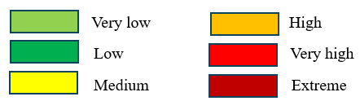

Chart 24

*Risk Register*

| RBS Code | Description | Risk Category | Cause | Consequence | Probability | Impact | Risk Score | Response | Strategy |
| --- | --- | --- | --- | --- | --- | --- | --- | --- | --- |
| 1.1.1. | Resistance to change | Organizational | Lack of understanding of the project’s benefits | Slows or derails program adoption | 1 | 3 | 3 | Mitigate | Engage stakeholders early in the process, provide clear communication on benefits, offer training, and address concerns through workshops or meetings. |
| 1.1.2 | Lack of engagement or support | Organizational | Stakeholders (such as school staff or parents) may not see the relevance or importance | Reduced buy-in, program stagnation, or failure to meet objectives | 1 | 3 | 3 | Mitigate | Conduct stakeholder analysis, assign champions for the project, and involve key figures in decision-making to foster ownership and support. |
| 1.1.3 | Poor communication with key stakeholders | Organizational | Ineffective communication strategies or unclear messaging | Conflicts, missed deadlines, or a poorly executed program. | 2 | 3 | 6 | Mitigate/  Transfer | Develop a detailed communication plan specifying the frequency, content, and medium of communication with stakeholders. |
| 1.2.1 | Inadequate involvement | Organizational | Key stakeholders, such are not actively engaged in decision-making or program activities | Critical insights and feedback are missed | 2 | 3 | 6 | Mitigate | Clearly define roles and responsibilities in a stakeholder engagement plan, and ensure each stakeholder understands their importance in the project. |
| 1.2.2 | Ineffective decision-making | Organizational | Lack of clear processes or authority, poor collaboration, or insufficient data | Delays in implementation, conflicting actions | 2 | 3 | 6 | Mitigate/  Transfer | Establish a clear decision-making hierarchy and process within the project team to streamline decision-making. |
| 1.2.3 | Lack of clear leadership and accountability | Organizational | Unclear roles and responsibilities | Confusion, uncoordinated efforts | 2 | 3 | 6 | Mitigate | Assign a strong project leader and ensure accountability by defining roles and key performance indicators (KPIs). |
| 1.3.1 | Shortage of staff | Organizational | Budget constraints, recruitment challenges | Overburdened existing staff, reduced quality of service | 1 | 3 | 3 | Mitigate/  Transference | Outsource some functions if in-house staff are not sufficient. |
| 1.3.2 | Lack of trained personnel | Organizational | Limited training opportunities, or lack of qualified trainers | Poor delivery of services | 3 | 3 | 9 | Mitigate/  Transfer | Develop a training program for staff, ensuring they are well-equipped with the necessary skills to carry out their roles effectively. |
| 1.3.3 | Inadequate facilities | Organizational | Limited space, outdated infrastructure, or insufficient resources. | limited capacity for program activities | 3 | 2 | 6 | Mitigate | Assess facility needs during the planning phase and make arrangements for upgrades or alternative venues if required. |
| 2.1.1. | Poorly defined program objectives or unclear goals. | Technical | Lack of strategic planning, insufficient stakeholder input | Misaligned efforts, lack of focus | 1 | 3 | 3 | Mitigate | Conduct a thorough scope definition workshop to ensure objectives are SMART. |
| 2.1.2 | Inadequate monitoring and evaluation mechanisms | Technical | Lack of resources or expertise, absence of proper tools or systems | Inability to assess program effectiveness | 2 | 2 | 4 | Mitigate | Develop a monitoring and evaluation (M&E) framework that includes clear metrics, timelines, and responsibilities for data collection and reporting. |
| 2.2.1 | Insufficient training for teachers or counsellors. | Technical | Lack of comprehensive training programs | Poor program implementation | 3 | 2 | 6 | Mitigate/  Transfer | Design tailored training programs that align with the practical needs of the school and ensure ongoing support through refresher courses. |
| 2.2.2 | Lack of follow-up support after initial training. | Technical | Limited resources for ongoing support, or poor planning for post-training activities. | Skills and knowledge gained in training may not be applied | 3 | 3 | 9 | Mitigate | Plan for continuous professional development and set up a mentorship or peer support system for newly trained personnel. |
| 2.2.3 | Training not aligned with the practical needs of the school | Technical | Disconnect between training content and the actual challenges faced in schools | leading to frustration and poor implementation. | 2 | 3 | 6 | Mitigate | Engage school stakeholders in the training needs assessment to ensure training programs are relevant and applicable. |
| 2.3.1 | Technical issues with digital platforms or software | Technical | Outdated systems, lack of IT support | Program delays, frustration among staff, | 3 | 2 | 6 | Mitigate/  Transfer | Test platforms beforehand, ensure backup options are available, and provide technical support to address any issues. |
| 2.3.2 | Lack of access to technology for online activities | Technical | Socioeconomic disparities, insufficient school resources | Exclusion of students or teachers from program activities, leading to inequity and poor outcomes. | 2 | 2 | 4 | Mitigate/  Transfer | Explore low-tech or offline alternatives, seek funding for technological upgrades, or create shared access points within the school. |
| 2.3.2 | Security risks related to student data and confidentiality breaches. | Technical | Weak security protocols, inadequate training on data privacy, or use of unsecured systems. | Breaches in confidentiality, and loss of trust from stakeholders. | 2 | 1 | 2 | Avoid | Avoid using platforms with known vulnerabilities for sensitive data. |
| 3.1.1 | Delays in project start or key milestones due to administrative or government processes. | Schedule | Slow approval processes, or conflicting priorities at the government level. | Missed deadlines, delayed program impact | 3 | 3 | 9 | Mitigate | Engage with government bodies early to understand processes and plan for delays. |
| 3.1.2 | Overly optimistic timelines for program implementation. | Schedule | Lack of realistic planning or underestimation of challenges. | Missed deadlines, stress on staff, and potential project failure | 2 | 3 | 6 | Mitigate | Reevaluate project timelines, accounting for potential delays and setting realistic milestones. |
| 3.1.3 | Conflicts with the school calendar or academic schedules. | Schedule | Poor alignment between program activities and academic cycles | Disruption to the school schedule, reduced participation, and diminished program impact. | 2 | 1 | 2 | Mitigate | Align project activities with the school calendar and avoid peak periods like exams. |
| 3.2.1 | Delays in external approvals | Schedule | Dependency on external authorities, lack of communication | Delays in critical stages of the project, affecting overall timelines. | 2 | 2 | 4 | Mitigate | Engage with government bodies early to understand protocols and expectations |
| 3.2.2 | Supplier or vendor delays for necessary resources or tools. | Schedule | Poor vendor management, or unexpected disruptions | Delays in program activities, resource shortages, and increased costs. | 2 | 1 | 2 | Transfer | Build buffer time into schedules and identify alternative suppliers if necessary. |
| 3.2.3 | Dependency on third-party consultants or counsellors | Schedule | Lack of internal capacity, reliance on external expertise, or insufficient staff training. | Loss of control over the project, and dependency issues. | 3 | 2 | 6 | Mitigate/  Transfer | Diversify resource pool and ensure knowledge transfer from external consultants to internal staff. |
| 4.1.1 | Underestimation of costs for program setup or training. | Financial | Incomplete cost analysis, failure to account for inflation, or unexpected training needs. | Budget overruns, resource shortages, and potential delays in implementation. | 3 | 3 | 9 | Mitigate | Conduct a thorough cost estimation during the planning phase and include contingency reserves for unexpected costs. |
| 4.1.2 | Unplanned expenses for additional resources or personnel. | Financial | Misjudgement of resource requirements, unforeseen project needs, or staff turnover | Increased financial strain, need for additional funding, and potential scope reduction. | 3 | 3 | 9 | Mitigate | Set aside contingency reserves for unforeseen expenses and regularly review budgets. |
| 4.1.3 | Funding delays from the government or sponsors | Financial | Bureaucratic processes, budget reallocations, or sponsor disengagement. | Project slowdowns, delayed hiring or procurement, and risk of program failure if funds are insufficient | 3 | 3 | 9 | Mitigate | Secure funding commitments early and engage sponsors with regular updates to avoid delays. |
| 4.2.1 | Overrun of the allocated budget | Financial | Misestimation of project costs, changes in project scope, or inflation | Potential scaling back of program activities, or delays | 2 | 2 | 4 | Mitigate | Implement cost control measures such as regular financial reviews and early identification of budget risks. |
| 4.2.2 | Increased costs in program requirements. | Financial | Rising prices for materials or services, unexpected requirements, or changing regulations. | Budget overruns, reduced resources for other critical activities | 2 | 2 | 4 | Mitigate | Implement cost control measures such as regular financial reviews and early identification of budget risks. |
| 4.2.3 | Unexpected costs associated with compliance or regulatory changes. | Financial | New government regulations | Additional financial burdens, program delays | 3 | 2 | 6 | Mitigate | Stay updated on relevant regulations and include a buffer for compliance-related expenses. |
| 5.1.1 | Issues with scheduling during school hours. | Operational | Conflicts with the academic calendar, poor coordination of counselling activities | Disruptions to academic activities, reduced student participation, or dissatisfaction among teachers. | 3 | 1 | 3 | Mitigate | Coordinate closely with school administrators to plan program activities during appropriate times. |
| 5.1.2 | Transportation or access issues for external personnel | Operational | Poor planning for logistics, geographic remoteness, or transportation costs. | Inconsistent delivery of counselling services, reduced program efficiency | 2 | 3 | 6 | Mitigate | Arrange for reliable transport and consider virtual engagement for external personnel where possible. |
| 5.1.3 | Poor coordination between project stakeholders and school staff. | Operational | Lack of communication, unclear roles, or conflicting priorities | Misalignment in program goals, delays in implementation, or failure to achieve project milestones. | 3 | 4 | 12 | Mitigate | Develop a clear coordination plan, assign roles, and hold regular meetings to ensure all parties are aligned. |
| 5.2.1 | Inadequate supervision of the counselling program | Operational | Lack of trained supervisors, insufficient resources for oversight, or low prioritization of supervision. | Decline in program quality, ethical breaches | 3 | 3 | 9 | Mitigate | Assign program supervisors and conduct regular evaluations to ensure proper oversight. |
| 5.2.2 | Lack of effective integration of the program into the school curriculum. | Operational | Resistance from teachers, poorly designed program structure, or lack of curriculum alignment. | Reduced student participation, and minimal impact on students’ well-being. | 3 | 4 | 12 | Mitigate | Involve curriculum developers early and ensure alignment between the program’s objectives and the school’s academic goals. |
| 5.2.3 | Difficulty in maintaining student participation | Operational | Lack of student engagement, program seen as irrelevant, or conflicts with academic demands. | Reduced program effectiveness, and failure to achieve desired outcomes. | 2 | 3 | 6 | Mitigate | Create engaging activities, gather feedback, and adapt the program to student interests and needs. |
| 6.1.1 | Project not achieving desired outcomes or goals. | Quality | Poor program design, ineffective implementation, or lack of appropriate resources | Wasted resources, dissatisfaction among stakeholders | 3 | 4 | 12 | Mitigate | Monitor progress closely, adjust strategies as needed, and engage stakeholders to keep the project aligned with goals. |
| 6.1.2 | Inconsistent quality of counselling activities. | Quality | Variation in counsellor skills, lack of standardized training, or insufficient supervision | Uneven program impact, dissatisfaction among students and parents, and risk to the program’s reputation. | 3 | 4 | 12 | Mitigate | Establish quality standards for the program and conduct regular assessments to maintain consistency. |
| 6.1.3 | Poor student or parent feedback on the project’s effectiveness | Quality | Perception that the program is irrelevant, failure to meet needs | Reduced program support, low participation | 3 | 2 | 6 | Mitigate | Conduct surveys, address concerns, and adjust the program based on feedback. |
| 6.2.1 | Inaccurate or incomplete data collection during monitoring and evaluation. | Quality | Lack of proper tools, insufficient staff training, or failure to establish clear data collection protocols. | Inability to accurately assess program success, missed opportunities for improvement, and incorrect reporting to stakeholders. | 4 | 3 | 12 | Mitigate | Train staff in data collection methods. |
| 6.2.2 | Lack of effective metrics to measure program success. | Quality | Failure to define clear success criteria or inadequate monitoring systems | Difficulty demonstrating impact to stakeholders, reduced accountability | 4 | 4 | 16 | Mitigate | Define clear, measurable KPIs and review them regularly to assess the program’s impact. |
| 6.2.3 | Difficulty in tracking long-term progress or outcomes. | Quality | Poor data management systems, lack of follow-up mechanisms | Inability to measure program sustainability, loss of insights for future planning | 4 | 4 | 16 | Mitigate | Use a digital platform (e.g., an online database) to consistently collect and store data related to student outcomes and counselling interventions. |
| 7.1.1 | Non-compliance with local government policies or educational regulations. | Compliance and Regulatory | Lack of awareness of policies, failure to update practices in line with new regulations | program shutdown, or damage to the school’s reputation. | 3 | 2 | 6 | Mitigate | Engage legal and educational experts to ensure alignment with regulations. |
| 7.1.2 | Failure to meet legal or ethical standards for student data privacy and confidentiality. | Compliance and Regulatory | Inadequate training, poor security protocols, or unclear data handling procedures. | Legal action, breaches of trust, and damage to the program’s reputation | 2 | 3 | 6 | Mitigate | Implement strong data governance policies and regularly review adherence to data protection laws. |
| 7.2.1 | Breaches of confidentiality or mishandling of sensitive student information | Compliance and Regulatory | Poor data management | loss of trust from parents and students, and potential program suspension. | 3 | 3 | 9 | Mitigate | Provide thorough training on confidentiality and monitor data access strictly. |
| 7.2.2 | Unethical behavior by staff or counsellors in the program. | Compliance and Regulatory | Lack of ethical guidelines, poor oversight, or inadequate vetting of personnel | Loss of financial support, program disruption | 2 | 4 | 8 | Mitigate | Review code of ethics and provide regular training on professional conduct. |
| 8.1.1 | Changes in government policies affecting program funding or support. | External | Shifts in political priorities, budget cuts, or changes in leadership. | Loss of financial support, program disruption, or complete discontinuation. | 4 | 4 | 16 | Mitigate | Use external agencies to fund project (UNICEF, LoveFoundation, PAHO) |
| 8.1.2 | Political instability affecting the school or program resources. | External | Political conflict, government instability | Disruptions to school operations and potential program closure. | 4 | 4 | 16 | Accept | Develop contingency plans for political disruptions and stay adaptable to changing environments. |
| 8.2.1 | Economic downturns affecting funding or school resources. | External | National or local economic recessions, inflation, or cuts to education budgets. | Reduced funding, scaling back of program activities | 4 | 5 | 20 | Mitigate | Seek diversified funding sources and plan for potential budget cuts. |
| 8.2.2 | Community resistance to the counselling program due to cultural or social factors. | External | Poor communication about program benefits. | Opposition from parents or community leaders, reduced participation, and potential program withdrawal. | 3 | 3 | 9 | Mitigate | Engage the community early, address concerns, and promote the program’s benefits culturally. |
| 8.3.1 | Natural disasters (e.g., floods, hurricanes) disrupting school activities. | External | Environmental factors beyond human control, climate change-related events. | Temporary school closures, and delays in program delivery. | 4 | 3 | 12 | Transfer/  Acceptance | Develop a disaster recovery plan and have backup options for program continuity. |
| 8.3.2 | Health-related risks (e.g., pandemics) affecting student attendance or program delivery. | External | Outbreaks of contagious diseases, lack of health protocols, or inadequate preparedness. | Reduced attendance, disruptions in service delivery, and increased stress on both staff and students | 3 | 3 | 9 | Mitigate | Develop virtual alternatives. |

Source: Author (Licia Castillo, 2024)

**4.2.9.3 Perform Quantitative Risk Analysis**

Using metrics to analyse the effect of each identified risks in this project has been deemed unnecessary due to the size of this project. Despite the many possible risks outlined in the Risk Register, most risks are identified as low to medium. The outcomes to the risks are predictable and manageable with simple risk mitigation strategies. The limited budget and number of staff and team members do not justify the need for quantitative measures and simpler tools like risk matrices and prioritization grid will be used. In addition, no major financial, reputational, or legal consequence can lead to project failure.

**4.2.9.4 Plan Risk Responses**

Once the risks, the probability, and impact on the project and have been identified, the approach to reducing or eliminating the negative effects of the threats will be outlined (Chart 24.) The PMBOK, 2017, describes Plan Risk Management as “process of developing options, selecting strategies, and agreeing on actions to address overall project risk exposure, as well as to treat individual project risks.”

The prioritized negative risks or threats to this project will be mostly mitigated with a few transfers and avoidances and one acceptance. The early detection and mitigation of the risk will lead to elimination or possible reoccurrence of the said risk. Measures will be put in place to avoid risks like “Failure to meet legal or ethical standards for student data privacy and confidentiality.” The effects of the acceptance of risks caused by “Political instability affecting the school or program resources” will need to be address should it occur. Transferring risk will include shifting the risk to a third party especially in the case of transferring the risk of training the counsellors to an external agency.

**4.2.10 Quality Management Plan**

Project Quality Management includes the processes for incorporating the organization’s quality policy regarding planning, managing, and controlling project and product quality in order to meet stakeholders’ objectives. (PMBOK 2017.)

**4.2.10.1 Plan Quality Management**

In Plan Quality Management, requirements, the standards for the project, and the corresponding deliverables will be identified. The activities that will be needed and applied to meet the quality objectives will be outlined. This process will guide and direct how the quality of the deliverables will be managed, assured and controlled throughout the implementation of the project. Customer and requirement prioritization will be completed early in the project.

The success of this project is contingent on not only ensuring that the school counselling model is implemented effectively but also that the setup, monitoring and evaluation are efficiently carried out in such a way that the counselling services satisfactorily meets the needs of the students.

**4.2.10.2 Customer Prioritization**

Using the L-shaped model in customer prioritization will allow for the categorization and prioritization of different customer needs or requirement based on the importance and impact. This project will focus on the customers’ needs, specifically, the students, parents, school administrators, teachers, and the Ministry of Education/CEO will be prioritized.

The resulting customer prioritization in Chart 25, indicates the students and the Ministry of Education/CEO are the most important customers. The staff, administration and parents needs will also be prioritized. The following key will be used.

Key:

10 Much more important – needs of stakeholder is top priority

5 More important – needs of stakeholder has significance importance

1 Equally important – need of stakeholder is equally important as other groups being compared

1/5 Less important – need of stakeholder has moderate importance

1/10 Much less important- need of stakeholder has minimal importance and do not need a high level of attention

Chart 25

*Customer Prioritization*

Source: Author (Licia Castillo, 2024)

|  |  |  |  |  |  |  |  |  |  |  |  |  |  |  |  |
| --- | --- | --- | --- | --- | --- | --- | --- | --- | --- | --- | --- | --- | --- | --- | --- |
| Customer Prioritization | Ministry of Education | Chief Education Officer | Licia Castillo  (Project Manager) | School Counsellor | District Education Officer | Board of Managers of OWTHS | Administration of OWTHS | Parents | Students | Teachers and Staff of OWTHS | Community resources | Data Analyst | Subject Matter Expert/  Trainer | Row Total | R.E.V.. |
| Ministry of Education |  | 1 | 5 | 5 | 5 | 5 | 5 | 1 | 1/5 | 1 | 10 | 10 | 10 | 58.2 | 0.15 |
| Chief Education Officer | 1 |  | 1 | 1 | 1/5 | 1 | 1 | 1/5 | 1/5 | 1/5 | 10 | 10 | 10 | 35.8 | 0.1 |
| Licia Castillo  (Project Manager) | 1/5 | 1 |  | 1 | 1 | 1/5 | 1/5 | 1/5 | 1/5 | 1/5 | 5 | 5 | 5 | 19.2 | 0.05 |
| School Counsellor | 1/5 | 1 | 1 |  | 1 | 1 | 1/5 | 1/5 | 1/5 | 1/5 | 5 | 5 | 5 | 19.8 | 0.05 |
| District Education Officer | 1/5 | 5 | 1 | 1 |  | 5 | 5 | 1 | 1 | 1 | 5 | 5 | 5 | 35.2 | 0.09 |
| Board of Managers of OWTHS | 1/5 | 1 | 5 | 1 | 1/5 |  | 1/5 | 1/5 | 1/5 | 1/5 | 5 | 5 | 5 | 23 | 0.06 |
| Administration of OWTHS | 1/5 | 1 | 5 | 5 | 1/5 | 5 |  | 1 | 1 | 1 | 5 | 10 | 10 | 44.2 | 0.11 |
| Parents | 1 | 5 | 5 | 5 | 1 | 5 | 1 |  | 1 | 1 | 5 | 10 | 10 | 50 | 0.13 |
| Students | 5 | 5 | 5 | 5 | 1 | 5 | 1 | 1 |  | 1 | 10 | 10 | 10 | 59 | 0.15 |
| Teachers and Staff of OWTHS | 1 | 5 | 5 | 5 | 1 | 5 | 1 | 1 | 1 |  | 10 | 10 | 10 | 55 | 0.14 |
| Community resources | 1/1 0 | 1/10 | 1/5 | 1/5 | 1/5 | 1/5 | 1/5 | 1/5 | 1/10 | 1/10 |  | 5 | 5 | 11.6 | 0.03 |
| Data Analyst | 1/10 | 1/10 | 1.5 | 1/5 | 1/5 | 1/5 | 1/10 | 1/10 | 1/10 | 1/10 | 1/5 |  | 1 | 2.6 | 0.007 |
| Subject Matter Expert/Trainer | 1/10 | 1/10 | 1/5 | 1/5 | 1/5 | 1/5 | 1/10 | 1/10 | 1/10 | 1/10 | 1/5 | 1 |  | 2.5 | 0.06 |
|  |  |  |  |  |  |  |  |  |  |  |  |  |  | 376.1 |  |

**4.2.10.3 Prioritizing Requirements**

Effective prioritizing of requirements will ensure that the efforts will be focused on most critical parts of the project. Based on Chart 26’s results, the counselling program will need to be adjusted based on the feedback and evaluations results received. Also, more attention will need to be given to the counselling space that will be used. In addition, staff and other stakeholders will need to be trained effectively on the importance and implementation of the model and the qualified counsellor be recruited.

According to the requirements prioritization for the Ministry of Education and the Chief Education Officer in Chart 27, a qualified school counsellor must be recruited. Second most important is that the implementation of the school counselling model must be in compliance with school policies and legal requirements.

To ensure successful implementation, teachers (Chart 28) must understand their role in this project. Training them on the program’s purpose and their specific responsibilities is of great importance. Also, teachers are the first responders in the classroom and their contributions to providing recommendations that contribute to improving the project is necessary.

For parents in this project, their need to conduct efficient initial counselling activities will be prioritized. In addition, much attention must be given to adjusting the counselling program based on feedback and evaluation, recruiting a qualified counsellor and training the staff and other stakeholders on the program model. (Chart 29)

Ensuring that compliance with school policies and legal requirements is a priority for the administrative team at OWTHS. Also, conducting initial counselling activities, evaluating its effectiveness, and adjusting the program based on this feedback are of most importance to the administration. (Chart 30)

Chart 31 illustrates the results when all customer requirements are weighted and prioritized. The two most outstanding requirements are the quality of the initial counselling activities and how the counselling program will be adjusted based on the feedback and evaluations.

**Chart 26**  
*Requirement Prioritization for Students*

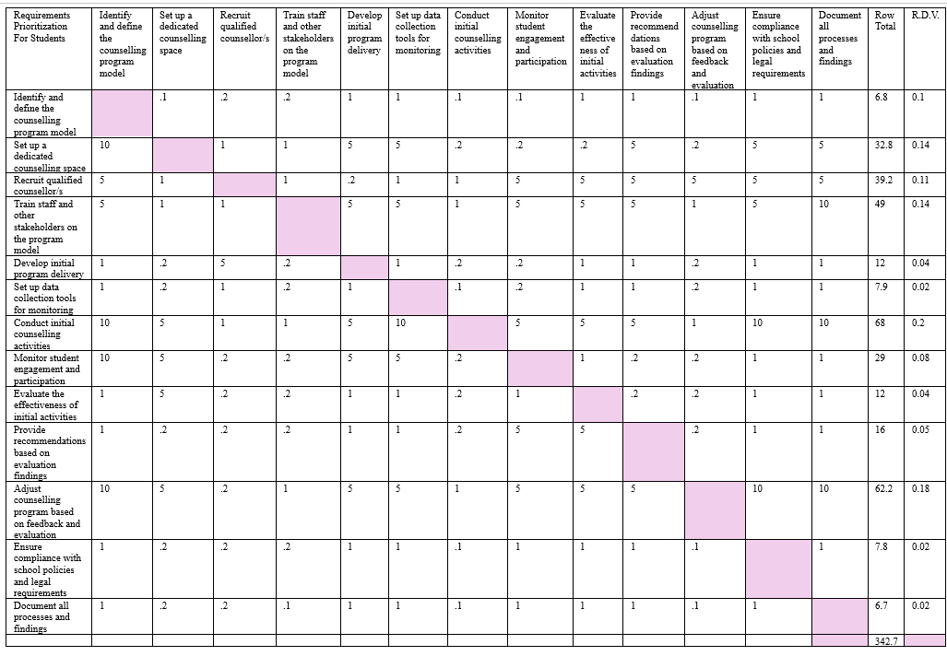

Source: Author (Licia Castillo, 2024)

**Chart 27**  
*Requirements Prioritization for Ministry of Education and Chief Education Officer*

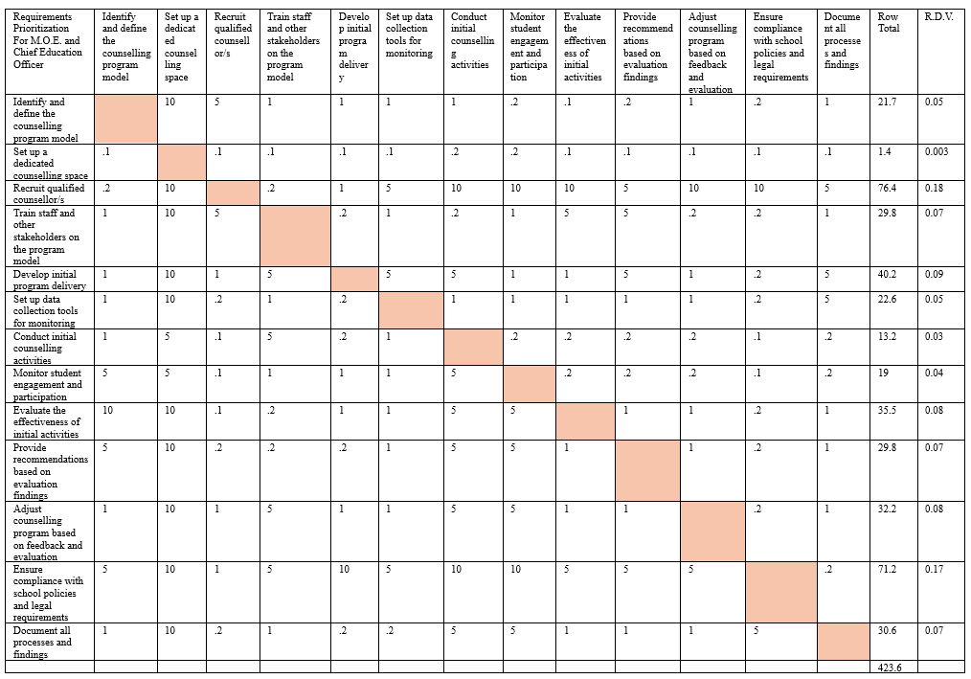

Source: Author (Licia Castillo, 2024)

**Chart 28** *Requirements Prioritization for Teachers*

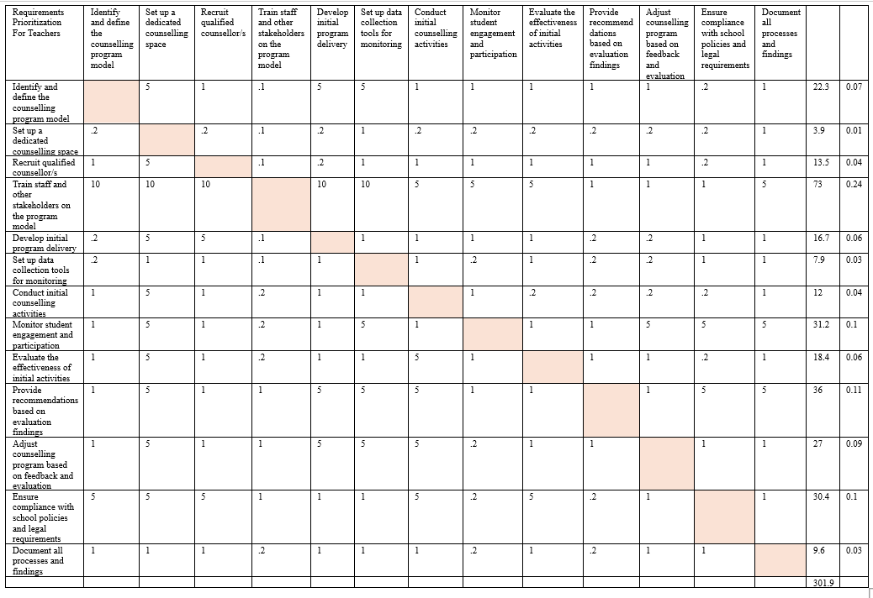

Source: Author (Licia Castillo, 2024)

**Chart 29**  
 *Requirements Prioritization for Parents*

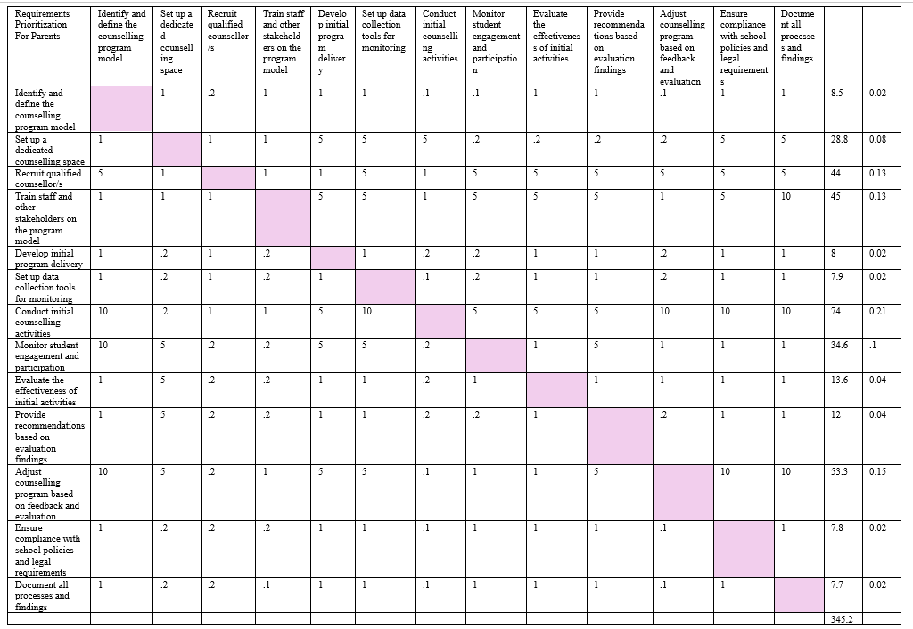Source: Author (Licia Castillo, 2024)

**Chart 30** *Requirements Prioritization for Administration of OWTHS*

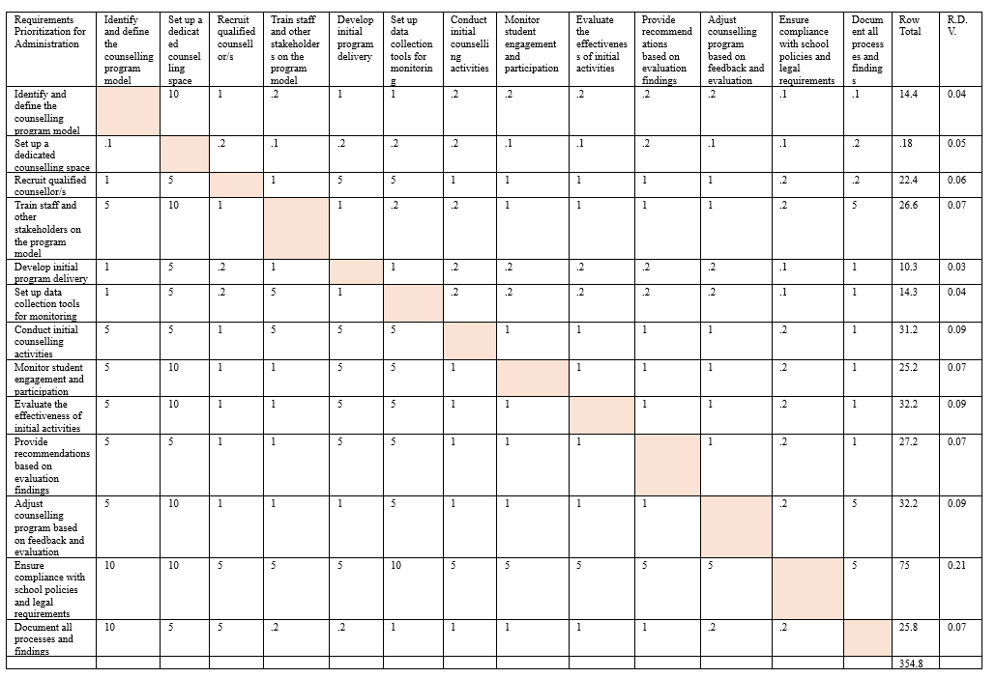

Source: Author (Licia Castillo, 2024)

Chart 31  
*Customer Weighted Requirements Prioritization*

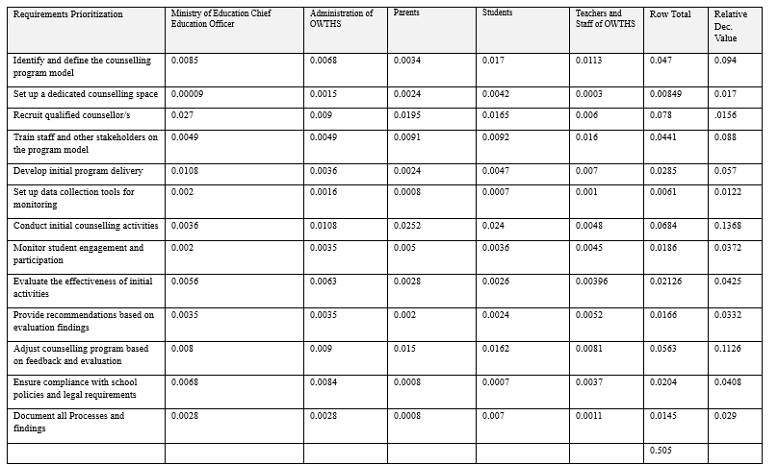

Source: Author (Licia Castillo, 2024)

# 4.3. Develop Project Execution Plan

**4.3.1 Project Execution**

The execution phase consists of the activities that will be performed to complete the work outlined in the project management plan and meet the project’s requirements. The most significant role for the project manager during this phase will be directing and managing the project work and managing the project knowledge.

**4.3.1.1 Direct and Manage project Work**

Direct and Manage Project Work is the process of leading and performing the work defined in the project management plan and implementing approved changes to achieve the project’s objectives. (PMBOK 2017) During this process the activities that have been outlined in the project management plan will be executed, school staff and counsellors will be trained, workshops for stakeholder engagement will be conducted and initial counselling services will be implemented. Resources allocations will be adjusted to address unplanned challenges or requirements. Project deliverable such as training materials, counselling guides and evaluation reports will be created and verified. Approved change requests into the project activities will be integrated. Performance data will be collected and stakeholders will be regularly updated about the progress, challenges and adjustments.

Change requests (Chart 26) will be utilized through the Perform Integrated Change Control process. In addition Lessons Learned Register (Chart 27) will be used to document adjustments that can assist in performance in the present and future projects.

Change Requests

Any adjustments or changes will be documented in a formal proposal called a “Change Request Form” see Chart 32. This form will document any modifications needed during the implementation of the project. It will ensure that all changes are tracked, reviewed and approved.

Chart 32

*Change Request Form*

|  |  |  |
| --- | --- | --- |
| **Change Request Form** | | |
| Project Name: A project management plan for the implementation of a school counselling program model in a government school. | | |
| Requestor Details: | | |
| Name: | Role: | Date of Request |
| **Change Description** | | |
| Type of Change: | | |
| Detailed Description: | | |
| Reason for Change: | | |
| Priority: 1. High 2. Medium 3. Low | | |
| Impact on Deliverables: | | |
| Impact of Not Responding to Change: | | |
| **Change Impact Assessment** | | |
| Scope: | | |
| Schedule: | | |
| Budget: | | |
| Resources: | | |
| Quality: | | |
| Stakeholders: | | |
| **Proposed Action Plan** | | |
| Proposed Solution: | | |
| **Risk Assessment** | | |
| Potential Risks: | | |
| **Approval Section:** | | |
| Reviewed by: | | |
| Decision: Approved Rejected On Hold | | |
| Comments: | | |

Source: Author (Licia Castillo, 2024)

**4.3.2 Manage Project Knowledge**

The project’s objectives and organizational learning will be achieved by using present knowledge and creating new knowledge. Managing the project knowledge will help the project capture, distribute and use information effectively. All stakeholders will benefit from the knowledge gained throughout the project.

Lessons Learned

Collecting and documenting the positive and negative occurrences experienced throughout the duration of this project, will be shared so that learning and improvement happens. This template (Chart 33) will capture insights and feedback from the implementation of the school counselling program model, highlighting what went well, what didn’t and how future efforts can be improved.

Chart 33

*Lesson Learned Register*

|  |  |  |  |  |  |
| --- | --- | --- | --- | --- | --- |
| **Lessons Learned** | | | | | |
| Project name: | A project management plan for the implementation of a school counselling program model in a government school. | | | | Date: |
| Key Successes: | | | | | |
| What went well: | |  | | Best Practices: | |
|  | |  | |  | |
| **Challenges Encountered:** | | | | | |
| What didn’t go well: | | | Root Causes: | | |
|  | |  |  | | |
| Lessons Learned #1 | | Lessons Learned #2 | | Lessons Learned #3 | |
| Description:  Impact:  Recommendation: | | Description:  Impact:  Recommendation: | | Description:  Impact:  Recommendation: | |
| Stakeholder Summary: | | | | | |
| Feedback Summary: | | | Suggestions for Improvements: | | |
| Recommendations for Future Projects: | | | | | |
| Opportunities for Improvement: | | | Follow-up Activities: | | |
| Project Manager: | | | | Date: | |

Source: Author (Licia Castillo, 2024)

**4.3.3 Manage Quality**

Quality management involves implementing specific actions to achieve the organization's quality objectives. This ensures that the project meets high standards and identifies potential quality issues. Quality assurance activities which are included in Manage Quality, are all the processes used in the project.

Quality assurance will provide stakeholders with information to reassure that what was promised is being done and that the project is meeting quality standards. It assures that the process and procedural tools are effective and that safety features are in place to ensure the safeguarding of the expected level of quality.

Quality assurance uses metrics to verify adherence to the quality plan. By utilizing both numerical and descriptive data, it measures project progress and customer satisfaction levels. These quality checks aid in predicting goal attainment and identifying problems that require resolution.

**4.3.3.1 Data Gathering**

Data gathering practical technique, will be used to ensure that the required steps based on the project’s requirements and practices have been completed. Regularly gathering feedback from students, parents, and staff will help to assess the quality and relevance of the school counselling program model. Techniques include:

1. Checklists, which will ensure that the data regarding student participation, program delivery, and counselling outcomes will be collected in a consistent and standardized manner. Checklists can be used to ensure that counsellors follow standard practices during each session.
2. Using Anonymous surveys, will allow students and staff to provide truthful feedback regarding the effectiveness of counselling activities, and the overall satisfaction with the implementation of the model.
3. Through open dialogue such as, Focus group discussions, the specific needs, challenges and concerns can be immediately addressed.
4. Suggestion boxes for students and staff will provide a medium for students and staff to continuously share their thoughts, concerns and ideas.

**4.3.3.2 Data Analysis**

Data analysis techniques are important and will be utilized in this project because its results will assist in making informed decisions, measure the effectiveness of the program and ensure continuous improvement. Analyzing data specifically related to counselling activities, student progress, and program outcomes will help in recognizing trends and areas that require improvement.

To identify any underlying reasons should an issue that affects the quality of this project arise, the Fishbone Diagram or the “5 Whys Analysis” will be utilized. These techniques will be used to explore issues like low student engagement or ineffective counselling activities.

Decision Making

Responsible decision-making is essential in quality management because it will ensure that the quality efforts are aligned with the project’s goals. This will guarantee that the quality of services will directly impact the well-being and satisfaction of the students and other stakeholders.

When making decisions especially complex ones, Multicriteria Decision Analysis will be used. This tool, while providing a structured approach, will prove effective by ensuring a holistic consideration of different project aspects. The following is an example of how it will be utilized:

1. Define the Problem: Define the specific decision that needs to be made keeping in mind the scope and the desired outcome.
2. Brainstorm Options: List all possible solutions to the decision problem.
3. Gather Criteria Information: Determine the factors necessary to the project’s success.
4. Assign Weight and scores : Determine the importance of each focus area using a weighted scoring method.
5. Analyze Results/Evaluation: Calculate total scores to determine which quality aspect should be prioritized first.

**4.3.3.3 Key Performance Indicators (KPIs):**

Establishing KPIs (Chart 34) will help in tracking the effectiveness of the counselling program. Possible KPIs could include:

* Student satisfaction rates based on feedback surveys.
* Reduction in incidents of bullying or behavioral issues.
* Number of students accessing counselling services.
* Improvement in students’ emotional well-being and academic performance.

Chart 34

*Track Key Performance Indicators*

| **KPI** | **Objective** | **Formula** | **Responsible Personnel** | **Target Accepted** | **Actions** | **How It Will Be Communicated** |
| --- | --- | --- | --- | --- | --- | --- |
| **Student Satisfaction Rate** | Measure student satisfaction with the counselling program based on feedback. | (Number of satisfied students / Total number of students surveyed) * 100 | Counselling team / school counselors | 85% or higher satisfaction | - Conduct regular satisfaction surveys after sessions. - Analyze feedback and improve services based on results. | Monthly reports shared with school management and stakeholders |
| **Reduction in Incidents of Bullying** | Track the impact of the counselling program on reducing bullying or behavioral issues. | (Previous period incidents - Current period incidents) / Previous period incidents * 100 | Discipline office and school counsellors | 20% reduction in bullying incidents over a 6-month period | - Implement anti-bullying initiatives. - Provide group and individual sessions addressing behavioral issues. | Quarterly reports and meetings with teachers and staff |
| **Number of Students Accessing Services** | Monitor the utilization of counselling services by students. | Total number of students accessing counselling services / Total number of students enrolled | Counselling team / school counsellors | 25% of the student population accessing services | - Promote counselling services through assemblies, flyers, and teachers. - Ensure availability of counsellors during key periods. | Monthly internal review with counselling team, and term-end summary for school leadership |
| **Improvement in Emotional Well-being** | Assess improvements in students' emotional well-being as a result of counselling intitiatives. | (Post-counselling emotional well-being score - Pre-counselling score) / Pre-counselling score * 100 | Counsellors and resources in the health services | 30% improvement in well-being scores over a 3-month period | - Use well-being surveys or emotional health scales pre- and post-counseling. - Tailor interventions based on identified needs. | Results shared with parents, teachers, and students in a confidential report |
| **Improvement in Academic Performance** | Measure how counselling activities have impacted students' academic performance. | (Post-counselling academic score at end of semester- Pre-counselling score at mid-semester) / Pre -counselling score * 100 | Teachers and academic co-  ordinators | 20% improvement in academic performance over two semesters | - Monitor academic progress of students receiving counselling. - Collaborate with teachers to address academic difficulties. | Data shared with academic department, teachers, and parents |

Source: Author (Licia Castillo, 2024)

**4.3.3.4 Quality Baseline**

The quality baseline (Chart 35) below outlines the quality standards and metrics that will be used in achieving the projects objectives. This quality baseline will assist in ensuring that the required quality levels and quality assurance processes are in place throughout the project lifecycle.

Chart 35

*Quality Baseline*

| Objective | Expected Outcome/Result | Quality Metrics | Quality Baseline | Measurement Frequency | Assurance Techniques | Person Responsible |
| --- | --- | --- | --- | --- | --- | --- |
| To establish a high-level project structure for the school counselling model in a government school by developing a plan for implementing initiation processes, including developing the project charter and identifying key stakeholders. | A clearly defined project charter and a comprehensive list of key stakeholders. | 100% Completion and approval of the project charter within the specified timeline (August 9, 2025)  95% of stakeholders identified and engaged  Feedback from stakeholders on the clarity and relevance of the project charter. | The project charter must be approved by all key stakeholders before moving to the next phase. At least 90% of identified stakeholders should participate in the initial engagement. | At the end of the initiation phase | Peer Reviews  Checklists  Stakeholder feedback | Project Manager |
| To create a detailed project management plan for implementing the school counselling model in a government school, which includes developing plans for scope, schedule, costs, resources, quality, communications, risks, acquisitions, and stakeholders. | A comprehensive project management plan that guides the entire implementation process. | Completion of all sub-plans (scope, schedule, cost, risk, quality, resource) within a set timeframe (October 18, 2025).  100% Approval of the project management plan by key stakeholders  Alignment of plan components with the project’s goals and stakeholder needs. | The project management plan must be 100% complete, with each sub-plan reviewed and approved before execution starts. | Upon finalization of the plan | Audits  Expert Judgement Consultation | Project Manager and Planning Team |
| To propose a plan to guide the execution of the project management plan for the school counselling model in a government school. | Successful plan that guides the execution of the project plan according to the defined scope, schedule, and budget. | Adherence to project schedule with all milestones achieved on time, with less than 5% deviation  Budget variance, maintaining costs within 5% of the planned budget  Stakeholder satisfaction with the implementation process through feedback surveys. | Achieve a minimum of 95% of planned activities on schedule, with budget overruns not exceeding 5%. Stakeholder satisfaction should be at least 80% positive | Monthly reviews and post-milestone evaluations | Quality Audits  Data Gathering  Data Analysis  Continuous Improvement: Plan-Do-Check-Act | Project Manager and Implementation Team |
| To develop a plan to implement a monitoring and control system with suitable tools and techniques to effectively track and integrate objectives and goals throughout the implementation of the school counselling model in a government school. | A dependable system that provides real-time tracking of project progress and facilitates timely adjustments. | Weekly status updates generated  Number of corrective actions taken in response to deviations (Root Cause Analysis) | Monitoring tools must track 100% of key project metrics, with adjustments made within a week of identifying an issue. | Weekly for status reports, monthly for overall effectiveness reviews. | Data Quality Assessment  Key Performance Indicators | Project Manager and Monitoring Team. |
| To define a project closure procedure for the school counselling model in a government school that encompasses evaluating the achievement of objectives and goals, documenting lessons learned, and transferring the program to the school management team. | A procedure that ensures the smooth transition of the counselling program model to the school management with documented lessons and clear evaluations. | Completion of project closure report with 100% of lessons learned and outcomes documented  Satisfaction with the handover process based on feedback from school management with a satisfaction rate of at least 85%  3-5 successful knowledge transfer sessions conducted with the school management team. | The closure report must be 100% complete and signed off by the school management with least 2 knowledge transfer sessions should be conducted with positive feedback | At the end of the project. | Lessons Learned Register  Compliance Checks | Project Manager and Closure Team. |

Source: Author (Licia Castillo, 2024)

**4.3.4 Manage Resource**

This activity refers to the ensuring that all the resources that will be acquired, this applies to both human and material, will be used efficiently and effectively throughout the lifecycle of this project.

**4.3.4.1 Acquire Resources**

According to the PMBOK 2017, Acquire Resources is the process of obtaining team members, facilities, equipment, materials, supplies, and other resources necessary to complete project work. This process will ensure that the resources that have been identified in the resource management plan are acquired and assigned prudently and efficiently to the task outlined.

Chart 36 below outlines the specific task and the human resource that will be required to complete the task. The Resource Calendar is used to tract resource availability and schedule activities accordingly, this will guarantee that the human resources will be employed effectively. Certain project tasks will require that several individuals collaborate to effectively complete the task. Several specialists for conducting specific training, evaluations, and performing data analysis will need to be acquired from external sources.

Multicriteria Decision analysis will be used to the external human resources. Because the success of this project relies to a great extent on their performance the selection criteria will be prioritized according to knowledge, skills, availability and experience.

Chart 36

*Resource Calendar*

| Level | WBS Code | Task Name | Duration | Start | Finish | Resources |
| --- | --- | --- | --- | --- | --- | --- |
| 2 | 1.1 | Develop Project Charter | 11 days | 01/08/25 | 15/08/25 | Project Manager  Project Sponsor,  Project Team Members, School Administration |
| 3 | 1.1.1 | Define project purpose and objectives | 2 days | 01/08/25 | 05/08/25 | Project Manager,  Subject Matter Experts (SMEs), School Administration |
| 3 | 1.1.2 | Identify project scope and deliverables | 9 days | 06/08/25 | 15/08/25 | Project Manager, Project Team,  School Counsellors, Teachers and School Administration |
| 3 | 1.1.3 | Define project roles and responsibilities |
| 2 | 1.2 | Identify Key Stakeholders | 10 days | 16/08/25 | 29/08/25 | Project Manager, School Leadership Team |
| 3 | 1.2.1 | Identify internal and external stakeholders |
| 3 | 1.2.2 | Create a stakeholder engagement plan |
| 2 | 2.1 | Conduct Needs Assessment | 15 days | 01/09/25 | 19/09/25 | Data Analysts,  School Counsellors,  Project Manager, Teachers |
| 3 | 2.1.1 | Gather data on current school needs | 10 days | 01/09/25 | 11/09/25 |
| 3 | 2.1.2 | Analyze data to define counselling needs | 5 days | 12/09/25 | 19/09/25 |
| 2 | 2.2 | Define Program Scope and Objectives | 10 days | 22/09/25 | 03/10/25 | Project Manager,  Subject Matter Experts (SMEs), School Counsellor |
| 3 | 2.2.1 | Outline key components of the counselling model |
| 2 | 2.3 | Develop Resource Management Plan | 10 days | 06/10/25 | 17/10/25 | Project Manager |
| 3 | 2.3.1 | Identify and allocate resources required for the project |
| 2 | 2.4 | Develop Comprehensive Project Plans | 10 days | 20/10/25 | 31/10/25 | Project Manager |
| 3 | 2.4.1 | Develop scope, schedule, and cost management plans |
| 3 | 2.4.2 | Develop quality, communications, and risk management plans |
| 3 | 2.4.3 | Develop procurement and stakeholder management plans |
| 2 | 3.1 | Conduct Training for Project Team and Stakeholders | 10 days | 03/11/25 | 14/11/25 | Training Coordinator,  Counselling Trainers, School Staff, School Counsellor |
| 3 | 3.1.1 | Train school staff on counselling model and procedures | 8 days | 03/11/25 | 12/11/25 |
| 3 | 3.1.2 | Conduct workshops for stakeholder engagement | 2 days | 14/11/25 | 15/11/25 |
| 2 | 3.2 | Execute the Program Launch | 10 days | 17/11/25 | 28/11/25 | Project Manger, School Counsellor |
| 3 | 3.2.1 | Implement initial counselling services | 8 days | 17/11/25 | 26/11/25 |
| 3 | 3.2.2 | Roll out key components of the project plan | 2 days | 27/11/25 | 28/11/25 |
| 2 | 4.1 | Set Up Monitoring and Control Systems | 30 days | 01/12/25 | 09/01/26 | Data Analysts,  Project Manager |
| 3 | 4.1.1 | Establish monitoring tools and performance metrics | 10 days | 01/12/25 | 12/12/25 |
| 3 | 4.1.2 | Set up initial data collection mechanisms | 20 days | 15/12 | 09/01/26 |
| 2 | 4.2 | Perform First Review of Project Progress | 40 days | 12/01/26 | 06/03/26 | Project Manager |
| 3 | 4.2.1 | Analyze initial performance data | 25 days | 12/01/26 | 13/02/26 | Project Manager, Data Analyst |
| 3 | 4.2.2 | Adjust plans based on initial findings | 15 days | 16/02/25 | 06/03/26 | Project Manager, Project Team, School Counsellor |
| 2 | 4.3 | Conduct Mid-Point Evaluation | 20 days | 09/03/26 | 03/04/26 | Project Manager, Project Team, School Counsellor |
| 3 | 4.3.1 | Collect feedback from stakeholders | 15 days | 09/03/26 | 27/03/26 |
| 3 | 4.3.2 | Adjust project execution as needed | 5 days | 30/03/26 | 03/04/26 |
| 2 | 4.4 | Conduct Compliance Check | 20 days | 06/04/26 | 01/05/26 | MOE Personnel, Chairman of Board, Administrative Team |
| 3 | 4.4.1 | Audit program against defined objectives and standards |
| 3 | 4.4.2 | Ensure adherence to quality and performance metrics |
| 2 | 4.5 | Perform Final Monitoring Review | 10 days | 04/05/26 | 15/05/26 | Project Manager, Data Analyst |
| 3 | 4.5.1 | Analyze data to assess overall program performance | 7 days | 04/05/26 | 12/05/26 |
| 3 | 4.5.2 | Document findings and prepare for closure | 3 days | 13/05/26 | 15/05/26 | Project Manager |
| 2 | 5.1 | Prepare Evaluation Report | 20 days | 18/05/26 | 12/06/26 | Project Manger |
| 3 | 5.1.1 | Summarize achievements and lessons learned | 10 days | 18/05/26 | 29/05/26 | Project Manager, Project Team, School Counsellor |
| 3 | 5.1.2 | Develop recommendations for future improvements | 10 days | 01/06/26 | 12/06/26 |
| 2 | 5.2 | Develop Handover Plan | 5 days | 15/06/26 | 19/06/26 | Project Manager, Project Team, School Counsellor |
| 3 | 5.2.1 | Create sustainability plan for continued implementation | 3 days | 15/06/26 | 17/06/26 |
| 3 | 5.2.2 | Prepare documentation for transfer to school management | 2 days | 18/06/26 | 19/06/26 |
| 2 | 5.3 | Conduct Project Closure Activities | 5 days | 22/06/26 | 26/06/26 | Project Manager, Project Team, School Counsellor |
| 3 | 5.3.1 | Finalize all project documentation | 2 days | 22/06/26 | 23/06/26 |
| 3 | 5.3.2 | Present outcomes to stakeholders | 3 days | 24/06/26 | 26/06/26 |
| 3 | 5.3.3 | Officially close the project | 1 day | 29/06/26 | 29/06/26 |

Source: Author (Licia Castillo, 2024)

**4.3.5 Develop Team**

Develop Team is the process of improving the capabilities, enhancing skills, fostering communication and collaboration, and team climate in order to improve the team performance. The aim is to create a team that is efficient, cohesive, motived and productive. For this project to be successfully implemented, all team members will need to be equipped with the skills, motivation, and support, the work environment must be supportive and the team and school culture positive. To strengthen the team members, the following will occur:

*Improve Skills and Capabilities*

Through training and development, the knowledge and skills of team members will be enhanced:

School counsellor – introduction to project implementation, advanced knowledge in the school counselling model, training in advanced counselling techniques.

Administration - introduction to project implementation, knowledge in the school counselling model

Teachers and staff - introduction to project implementation, knowledge in the school counselling model, introduction to basic counselling skills, emotional intelligence and other student related topics

*Boosting Team Motivation and Morale:*

All school team members: acknowledge and reward team members for their contributions and accomplishments through informal (accolades on WhatsApp or at staff meetings), formal recognition programs (certificates of appreciation, recognition or achievement) and small incentives (bonuses).

*Building a Supportive Work Environment:*

Team members (including school counsellors): ongoing support through one-on-one coaching and mentoring programs. This will be beneficial especially if the school counsellor or teachers are new to the profession or model. They will be paired with experienced professionals.

*Promoting a Positive Team Culture:*

Team Members including school counsellors: create a safe space for debriefing where counsellors and teachers can share their challenges and successes, this will create an inclusive environment where team members will feel valued, respected and encouraged.

**4.3.6 Manage Team**

In the process of Manage Team, feedback on team members performance will be provided, and issues resolved to ensure that the team is functioning efficiently and optimally to meet the project objectives. Throughout the project, the team’s behavior their interpersonal interactions and work environment will be overseen in order to maintain a positive work environment and limit conflicts. A harmonious and positive relationship among school counsellors, team members and school staff is central to the delivery of the project’s goals. To create this environment, the following will occur:

*Managing Team Performance:*

Counsellors and Team Members: regular performance evaluations will be conducted to ensure that the team is meeting project objectives.

*Providing Constructive Feedback:*

Counsellors and Team Members: Timely and constructive feedback will be used to improve performance through guidance, training and/ support.

*Managing Team Dynamics and Resolving Conflicts:*

Counsellors and Team Members: Managing interpersonal relationships by taking a proactive approach to resolve disputes or conflicts through mediation, conflict resolution strategies, or reassigning tasks will ensure that the team will functions smoothly. High Emotional Intelligence is the foundation of productive, collaborative and cooperative teams, and will be fostered and developed throughout the project.

**4.3.7 Manage Communications**

To Manage Communications is to “ensure timely and appropriate collection, creation, distribution, storage, retrieval, management, monitoring, and the ultimate disposition of project information,” (PMBOK 2017) The purpose of managing the communication is to ensure that the necessary and relevant information distributed to and among stakeholders is accurate and effectively distributed and targeted.

When managing communications in this project, important updates, reports, and information will be shared with counsellors, school staff, administrators, students, and parents. To avoid miscommunication among the team and primary stakeholders and to ensure that everyone is understanding the project goals and updates, all communications will be kept clear, concise and consistent throughout the project. Also, to consistently solicit feedback from school staff about the effectiveness of the counselling model and to address concerns from parents about their children's participation, establishing two-way communication channels will be most important.

Through feedback surveys sent periodically to staff and parents, and meeting and check-ins conducted regularly with the counselling team and school administrators, the effectiveness of the communication methods and timeliness will be determined. Communication tools and technology such as face-to-face meetings, internet platforms and collaborative platforms (Zoom, Google and Microsoft Teams) will be used to immediately address any misunderstandings, missing information or unclear instructions.

**4.3.8 Implement Risk Responses**

The strategies and actions that were defined in the planning process will be carried out effectively to address any identified risk throughout the project so as to minimize threats or maximize opportunities. In this project, implementing risk responses will involve taking proactive actions to minimize such risks as staff resistance, lack of resources, or student participation difficulties.

The proactive actions or specific risk response strategies will involve avoidance, mitigation, or acceptance. If the risk response chosen is not yielding the desired results, the current response may need to be revised or replaced. Since human behavior is not predictable, for example if student engagement is lacking or below expectation despite communication efforts, then an external body may become involved should the scripted responses not prove helpful. This external body will include professionals with specialized knowledge in the area.

The risk register will be updated to reflect the current status of the risk and the results of implementing the specific previously agreed-upon risk response. The results will include the successes and failures of the response.

**4.3.9 Conduct Procurements**

The process of conducting procurement involves collecting responses from vendors, selecting suppliers, and making selections. Contracts are then awarded and signed. This process will ensure that the necessary supplies and services are acquired from external suppliers according to the procurement plan.

The process for execution will occur when the collected proposals or bids are evaluated against criteria such as qualifications and technical ability. For acquiring external trainers, factors like cost, experience in educational settings, and the quality of their proposed training program will be assessed. The trainers who best meet the project’s requirements based on the evaluation process and negotiations will be selected.

With the seller selected and the contract terms and conditions finalized, regular communication will occur to ensure that the project expectations are understood. Maintaining a professional and healthy working relationship will be achieved through collaboration and problem resolution.

**4.3.10 Manage Stakeholder Engagement**

The process of Manage Stakeholder Engagement involves ensuring that the stakeholders needs and expectations are met through actively engaging with them, addressing their concerns and encouraging continued involvement throughout the project. Communications strategies tailored specifically to understanding the needs, and expectations will lead to continuous support and less resistance from stakeholders.

To make sure that the stakeholders stay aligned with the project objectives, updates and feedback will be given and collected throughout the project. Continuous updates will allow for concerns and conflicts to be resolved through discussions and negotiations in a timely manner. In addition, stakeholders will be encouraged to participate in important decisions and activities. Stakeholders, especially the end user – the students – come from diverse cultural and economic background, so it is essential to continuously involve them.

Building and maintaining positive relationships with stakeholders will confirm and maintain a solid commitment to this project. Through active listening and demonstrating empathy, rapport will be strengthened and potential conflicts will either be avoided or quickly mitigated.

If stakeholder engagement leads to changes, change requests will be processed. Updates to the project management plan, specifically the stakeholder engagement plan, will be made to reflect any new or changed management strategies.

# 4.4 Develop Monitoring and Control Plan

According to PMBOK 2017, Monitor and Control is the process of tracking, reviewing, and reporting the overall progress to meet the performance objectives defined in the project management plan. This process offers key benefits that increases stakeholders understanding of the project’s current status, corrective actions for performance issues, and future project projections. Tools and techniques will be utilized to ensure that the objectives of the project will be met by regularly tracking reviewing, and reporting the progress being made.

**4.4.1 Monitor and Control Project Work**

Checklists, interviews and Work Performance Data will be used to ensure that the required tasks are completed, information from stakeholders are collected to assess the project’s current status and real-time data will be collected on the project performance respectively. In addition to monthly, and if necessary, weekly meetings to report on task status, the Gantt Chart and/or Earned Value Analysis will be used to track task completion.

Earned Value Analysis can be used to evaluate the project's performance and identify any deviations from the planned schedule and budget. Additionally, it will help to predict future performance by estimating completion dates and costs based on current progress and trends.

The project manager will interpret the results and make the necessary decisions guided by the collected data and communicate the results. With the assistance of the project team who will be responsible for providing updates on ongoing progress and task completion, corrective measures will be undertaken to bring the project back on track or preventative actions will be used to address any potential issues before they actually become a problem. The information gathered, data and corrective measures, will be recorded and the information disseminated either electronically or in hardcopy to relevant stakeholders.

All adjustments will go through the identified change control process by a change request in written form. Changes may be made to the cost or schedule forecasts, lessons learned register and if necessary, risk register.

**4.4.2 Perform Integrated Change Control**

Perform Integrated Change Control is vital for keeping the project aligned with the objectives and project baselines by ensuring that all changes suggested are evaluated, approved or rejected in a structured manner. This process allows for the change request to be analysed as to its impact on the project cost, quality, risks, resources, scope, and customer satisfaction.

Steps in Performing Integrated Change Control will follow the sequence:

* + The project manager, project team and relevant stakeholders will evaluate the impact of the change suggested. (If the school counselling program needs additional materials, how it will affect the project budget and schedule for material procurement will be analysed.
  + After evaluating the impact on the project it will be decided if the change request will be approved, rejected or deferred. If it is approved, adjustments will be made to the project plan, and the team is notified of the changes. If the change request is rejected, rationale for objections will be explained and documented. The change may be postponed for future phases or until more information is available.
  + Once the decision on the change request is made, it will be communicated to the relevant stakeholders for awareness of the intention. In the case of an approved extension of the training schedule, the trainers, school administration, and other stakeholders will be informed through previous communication tools of the change.
  + The project management plan and other related documents approved change affected like schedule, cost baseline, risk register and stakeholder engagement plan will be updated to include the change.
  + Once documented, the project team will be allowed to implement the change that is aligned with the revised project management plan.
  + The impact of the change will be monitored to assess its impact on the project and to ensure that the change has met its desired effect.

**4.4.3 Validate Scope**

Validate Scope is the process of formalizing acceptance of the completed project deliverables. (PMBOK 2017) the purpose of this process is to ensure that the deliverable outline in this project meet the established requirements and that it is accepted by the main stakeholders. In this project, this process is necessary to confirm that the deliverables, such as the training session, counselling services, and setup of the infrastructure, meet the expectation and are accepted by the stakeholders.

The steps in the Validate Scope Process begin with comparing the completed deliverable such as the school counsellor training, to the requirements documentation and scope baseline. In this project, the number of school counsellors trained or the training sessions with the school staff and administration, the training content and the duration of the program will need to match with what was agreed upon. Next, these deliverables will be reviewed or inspected by stakeholders through formal inspections or walkthroughs to gather feedback. After the revision of the deliverables, formal acceptance from the school administration and the government education authorities will occur. This formal acceptance will be done either by providing the school administration and/MOE with a checklist or formal document that verifies that the objectives have been met. The formally accepted deliverables will then be documented as part of the project records.

**4.4.4 Control Scope**

The process of Control Scope involves monitoring the projects’ scope, managing the emergent changes to the scope baseline, and ensuring that the project stays aligned with its approved scope. “Scope creep” is managed when additional tasks are added or changed so as to avoid or minimize changes to the scope in terms of schedule, costs, and resources.

The following steps will be used to Control Scope:

* Regularly measuring performance against the scope baseline will determine if the deliverable meets the agreed upon requirements. An example of this will be checking that training session for counsellors are being conducted as outlined.
* If the deliverable does not meet the agreed requirements and scope, the magnitude of variance will be determined. This can be caused by the school administration requesting additional training modules for counsellors, teachers and administrations in handling mental health crisis that was not originally a part of the original scope.
* If a variance is ascertained, the need to either use corrective or preventative action to modify the scope will be determined. If it is determined that additional mental health training is necessary due to the increase in anxiety and stress-related illnesses, this legitimate request will be submitted to adjust the scope to include the new training module.
* Updates are then made to the scope baseline, project management plan, or project documents to reflect the new scope.
* The impact of the changes will be evaluated and revalidated to ensure that the updated scope is aligned with the overall project objectives.

**4.4.5 Control Schedule**

According to PMBOK 2017, Control Schedule is the process of monitoring the status of the project to update the project schedule and managing changes to the schedule baseline. Control schedule is necessary to maintain schedule baseline for the duration of the project lifecycle by adhering to the guideline in the schedule management plan.

Control Schedule is important to this project because its success depends on its timely implementation. Because the program being implemented addresses critical issues, delays may result in students not receiving the support needed within the intended academic year. Also, poor scheduling may disrupt the regular school calendar, causing discontent among the school staff, students, and parents. Key activities like the training of teachers will be aligned with time slots that causes the least amount of disruptions.

The Gantt Chart will be used to track the project ‘s progress over time because it visually represents the timeline of tasks, dependencies, and milestones. The start and end dates for each task will be easily identifiable. The chart will allow the percentage completion of each task to be tracked in real time by comparing planned progress against actual progress.

Earned Value Analysis is another tool that will be used to provide important insights into how well the project is adhering to the planned schedule and to take corrective measures to get the project back on track. This tool will also aide in identifying certain areas where the project may fall behind, predict future schedule performance and guide data-driven decisions.

**4.4.6 Control Costs**

Control Costs involves the process of monitoring the status of the project to update the project costs and managing changes to the cost baseline. (PMBOK 2017) This project’s expenditures on resources, materials, and activities necessary to implement the program will be tracked to ensure that it stays within the approved budget. It will ensure that tasks like stakeholder engagement, training sessions, monitoring system implementation, and evaluation activities are completed without exceeding the allocated budget.

The project’s budget is relatively small and the objective is to deliver an effective and efficient service. The Project Manager will monitor how much is being spent on each task such as the cost of training materials, trainers’ salaries, and administrative expenses. Earned Value Analysis (Figure 9) will be used to determine whether the project is within budget by calculating the Cost Variance which compares the Earned Value (EV) and the Actual Cost (AC.) Regular variance analysis will also help to compare planned costs with the actual costs and determine the causes of the deviations.

Some cost control challenges may arise if additional resources are needed for additional training. If this occurs, several corrective actions will be undertaken like shifting budget from tasks that are under budget to those that are over budget or identify and eliminate non-essential spending on materials.

Figure 9  
*Earned Value, Planned Value and Actual Costs*

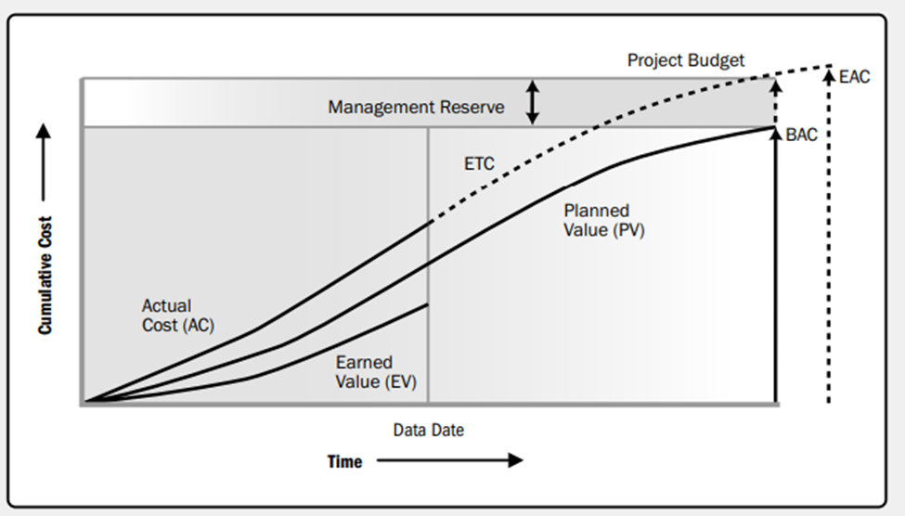

*Note*. Earned Value data for a project that is performing over-budget and behind schedule Reprinted from A Guide to the Project Management Body of Knowledge PMBOK GUIDE (SIXTH EDITION, p.264) by Project Management Institute, Inc., 2017. All rights reserved.

**4.4.7 Control Quality**

Control Quality monitors and assesses project performance to confirm that project deliverables meet specified quality standards and customer needs. The process, executed throughout the project, determines if the outputs meet expectations and comply with the standards, requirements, regulations and specifications. For this project, it ensures that the outputs produced is aligned with the quality criteria outlined in the quality management plan.

The following will be used to Control Quality in this project:

**4.4.7.1 Data Gathering**:

Checklists, questions, and surveys will help to ensure that all deliverables, like training materials or stakeholder communication, adhere to the necessary standards.

Checklists will be used to ensure that each step in the project (like stakeholder engagement, counsellor training, or monitoring) follows predefined standards. For example, when developing counselling sessions or training materials, a checklist could ensure all necessary content is included and complies with educational guidelines.

Questions and Surveys will be distributed to project stakeholders (teachers, students, parents, and counsellors) to gather feedback on the effectiveness of the counselling services, training quality, and overall program satisfaction. This feedback helps in identifying areas where improvements are needed and whether project objectives are being met.

**4.4.7.2 Data Analysis:**

Root Cause Analysis helps to identify underlying issues in the project when a quality defect or failure occurs, ensuring that similar issues are avoided in the future. If feedback from surveys shows that counsellors are not implementing the training effectively, RCA will help to determine if the problem is due to inadequate training, lack of resources, or unclear communication of expectations.

**4.4.7.3 Inspections:**

Inspections will ensure that every deliverable, from counselling materials to session outlines, meet the required standards before being used in the project. This involves the Project Manager physically or virtually reviewing deliverables (e.g., training materials, counselling activities, stakeholder plans) to ensure they meet the quality standards set out in the project’s quality management plan.

**4.4.7.4 Evaluations:**

Evaluations provide structured, formal feedback to assess whether the project’s objectives (e.g., improved student well-being or effective counsellor training) are being met. Evaluation techniques can include pre-and post-testing for trainees or performance reviews based on feedback from students and teachers.

**4.4.7.5 Retrospective Meetings:**

Retrospective Meetings offer an avenue to continuously improve the quality of the project by reflecting on past work and identifying opportunities for enhancement. These meetings will be held with the project team to reflect on what went well and what could be improved. For tis school counselling project, conducting a retrospective after key phases (like after the initial setup or after a training workshop) helps identify areas for improvement, new risks, and corrective actions that could enhance quality for future stages.

**4.4.8 Control Resources**

Control Resources monitors the availability and effective use of project resources, including people, equipment, materials, and finances, identifies potential issues, and takes corrective action to maintain project schedule and budget. For this school counselling program model implementation project, this process would focus on ensuring that the necessary resources (e.g., training materials, counsellors, SMEs, technology) are allocated properly and managed effectively throughout the project’s lifecycle.

The following tools will be used to Control Resources:

Problem-Solving will help to address resource shortages, conflicts, or inefficiencies by identifying solutions and ensuring the project stays on track. If it is discovered that the school lacks sufficient counsellors to meet student needs, problem-solving will involve identifying the root cause and finding solutions, such securing additional funding to retain another counsellor.

Interpersonal and Team Skills such as negotiation, conflict resolution, and collaboration build a positive working environment where resources can be shared and allocated smoothly. Negotiation may be needed between departments, or team members to ensure that resources are distributed fairly and equitably as in a situation where negotiation with school administrators for additional space or equipment for counselling activities may occur.

Meetings offer a formal way to monitor resource use, resolve issues, and plan for future needs, ensuring that resources are effectively controlled and adjusted as necessary. Status Review Meetings will help keep track of current resource usage, discuss whether resources are sufficient, how they’re being utilized, and if any adjustments are needed. These meetings will provide an opportunity to gather feedback from the team about resource challenges.

**4.4.9 Monitor Communications**

Monitor communication involves assessing whether project information needs are being fulfilled and whether planned communication efforts are successfully increasing or maintaining stakeholder support for project deliverables and outcomes. This will involve tracking how information is distributed among project stakeholders, verifying that communications are clear, timely, and relevant, ensuring that all stakeholders in the school counselling program project are well-informed, that communication flows are effective, and that any communication-related issues are promptly addressed to keep the project on track. In addition, metric regarding meeting attendance, feedback response rates, and internet engagement will be collected and analysed.

Communication is key to the success of this project, as a result, regular communication review meetings with relevant stakeholders will be held to gather feedback on whether the communication methods are efficient. Surveys, feedback forms, or informal discussions will be used to assess whether stakeholders are receiving, understanding, and responding to communications effectively.

Effective Interpersonal and Team Skills are essential for this project. Active listening skills during meetings, conflict resolution situations, and informal conversations will better allow the project manager and team to clarify misunderstandings or communication breakdown between stakeholders.

Clear and concise progress reports will be distributed regularly to all stakeholders to keep them informed. If communication issues are identified, the problem will be documented and the corrective action taken.

**4.4.10 Monitor Risks**

Monitor risks entails continuously tracking the implementation of risk response plans, identifying and analyzing emerging risks, and evaluating the effectiveness of the risk management process to ensure informed decision-making throughout the project.

Regularly monitoring risks that were identified during the planning phase, such as potential delays in counsellor training, resistance from school administrators, or budget overruns will ensure that each risk response plan is still effective and working as planned. The project will also be monitored for new risks during regular risk reviews during project status meetings. At these meetings with stakeholders, the current risk will be discussed and stakeholders will be updated on the potential risks and their status. Based on the outcome of these reviews, mitigation strategies will be adjusted.

If new risks arise or risk responses prove ineffective, change requests will be submitted to adjust the project plan. As risks evolve, the risk register will be updated to reflect the current state of each risk, its likelihood and impact, and the effectiveness of its mitigation plan.

One of the biggest risks is resistance from stakeholders, if this is proving to be a higher risk than originally assessed, the risk register will be updated to reflect this higher likelihood and mitigation strategies adjusted, possibly by more interaction, increasing engagement and communication with staff, parents, or students.

**4.4.11 Control Procurements**

According to PMBOK 2017, Control Procurements is the process of managing procurement relationships; monitoring contract performance, and making changes and corrections as appropriate; and closing out contracts. The purpose is to ensure that the products and services procured meet the project’s requirements and that the necessary adjustments to the procurement contracts are made and any performance issue is addressed. In this project, procurement control will involve managing contracts for training materials, hiring external trainers, and procuring resources for the school counselling program.

Vendor performance will be monitored. Service providers (training suppliers and SMEs) will be regularly assessed to ensure that they are meeting the terms outlined in their contracts. This includes checking if they are delivering resources, such as counsellor training materials, on time and to the required quality. Inspections will be performed on services procured to verify that they meet the required specifications and are aligned with quality standards in the case of tools and materials that will be utilized for counselling training. The procurement process will be audited to ensure that all vendors who provide materials and services have followed proper invoicing and payments aligned with the work delivered.

Regular Status Meeting will be held with vendors to discuss progress, any issues they are encountering, and review upcoming deliverables. This will help keep the procurement activities on track and resolve issues early.

**4.4.12 Monitor Stakeholder Engagement**

Monitor Stakeholder Engagement involves monitoring project stakeholder relationships and tailoring engagement strategies to maintain relevance, timeliness, and impact. (PMBOK 2017) By assessing stakeholder engagement throughout the project, this process helps to enhance the efficiency and effectiveness of the engagement activities so that it remains relevant, timely, and impactful.

It is necessary in this project that key stakeholders, such as school administrators, counsellors, students, parents and MOE remain engaged and supportive of the project. Monitor Stakeholder Engagement will be applied through various techniques. The current level of stakeholder engagement will be assessed regularly through surveys, one-on-one conversations, or observation of stakeholder participation in meetings and project activities. Feedback will be gathered regarding the concerns and progress of the project. Should the school administrators feel that they are not receiving enough updates on the program’s implementation, the frequency of progress reports will be increased or schedule more regular check-ins to keep them in the loop.

Stakeholder engagement assessment matrix and data gathering will be used to track how involved and interactive the key stakeholders (students, teachers, and administration) are in the project. The project manager will determine the right communication methods to use for different stakeholders. For example, some stakeholders may prefer email updates, while others may benefit from face-to-face meetings or workshops.

Interpersonal and Team Skills will be used when gathering information and resolving conflicts. Active listening when gathering feedback builds rapport and trust and encourages open communication. By mediating conflicts among stakeholders and finding solutions to resolve the conflict quickly will help to keep stakeholders engaged and the project on track.

# 4.5 Develop Close Project Plan

Close Project or Phase includes finalizing all project activities, ensuring that all deliverables are accepted, project objectives met, all stakeholders are satisfied with the results and the formal closing of the project. This means that the project is officially handed over to school management.

The following tools and techniques will be used during this process: data analysis, meetings and inspections. Data analysis will be used to compare project performance against the original plan. Close-out meetings will be conducted with the project team, key stakeholders, and sponsors to confirm that the project’s objectives were met and to discuss any remaining items. A formal inspection of the final deliverables will be conducted to ensure they meet the required standards. All project documents, such as the risk register, issue log, and project reports, will be finalized and archived. A comprehensive report summarizing the project’s performance, the achievement of objectives, the benefits realized, and any deviations from the original plan will be prepared and presented.

**4.5.1 Lessons Learned Register**

A final review session with the project team and key stakeholders will be scheduled to discuss what worked well and what could have been improved. A meeting will be held with the school counsellors, administrators, and project team to discuss how the counselling program project implementation went, identify any challenges, such as delays in procuring resources or difficulties with training schedules, and document solutions for future reference. The following steps will be followed to populate the Lesson Learned Register in Chart 37.

Step 1: Following the completion of the project in June (a week before the end of the academic year) a lessons learned survey will be sent to all project team members electronically.

Step 2: A lessons learned session with the project team will be scheduled to review the feedback. During this brainstorming session, team members will be able to elaborate on their lessons learned by answering three main questions: 1. What went well? 2. What didn’t go well? And 3. What could be improved?

Step 3: The lessons learned will be analysed and included to be used in future projects.

Chart 37

*Lesson Learned Register*

|  |  |  |  |  |  |
| --- | --- | --- | --- | --- | --- |
| **Lessons Learned** | | | | | |
| Project name: | A project management plan for the implementation of a school counselling program model in a government school. | | | | Date: |
| Key Successes: | | | | | |
| What went well: | | Best Practices: | | | |
|  | |  | |  | |
| **Challenges Encountered:** | | | | | |
| What didn’t go well: | | | Root Causes: | How can it be improved? | |
|  | | |  |  | |
| Lessons Learned #1 | | Lessons Learned #2 | | Lessons Learned #3 | |
| Description:  Impact:  Recommendation: | | Description:  Impact:  Recommendation: | | Description:  Impact:  Recommendation: | |
| Team Member Summary: | | | | | |
| Feedback Summary: | | | Suggestions for Improvements: | | |
| Recommendations for Improvements: | | | | | |
| Opportunities for Improvement: | | | Follow-up Activities: | | |
|  | | |  | | |
| Recommendations for Future Projects: | | | | | |
|  | | | | | |
| Project Manager: | | | | Date: | |

Source: Author (Licia Castillo, 2024)

**4.5.2 Project Closure**

The counselling program project will be formally handed over the management of the school counselling program to the school principal and administrative team. Before the handing over, the project manager will use a project closure checklist to ensure the correct project closure activities (Chart 38) have been carried out. This will help the project team assess if all tasks were completed, objectives met and if the project delivered its intended results.

Chart 38

*Project Closure Activities*

| Project Closure Steps | Project Closure Activities | Status  Completed/  Closing/  Incomplete | Documents,  Deliverables, or  tools required | Completed? |
| --- | --- | --- | --- | --- |
| Tie up loose ends | • Finalize Deliverables: Ensure all aspects of the counselling program are fully implemented, including training, resources, and staffing. |  | • Project Milestone Reports: Summary of key milestones achieved. |  |
| • Review Milestones: Confirm that all milestones outlined in the project plan have been met. |  | • Final Deliverables Checklist: A checklist to confirm completion of all project outputs. |  |
| • Check Compliance: Verify adherence to regulations, school policies, and data privacy standards. |  | • Compliance Documentation: Signed agreements or reports showing adherence to legal and policy requirements. |  |
| Wrap up admin tasks | • Close Financials: Ensure all payments, invoices, and contracts have been finalized. |  | • Financial Report/Final Budget: A report detailing project costs, expenses, and the final budget reconciliation. |  |
| • Close Vendor Contracts: Terminate any contracts with external vendors or consultants. |  | • Vendor Contracts: Signed contracts and closure documents for third-party vendors. |  |
| • Archive Communications: Store all key communications for future reference. |  | • Communication Archive: Emails, meeting minutes, and memos organized in a secure digital archive. |  |
| Close the loop with stakeholders | • Provide Final Updates: Present a project closure report summarizing outcomes to key stakeholders. |  | • Project Closure Report: A comprehensive report detailing project outcomes, objectives met, challenges faced, and overall performance. |  |
| • Gather Feedback: Solicit feedback from stakeholders on project success and areas of improvement. |  | • Stakeholder Satisfaction Surveys: Forms or surveys to collect feedback from stakeholders |  |
| • Obtain Formal Sign-off: Ensure that stakeholders approve the final deliverables. |  | • Sign-off Document: A formal sign-off sheet from key stakeholders, acknowledging project completion. |  |
| Provide the next steps to your project team | • Define Post-Project Roles: Assign roles for ongoing monitoring and support of the counselling program. |  | • Post-Project Action Plan: A document outlining the roles and responsibilities for school staff and any continued support required. |  |
| • Transition Responsibilities: Make sure the school’s staff understands their new roles related to the program. |  | • Handover Documentation: Detailed documentation on how to manage, monitor, and sustain the program. |  |
| • Communicate Future Support Plans: Provide information about ongoing support and program sustainability |  | • Support Agreement: A written agreement detailing post-implementation support plans. |  |
| Hold a project evaluation meeting (or post-mortem) | • Review Project Performance: Discuss what worked, what didn’t, and how the project met its objectives. |  | • Post-Mortem Meeting Agenda: An agenda for the evaluation meeting, focusing on key areas such as scope, schedule, budget, and risks.  • Team Feedback Survey: A tool for gathering feedback from the team on the project experience |  |
| • Identify Lessons Learned: Document the key lessons learned for future projects. |  | • Lessons Learned Document: A formal document summarizing the lessons learned during the project.  • Project Performance Report: An analysis of how well the project met its objectives and timelines. |  |
| Map out improvements for future projects | • List Areas for Improvement: Develop a set of recommendations for future school counselling program implementations or similar projects. |  | • Recommendations Report:: A document outlining proposed improvements and recommendations for future projects. |  |
| • Propose Process Enhancements: Identify inefficiencies and ways to improve processes in future projects. |  | • Process Improvement Plan: A plan identifying how to optimize project workflows and procedures in future endeavors. |  |
| Index documentation | Organize and Archive Project Documents: Ensure that all relevant project documentation is properly indexed and stored. |  | • Document Index: A structured, searchable index of all project documentation. |  |
| • Create a Final Closure Report: Prepare a comprehensive final report that summarizes the entire project lifecycle. |  | • Final Project Report: A high-level summary report covering all phases of the project, including scope, risks, deliverables, and outcomes. |  |
| Celebrate Your Team  Activities: | • Recognize Contributions: Acknowledge team members for their dedication and contributions to the project’s success. |  | • Recognition Letters or Certificates: Formal letters or certificates of appreciation for team members. |  |
| • Host a Celebration Event: Organize a celebration to mark the completion of the project. |  | • Celebration Event Plan: A plan for the celebratory event, including date, location, and agenda. |  |
| • Provide Certificates or Awards: If appropriate, distribute certificates or awards to team members. |  |  |  |

Source: Author (Licia Castillo, 2024)

# CONCLUSIONS

This project was developed to implement a structured and effective school counselling program in a government school. The goal is to improve the effectiveness and sustainability of the school's counselling services by providing structured, comprehensive support for students' academic, career, and personal development. Implementing this model in a government school helps address students' evolving needs and enhances the quality of services provided by the school counselling team. All key stakeholders within the school body, government educational representatives and external consultants will be instrumental in the successful implementation of this project. This project plan will provide an organized and structured comprehensive framework that is aligned with the overall goals of improving the school’s counselling services. The success of this project relies heavily on stakeholder engagement, effective communication, adequate training, risk management, continuous monitoring and strong leadership. Conclusion referencing the project’s objectives follows:

1. The first specific objective of the project—establishing a high-level project structure for the school counselling model—begins with developing an inclusive plan for the initiation processes. The development of the project charter formalizes the project's existence, sets its scope, and defines clear goals, creating a structured pathway for implementing the school counselling model. Identifying distinct stakeholders ensures their roles, interests, and responsibilities are well-understood, fostering collaboration and alignment with the project’s vision.

2. The second objective of the project – creating a detailed project management plan- outlines a structured and effective plan for the execution of the project that includes developing plans for scope, schedule, costs, resources, quality, communications, risks, acquisitions, and stakeholders. Including needs assessments and data analysis, ensures that the project is aligned with the school's requirements and effectively addresses stakeholder needs.

3. The third objective-proposing a plan to guide the execution of the project-includes critical components such as managing project knowledge, ensuring quality, effectively utilizing resources, maintaining clear communication, and actively engaging stakeholders. This comprehensive execution plan provides the structure and guidance needed to achieve the desired outcomes of the school counselling program, ultimately benefiting the students and the school community.

4. The fourth objective-developing a monitoring and control system-outlines key processes, such as monitoring project work, managing changes, validating and controlling scope, schedule, costs, and quality, and ensuring resources are effectively managed. By utilizing various monitoring tools and techniques, issues can be identified and addressed immediately, ensuring alignment with goals, and effective and informed decision making.

5. The fifth objective- defining a comprehensive project closure procedure- includes evaluating the achievement of project objectives and goals, utilizing performance ratings across various administrative, preventative, interventive, collaborative, and professional responsibility areas. Documenting lessons learned and evaluating the success of the counselling program, encourages continuous improvement and professional development. Transferring ownership of the program to the school management team ensures sustainability and alignment with long-term school goals.

# RECOMMENDATIONS

The Ministry of Education's support and resources are vital for the success of this project. Their involvement will enhance the implementation of the school counselling model, ensuring long-term sustainability and alignment with national education goals. The following recommendations below reinforces their role.

1. The Ministry of Education should actively endorse and support the project charter ensuring that the overall vision align with broader national education policies on mental health and well-being in schools. This formal endorsement ensures that the project receives full government backing for its implementation.
2. In creating a detailed project management plan the Ministry of Education should provide access to critical data that can inform the needs assessment phase, including demographic data, school performance reports, and statistics on student well-being to ensure the project’s scope is responsive to actual needs in the education system. Also, the government should allocate dedicated funding for the project, ensuring that sufficient financial resources are available to cover staffing, training, and infrastructure costs. They should also assist in acquiring any necessary tools, such as digital platforms or counselling resources.
3. The Ministry should facilitate targeted capacity-building workshops and training for school staff and administrators. This could include professional development programs or certifications for school counsellors, enhancing their ability to execute the counselling model effectively.
4. The Ministry of Education should establish a unit in the education department that includes a team of qualified personnel responsible for monitoring the project’s progress. This unit could review reports on scope, schedule, costs, and resource utilization, ensuring alignment with national educational objectives.
5. In defining a comprehensive project closure procedure the Ministry of Educations should lead the final evaluation of the project, using national educational benchmarks and performance ratings. In addition, the government should ensure that lessons learned from this project are documented and shared across schools and regions. This could be formalized in national reports that highlight best practices for future counselling programs in other schools. Also, the Ministry should ensure that sufficient resources (financial, staffing, and training) are in place to maintain the program after project closure. A long-term sustainability plan, supported by government funding or initiatives, will ensure the school counselling model continues to operate and adapt to evolving needs. Finally, the Ministry of Education should Integrate the counselling model into national education policies, ensuring that it becomes a part of the standard support structure for schools across the country.

# VALIDATION OF THE FGP IN THE FIELD OF REGENERATIVE AND SUSTAINABLE DEVELOPMENT

The end product of the final graduation project " A project management plan for the implementation of a school counselling program model in a government school" relates to six sustainable development objectives:

SDG 3: Good Health and Well-being

The school counselling program directly supports mental health and well-being by providing students with access to psychological support, guidance, and counselling services. By helping students manage stress, building resiliency, and developing coping mechanisms through prevention and intervention activities, the program promotes a healthier school environment, which is important to achieving good health and well-being.

SDG 4: Quality Education

The counselling program supports the acquiring of quality education by addressing the diverse needs of students through data-driven activities, particularly for those who may be struggling with emotional, social, or psychological challenges. This ensures that all students are equip with the tools to succeed academically. By addressing the underlying issues that may lead to student dropouts or academic failure, the program helps to reduce dropout rates and improve student retention, which is a key aspect of ensuring quality education for all.

SDG 5: Gender Equality

School counselling programs often address issues related to gender, such as bullying, harassment/sexual harassment, or discrimination, and provide support to students who may be vulnerable due to their gender identity or gender-based violence. They work towards creating a safe and supportive environment for all students, regardless of gender. The programs focus on empowering girls and young women in completing their education, and in pursuing their academic/career and personal goals, contributing to the broader goal of achieving gender equality.

SDG 10: Reduced Inequalities

Counsellors can help identify and address social inequalities within the school, such as issues related to race, ethnicity, or disability, and work. In addition, the program ensures that all students, regardless of their socio-economic background, have access to counselling and psychological support. This contributes to reducing inequalities within the school community by providing equal opportunities for mental and emotional well-being.

SDG 16: Peace, Justice, and Strong Institutions

Belize has a high violent crime rate, by addressing and mitigating contributing issues such as bullying, conflict, and violence, the counselling program contributes to creating a more peaceful and supportive school environment. By strengthening the support structures within schools through counselling programs, the project contributes to building stronger, more resilient educational institutions that can support students' holistic development.

6. SDG 17: Partnerships for the Goals

The successful implementation of a school counselling program often involves collaboration with all stakeholders, including government bodies, NGOs, school staff, parents, and the community.

**P5 Standards and Sustainability**

By incorporating the five critical aspects: People, Planet, Prosperity, Processes, this holistic approach ensures that every aspect of a project's lifecycle is evaluated and enhanced for sustainability (Charts 39, 40, 41, 42.) This project " A project management plan for the implementation of a school counselling program model in a government school", aims to enhance student well-being and academic performance through a comprehensive school counselling program model. By providing mental health support, strengthening emotional resilience, and bridging the gaps initiatives, the program contributes to a healthier and more inclusive school environment. Successful implementation involves collaboration with stakeholders to adapt the program to fit specific needs. Environmental considerations are integrated by using eco-friendly practices and minimizing resource consumption. The project promotes long-term student success, economic sustainability, and social prosperity. Effective project management, continuous improvement, and capacity building with all stakeholders are essential for ensuring the program's sustainability and impact. The primary deliverables include the counselling program model itself, along with culturally and developmentally relevant and sustainable educational materials.

Chart 39

*P5 Impact Analysis – People*

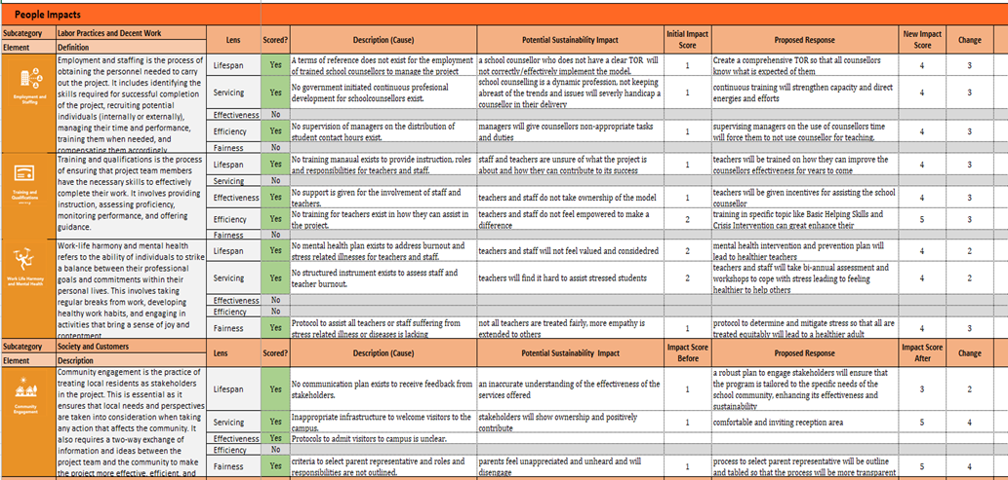

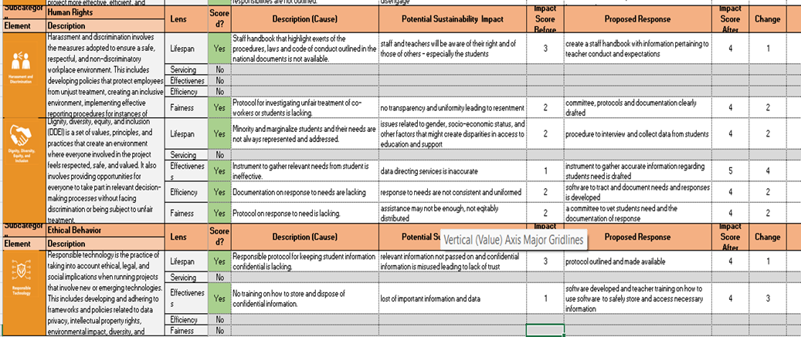

*Note.*Chart 39 shows P5 impact analysis - people (social) category of sustainability concerns the impacts that the project’s activities and results may have on individuals, society, and communities. Table reproduced from Global, G. (2023). The GPM P5 Standard for Sustainability in Project Management. <https://greenprojectmanagement.org/gpm-standards/the-p5-standard-for-sustainability-in-project-management>

Chart 40

*P5 Impact Analysis - Planet*

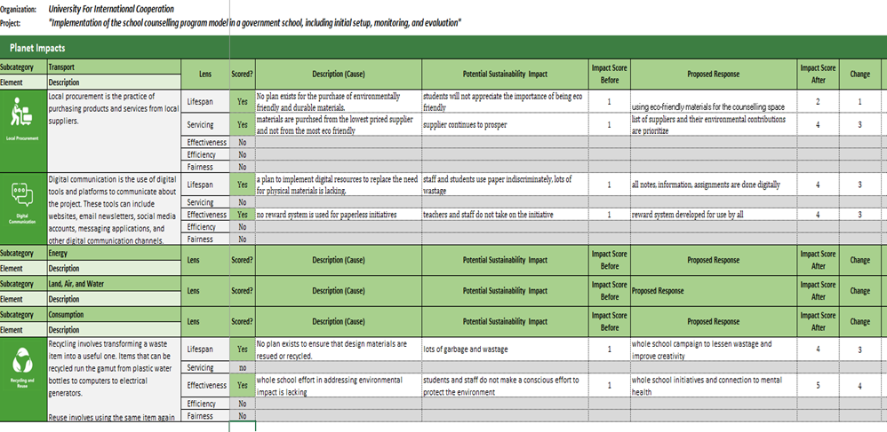

*Note*. Chart 40 shows P5 impact analysis - planet (social) category of sustainability concerns the impacts that the project’s activities and results may have on living and non-living natural systems. Table reproduced from Global, G. (2023). The GPM P5 Standard for Sustainability in Project Management. <https://greenprojectmanagement.org/gpm-standards/the-p5-standard-for-sustainability-in-project-management>

Chart 41

*P5 Impact Analysis - Prosperity*

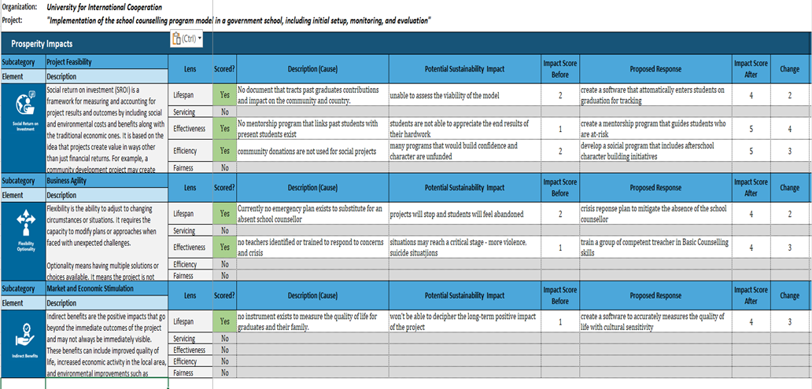

*Note.* Chart 41 shows P5 impact analysis - prosperity (social) category of sustainability concerns the impacts that the project’s activities and results may have on the finances of the project’s stakeholders. Table reproduced from Global, G. (2023). The GPM P5 Standard for Sustainability in Project Management. <https://greenprojectmanagement.org/gpm-standards/the-p5-standard-for-sustainability-in-project-management>

Chart 42

*Score Card of P5 Analysis*

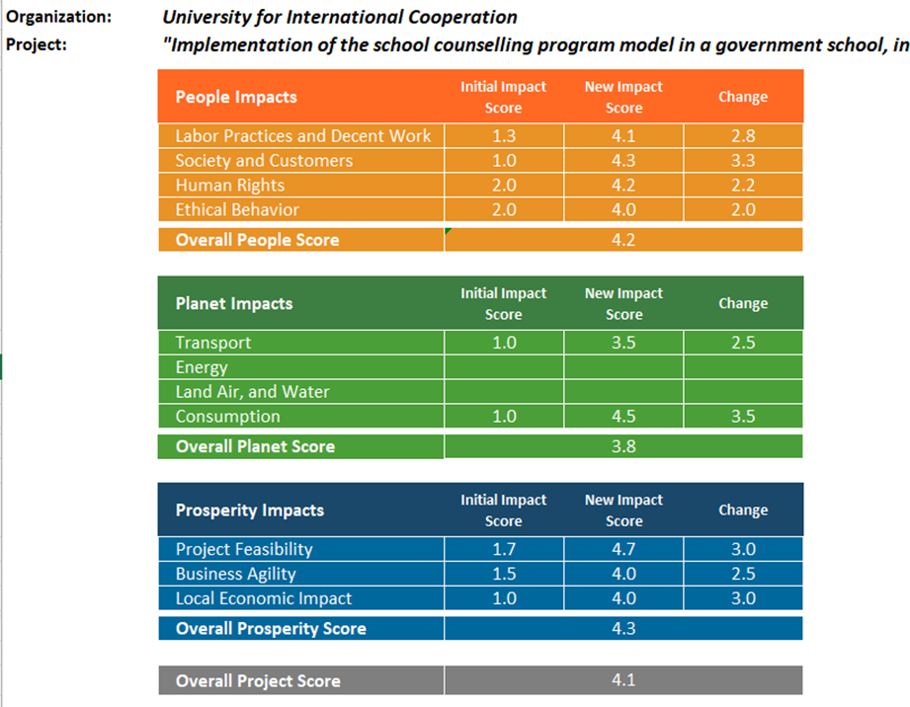

*Note.* Chart 42 shows P5 impact analysis – the impacts that the project’s activities and results may have on the people, planet and prosperity. Table reproduced from Global, G. (2023). The GPM P5 Standard for Sustainability in Project Management. <https://greenprojectmanagement.org/gpm-standards/the-p5-standard-for-sustainability-in-project-management>

**Dimensions of Regenerative Development**

The " A project management plan for the implementation of a school counselling program model in a government school" aligns with the dimensions of Regenerative Development by contributing to the ecological, social, economic, cultural, and spiritual regeneration of the school community. The program can integrate activities that foster a connection to nature through mindfulness techniques, and environmental awareness activities. By involving students, teachers, parents, and local stakeholders in its design and implementation, the school counselling program can foster a sense of school community and empowerment. The project can be designed to be economically sustainable by ensuring it is integrated into the school’s budget and operational framework. Also, students who receive equitable and adequate support are more likely to succeed academically, pursue higher education, and secure better employment, contributing to the economic regeneration of the community. Keeping in consideration the values, traditions, and social dynamics of the school community, the program is designed to be culturally sensitive and relevant, effectively addressing the needs of students. Finally, exploring their identities, values, goals, and career aspirations, can help students find purpose and meaning in their lives, contributing to their overall sense of well-being and fulfilment.

**Project execution, Deliverables, Maintenance and Operations**

Careful and continuous planning is needed for the project’s long-term sustainability. By considering the school’s needs, potential challenges, and available resources during the planning stage, the project can be integrated into the existing school structures. On the contrary, a resource-intensive setup without focusing on sustainability may strain the school’s budget and hinder the program's permanence. Including training programs facilitated by the counsellor for teachers, staff, parents and even students not only cuts costs but also builds capacity, enabling the program to adapt to new challenges and needs, and contributing to a sustainable and evolving educational environment.

Continuous monitoring and feedback gathering, will keep the counsellor abreast of the changing needs supporting the program in its evolution and adaption. The program’s end result will include an adapted model that can be replicated in other schools or scaled within the same school. To know if the adapted model is sustainable or regenerative, data to measure the long-term impact must be collected. In the absence of this data, the school may struggle to make informed decisions about the program’s future.

# BIBLIOGRAPHY

Akos, P., Bastian, K. C., Domina, T., & de Luna, L. M. M. (2018). *Recognized ASCA*

*Model Program (RAMP) and student outcomes in elementary and middle schools. Professional School Counseling*, 22(1), 2156759X1986993. <https://doi.org/10.1177/2156759x19869933>

Amat, S. (2019). Guidance and counselling in schools. *Proceedings of the 3rd International Conference on Current Issues in Education (ICCIE 2018)*. <https://doi.org/10.2991/iccie-18.2019.3>

American Project Management Institute. (2021). *A Guide to the Project Management Body of Knowledge* (PMBOK® Guide) - Seventh Edition, *Project Management Institute, Inc., 2021.*

American School Counselor Association. (2019). *ASCA National Model Implementation*

*Guide: Manage and assess (2nd ed.)*. Author. <https://booksrun.com/9781929289608-asca-national-model-implementation-guide-2nd-edition>

American School Counselor Association. (2019). *The ASCA national model: A framework*

*for school counseling programs (4th ed.)*. Author.

Ashikuzzaman, Md. (2023, December 23). Sources of information. Library & Information

Science Education Network.

h<ttps://www.lisedunetwork.com/sources-of-i>nformation/

*Belize Education Sector Plan 2021-2025*. (2021).

<https://www.moecst.gov.bz/wp-content/uploads/2022/02/The-Belize-Education-Sector-Plan-2021-2025_MoECST.pdf>

Benalet, C. E. C., Paquiao Jr., M. E., Baldezamo, R. C., Vincente, R. S., Reomero, J. I., &

Junsay, M. D. (2023, November 24). *A systematic review on Educational Strategic Management.* <https://www.researchgate.net/publication/375888611_A_Systematic_Review_on_Educational_Strategic_Management>

Brewington, M., & Kushner, J. (2020). School counselor perceptions of a comprehensive

school counseling model and implications for practice. *Administrative Issues Journal, 10(2), Article 3.* [*https://dc.swosu.edu/aij/vol10/iss2/3*](https://dc.swosu.edu/aij/vol10/iss2/3)

Bridgen, B. (2023, October 10). *Implementation plan: What to include and 5 essential*

*steps.* Teamwork.com.

h<ttps://www.teamwork.com/blog/implementing-a-project-p>lan/

Burkard, Alan W.; Gillen, Mark; Martinez, Michael J.; and Skytte, Sarah L.,

"Implementation Challenges and Training Needs for Comprehensive School Counseling Programs in Wisconsin High Schools" (2012). College of Education Faculty Research and Publications. 320. <https://epublications.marquette.edu/edu_fac/320>

Camelford, K. G. (2014). *The relationship between implementation of the American School*

*Counselor Association National Model and professional secondary school counselor burnout* [*Doctoral dissertation*, University of New Orleans]. <https://scholarworks.uno.edu/td/1857>

Carey, J., Harrington, K., Martin, I., & Stevenson, D. (2012*). A statewide evaluation of the*

*outcomes of the implementation of ASCA National Model school counseling programs in Utah high schools*. *Professional School Counseling*, 16(2), 89–99. <https://doi.org/10.5330/psc.n.2012-16.89>

Cooper, M., Stafford, M. R., Saxon, D., Beecham, J., Bonin, E.-M., Barkham, M., & Ryan,

G. (2021). *Humanistic counseling plus pastoral care as usual versus pastoral care as usual for the treatment of psychological distress in adolescents in UK state schools (ETHOS): A randomized controlled trial*. *The Lancet Child & Adolescent Health*, 5(3), 178–189.

<https://doi.org/10.1016/s2352-4642(20)30363-1>

Creswell, J. W. (2008). *Research design: Qualitative, quantitative, and mixed methods*

*approaches*. SAGE Publications.

Curtis, R., Van Horne, J. W., Robertson, P., & Karvonen, M. (2010). *Outcomes of a school-*

*wide positive behavioral support program. Professional School Counseling*, 13(3), 2156759X1001300. <https://doi.org/10.1177/2156759x1001300303>

*Do We Need More Counseling in Schools?* (n.d.). Wake Forest University.

https://counseling.online.wfu.edu/blog/do-we-need-more-counseling-in-schools/

Durlak, J. A. (1998). *Why program implementation is important. Journal of Prevention &*

*Intervention in the Community,* 17(2), 5–18. <https://doi.org/10.1300/j005v17n02_02>

*Effectiveness of school counselling revealed in new research*. (2021, January 21). News

from BACP. <https://www.bacp.co.uk/news/news-from-bacp/2021/21-january-effectiveness-of-school-counselling-revealed-in-new-research/>

Global, G. (2023a). *The GPM for Sustainability in Project Management.* <https://greenprojectmanagement.org/gpm-standards/the-p5-standard-for-sustainability-in-project-management>

Goodman-Scott, E., Sink, C. A., Cholewa, B. E., & Burgess, M. (2018). *An ecological view*

*of school counselor ratios and student academic outcomes: A national*

*investigation.* Journal of Counseling & Development, 96(4), 388–398. <https://doi.org/10.1002/jcad.12221>

Gysbers, N. C., & Lapan, R. T. (2001). *International Journal for Educational and*

*Vocational Guidance*, 1(3), 197–208. https://doi.org/10.1023/a:1012297314669

Hatch, T., & Chen-Hayes, S. (2008). *School counselor beliefs about ASCA National Model*

*school counseling program components using the SCPCS. Professional School Counseling,* 12(1), 34–42. <https://doi.org/10.5330/psc.n.2010-12.34>

Hilts, D., Kratsa, K., Joseph, M., Kolbert, J. B., Crothers, L. M., & Nice, M. L. (2019).

*School counselors’ perceptions of barriers to implementing a RAMP-designated school counseling program*. *Professional School Counseling*, 23(1). <https://doi.org/10.1177/2156759x19882646>

Hilts, D., Liu, Y., & Luke, M. (2022). *School counselors’ emotional intelligence and*

*comprehensive school counseling program implementation: The mediating role of transformational leadership.* *The Professional Counselor*, 12(3), 232–248. <https://doi.org/10.15241/dh.12.3.232>

Ivankova, N. V., Creswell, J. W., & Stick, S. L. (2006). *Using mixed-methods sequential*

*explanatory design: From theory to practice*. *Field Methods*, 18(1), 3–20. <https://doi.org/10.1177/1525822x05282260>

Kerzner, H. (2017). *Project management: A systems approach to planning, scheduling, and*

*controlling.* Wiley.

Kratsa, K. (2019*). Exploring ecological-systems barriers to implementing a recognized*

*American School Counselor Association Model Program (RAMP)* (Doctoral dissertation, Duquesne University). <https://dsc.duq.edu/etd/1766>

Kushner, J. (2017). *Policy, research, and implications for school counseling in Canada.*

*International Handbook for Policy Research on School-Based Counseling*, 417–426. <https://doi.org/10.1007/978-3-319-58179-8_27>

Lapan, R. T. (2012). *Comprehensive school counseling programs: In some schools for*

*some students but not in all schools for all students*. *Professional School Counseling*, 16(2), 2156759X1201600. <https://doi.org/10.1177/2156759x1201600201>

Lewis, J. P. (2007). *Fundamentals of project management*. American Management

Association.

*Libguides: Information literacy guide:* *Types of information sources*. (2021, September 27).

University of Fort Hare. <https://ufh.za.libguides.com/c.php?g=91523&p=590868>

*Libguides:* *Primary, secondary, and tertiary sources of information in the sciences.* (2023).

University of Wisconsin Stevens Point. <https://libraryguides.uwsp.edu/InformationSourcesInTheSciences>

*Libguides:* *Research methods: What are research methods?* (2024, April 18). University of

Newcastle Library. <https://libguides.newcastle.edu.au/researchmethods>

Lock, D. (2016). *The essentials of project management.* Routledge.

Mishra, A., & Mishra, D. (2013). *Software project management tools*. *ACM SIGSOFT*

*Software Engineering Notes*, 38(3), 1. <https://doi.org/10.1145/2464526.2464537>

Mughiroh, M., Hariastuti, R. T., & Naqiyah, N. (2018). *The development of comprehensive*

*guidance and counseling program model.* Proceedings of the 2nd International Conference on Education Innovation (ICEI 2018). <https://doi.org/10.2991/icei-18.2018.81>

Olsen, J., Parikh-Foxx, S., & Flowers, C. (2021, September*). A confirmatory factor*

*analysis of the school counseling program implementation survey.* <https://files.eric.ed.gov/fulltext/EJ1328919.pdf>

Patanakul, P., Iewwongcharoen, B., & Milosevic, D. (2010). *An Empirical Study on the use*

*of Project Management Tools and Techniques across Project Life-Cycle and their*

*Impact on Project Success. Journal of General Management, 35(3), 41–*

*66.* doi:10.1177/030630701003500304

Popov, N., & Spasenovic, V. (2020, June). *School counseling: A comparative study in 12*

*countries.* <https://www.researchgate.net/publication/342123122_School_Counseling_A_Comparative_Study_in_12_Countries>

Project Management Institute. (2021). *A Guide to the Project Management Body of Knowledge,* (*PMBOK® Guide*) - Seventh Edition, Project Management Institute, Inc., 2021.

Rathbun, Keri Ann. (2017, May 1). *Perceptions of Arkansas School Counselors Regarding the Barriers of Implementing the ASCA National Model.* ttps://orc.library.atu.edu/cgi/viewcontent.cgi?article=1014&context=etds_2017

Robinson, D. M., Mason, E. C. M., McMahon, H. G., Flowers, L. R., & Harrison, A.

(2018). *New School Counselors’ Perceptions of Factors Influencing Their Roles as Leaders. Professional School Counseling, 22(1), 156759X1985261.*<https://doi:10.1177/2156759x19852617>

Salina, C., Girtz, S., Eppinga, J., Martinez, D., Kilian, D. B., Lozano, E., … Shines, T.

(2013). *All Hands on Deck: A Comprehensive, Results-Driven Counseling Model. Professional School Counseling*, 17(1), 2156759X0001700. <https://doi:10.1177/2156759x0001700112>

*Secondary education*. Ministry of Education, Culture, Science and Technology. (2022, February 23). https://www.moecst.gov.bz/education-sectors/secondary-education/

*School counsellors* - UNICEF. (2021b). <https://www.unicef.org/romania/media/8556/file/School>

Smith-Augustine, S., & Wagner, M. (2012). *School counseling in Belize: Poised for great*

*development.* *International Journal for the Advancement of Counselling,* *34*(4), 320–330.

<https://doi.org/10.1007/s10447-012-9160-x>

Sokolova, V. (2024, July 5). *Project Management in Education: Specific challenges and*

*ways of addressing them.* Epicflow.

<https://www.epicflow.com/blog/managing-projects-in-education-challenges-and-ways-of-addressing-them/>

Springer Publishing Company. (2023, August 20). *Assessing the development, implementation, and Management of Your Comprehensive School Counseling Program*. Springer Publishing. <https://connect.springerpub.com/content/book/978-0-8261-8554-9/chapter/ch03>

Stockton, R., & Güneri, O. Y. (2011). *Counseling in Turkey: An*

*Evolving Field. Journal of Counseling & Development, 89(1), 98–104.* [https://doi:10.1002/j.1556-6678. 2011.tb00065.x](https://doi:10.1002/j.1556-6678.%202011.tb00065.x)

Studer, J. R., Diambra, J., Breckner, J. A., & Heidel, R. E. (2011, January). (PDF) *Obstacles and successes in implementing the ASCA National Model In Schools*. <https://www.researchgate.net/publication/228839533_Obstacles_and_Successes_in_Implementing_the_ASCA_National_Model_in_Schools>

Whiston, S. C., Tai, W. L., Rahardja, D., & Eder, K. (2011). *School Counseling Outcome: A Meta-Analytic Examination of Interventions. Journal of Counseling & Development, 89(1), 37–55.* <https://doi:10.1002/j.1556-6678.2011.tb00059.x>

Zimmer, D., Laux, J., Liu, Y., Clark, M., & Reynolds, J. (2021, August). (PDF*) listen to the voices: School Counselors and Comprehensive School Counseling Programs.* <https://www.researchgate.net/publication/276189624_Listen_to_the_Voices_School_Counselors_and_Comprehensive_School_Counseling_Programs>

# APPENDICES

## Appendix 1: FGP Charter

**CHARTER OF THE PROPOSED**

**FINAL GRADUATION PROJECT (FGP)**

1. Student name

|  |
| --- |
| Licia Camille Castillo |

1. FGP name

|  |
| --- |
| " A project management plan for the implementation of a school counselling program model in a government school." |

1. Application Area (Sector or activity)

|  |
| --- |
| Education |

1. Student signature

|  |
| --- |
|  |

1. Name of the Graduation Seminar facilitator

|  |
| --- |
| Dr. Roger Valverde |

1. Signature of the facilitator

|  |
| --- |
|  |

1. Date of charter approval

|  |
| --- |
|  |

1. Project start and finish date

|  |  |
| --- | --- |
|  |  |

1. Research question

|  |
| --- |
| How does the implementation of a school counselling program model in a government school enhance the overall effectiveness and sustainability of the school counseling program? |

1. Research hypothesis

|  |
| --- |
| A project management plan for the implementation of a school counselling program model in a government school will significantly enhance the overall effectiveness and sustainability of the school counseling program. |

1. General objective

|  |
| --- |
| To develop a project management plan to implement the adapted ASCA National Model in a government school in order to enhance the overall effectiveness and sustainability of the school's counselling services. |

1. Specific objectives

|  |
| --- |
| Specific Objectives:  1. To establish a high-level project structure for the school counselling model in a government school by developing a plan for implementing initiation processes, including developing the project charter and identifying key stakeholders.  2. To create a detailed project management plan for implementing the school counselling model in a government school, which includes developing plans for scope, schedule, costs, resources, quality, communications, risks, acquisitions, and stakeholders.  3. To propose a plan to guide the execution of the project management plan for the school counselling model in a government school.  4. To develop a plan to implement a monitoring and control system with suitable tools and techniques to effectively track and integrate objectives and goals throughout the implementation of the school counselling model in a government school.  5. To define a project closure procedure for the school counselling model in a government school that encompasses evaluating the achievement of objectives and goals, documenting lessons learned, and transferring the program to the school management team. |

1. FGP purpose or justification

|  |
| --- |
| School counsellors deliver counselling programs across three essential domains: academic, personal/social, and career. These services and programs assist students in addressing emotional, social, or behavioural issues, helping them gain clarity and direction. Effective counselling programs are vital for fostering a positive school environment and are integral to enhancing student achievement. It also structures counselors' practices to emphasize a proactive approach, encouraging the implementation of preventative programs that align with overall school improvement plans.  Presently, approximately 40 counsellors serve a fraction of the 349 Belizean primary and secondary schools. No common job description or standardized framework for the practice of school counselling exists. In the absence of a national program, a standardized structure for the delivery of counselling services, the delivery of services depends on the interpretation of each school’s administration and the vision, preference, and knowledge of the school counsellor. This lack of structured guidance may hinder the utilization of a school counsellor’s skills and mission. In response to this shortcoming, the American School Counselling Association (ASCA) National Model has been adapted to reflect the Belizean reality. This model will provide the framework to guide the school counsellor’s vision and program.  Implementing the school counselling program model using program management methodology will ensure that the project is well-organized, efficient, effective, and sustainable. It will aid in defining the scope of the program - outlining the services to be provided and the target population, ensure that resources (staff, budget, materials) are allocated efficiently - avoiding wastage and ensuring that all necessary elements are covered, identify potential risks early in the process and develop mitigation strategies to handle them - reducing the chances of program failure, develop a detailed timeline with milestones - ensuring that the program is implemented in a timely manner, ensure that the program adheres to established standards and best practices - maintaining a high level of quality in service delivery, facilitate continuous improvement through regular monitoring, feedback collection, and iterative adjustments, enhance communication with stakeholders (students, parents, teachers, administrators) through regular updates and transparent processes, use data and feedback from monitoring and evaluation to make informed decisions and improvements, and create a framework for accountability, making sure that everyone involved understands their roles and responsibilities. |

1. Work Breakdown Structure (WBS).

|  |
| --- |
| 1. **Graduation Seminar**    1. FGP Deliverables       1. Charter       2. WBS       3. Chapter I. Introduction       4. Chapter II. Theoretical Framework       5. Chapter III. Methodological Framework       6. Annexes          1. Bibliography          2. Schedule    2. Corrections/Signed FGP Charter   **2.0 Tutoring Process**  2.1 Tutor  2.1.1 Tutor Assignment  2.1.2 Communication  2.2 Adjustments of previous charters (if needed)  2.3 Chapter IV. Development (results)  2.4 Chapter V. Conclusion  2.5 Chapter VI. Recommendations  **3.0 Reading by Reviewers**  3.1 Reviewers Assignment Request  3.1.1 Assignment of two reviewers  3.1.2 Communication  3.1.3 FGP Submission to Reviewers  3.2 Reviewers Work  3.2.1 Reviewer 1  3.2.1.1 FGP Reading  3.2.1.2 Reader 1 Report  3.2.2 Reviewer 2  3.2.2.1 FGP Reading  3.2.2.2 Reader 2 Report  **4.0 Adjustments**  4.1 Report for Reviewers  4.2 FGP Update  4.3 Second Review by Reviewers  **5.0 Presentation to Board of Examiners**  5.1 Final Review by Board  5.2 FGP Grade Report |

1. FGP budget

|  |
| --- |
| FGP Budget: $650.00USD  Reference Materials: $150.00USD   * Purchasing books, journal, and access to paid databases for research   Expert Consultation: $100.00USD  Software Licenses: $100.00USD   * Project management and document editing software   Printing and professional binding: $100.00USD   * Final printing and binding of Final FGP document   Postage of Final FGP Document: $100.00USD  Incidentals: $100.00USD |

1. FGP planning and development assumptions

|  |
| --- |
| 1. Project management methodologies are applicable and will be suitable to assist in the implementation of the school counselling model. 2. Necessary resources will be available for conducting research and analysis such as research materials and necessary and pertinent tools. 3. UCI personnel and experts in the field will provide guidance and support throughout the planning, development, and final stage to completion. 4. All deliverables, including the final graduation project will be completed and submitted to the UCI with ample time for revision and corrections. 5. The management plan will contribute to my academic and professional development and assist me in improving the school counselling profession. |

1. FGP constraints

|  |
| --- |
| 1. Maintaining a balance with the deadlines of deliverables, the demand of my profession, the expectations of the school counselling associations and the commitments of my family. 2. Receiving timely and constructive recommendations and guidance from tutors and advisors. 3. Personal reservations regarding competency in utilizing software tools for analysis. 4. Completion of FGP within the 12-week time frame. |

1. FGP development risks

|  |
| --- |
| 1. Unstable electrical and Wi-Fi service and technical issues with computer may delay submission and quality of work. 2. Challenges in obtaining pertinent supporting research. 3. As a country prone to hurricanes, a natural disaster may interrupt the timeliness in the production of deliverables. |

1. FGP main milestones

|  |  |
| --- | --- |
| **Milestone Deliverables** | **Estimated Finish Date** |
| **Final Graduation Seminar** | **Duration: 8 Weeks** (due to hurricane interruption) |
| Appendix 1 FGP Charter (Items 1 – 10)  Appendix 5 Bibliographical Research | July 15, 2024 |
| Appendix 1 FGP Charter (Items 11 – 12)  Appendix 2 FGP WBS | July 15, 2024 |
| Corrections  Appendix 1 FGP Charter (Items 13 – 19) | July 22, 2024 |
| Chapter II: Theological Framework  Appendix 1 FGP Charter (Item 20) | July 29, 2024 |
| Chapter III: Methodological Framework  Appendix 1 FGP Charter (Item 21) | August 5, 2024 |
| Chapter 1: Introduction  Chapter 7: Project validation  Appendix 1 FGP Charter (Item 22) | August 12, 2024 |
| Corrections  Executive summary, Abstract, bibliographical references, Indexes, Signed FGP Charter | August 19, 2024 |
| **Tutor** | **Duration: 3 Months** |
| Tutor Assignment | September 2, 2024 |
| Appointment and Communication with Tutor | September 16, 2024 |
| Adjustment to Previous Chapters | September 30, 2024 |
| Chapter IV Development | October 14, 2024 |
| Chapter V Conclusion | October 28, 2024 |
| Chapter VI Recommendations | November 11, 2024 |
| **Reading by Reviewers** | **Duration: 1 Month** |
| Reviewers Assignment Request | November 18, 2024 |
| Communication | November 20, 2024 |
| FGP submission to reviewers | November 22, 2024 |
| Reviewer 1 FGP Reading | November 22, 2024 |
| Reader 1 Report | December 2, 2024 |
| Reviewer 2 FGP Reading | December 2, 2024 |
| Reviewer 2 Report | December 16, 2024 |
| **Adjustments** | **Duration: 1 Month** |
| Report of Reviewers | December 16, 2024 |
| FGP Document update based on Reviewers report | December 23, 2024 |
| Second Review by Reviewers | January 20, 2024 |
| **Presentation to Board of Examiners** | **Duration: 1 Month** |
| Final Review by Board | January 20, 2024 |
| Presentation to Board | January 27, 2024 |
| Board Examination Evaluation and Grade Report | February 17, 2025 |

1. Theoretical framework
   1. Estate of the “matter”

|  |
| --- |
| The school counselling model in Belize is relatively emerging and evolving. The education system in Belize has emphasized traditional academic learning, with limited structured support for students' psychological, emotional, and social needs. Over time, the recognition of the importance of holistic education has grown, leading to the integration of counselling services in schools.  School counsellors in Belize typically serve multiple roles, including academic advising, career counselling, and personal development support. However, the structure and implementation of these services vary widely across schools. The scarcity of trained professionals and resources has been a significant challenge in developing a consistent and comprehensive school counselling model.  The school counselling system in Belize faces several critical challenges:   * **Inconsistent Training and Standards**: There is no standardized curriculum or certification process for school counsellors in Belize, leading to variability in the quality and consistency of services provided. * **Integration into Educational Policy**: While there is growing recognition of the importance of counselling, it is not yet fully integrated into national education policy or curriculum frameworks, resulting in inconsistent implementation across schools. * **Resource Limitations**: There is a widespread shortage of trained school counsellors. Many schools, especially in rural areas, lack dedicated counselling personnel, and existing counsellors often manage large caseloads that limit their effectiveness.   The Ministry of Education has only recently begun making significant efforts to address these challenges over the past year by partnering with various non-governmental organizations (NGOs) and the Belize School Counselling Association (BSCA) to advocate for the formalization and standardization of school counselling services. This includes a proposed amendment to the Education Act to include school counsellors, developing guidelines and policies to define the role and responsibilities of school counsellors and integrating these services into the broader educational framework. Initiatives to enhance the training of school counsellors have also been implemented, including partnerships with international organizations and educational institutions to provide specialized training programs. These programs focus on areas such as mental health, career guidance, and crisis intervention.  A robust school counselling program in secondary schools is crucial for students' holistic development, addressing various aspects of their growth:   * **Academic Achievement**: Counsellors help students identify their academic strengths and weaknesses, set realistic goals, and develop effective study habits, leading to improved performance. * **Career Planning**: They guide students in exploring career options, understanding their interests and skills, and making informed decisions about future education and career paths. * **Personal and Social Development**: Counsellors support adolescents in tackling challenges related to peer relationships, self-esteem, conflict resolution, and decision-making skills. * **Emotional Well-being**: They provide a safe environment for students to express feelings, seek help, and develop coping strategies for managing stress, anxiety, depression, and identity issues. * **Behavioral Issues**: Counsellors work with students, parents, and teachers to address behavioral problems like aggression, substance abuse, or defiance, identifying underlying causes and strategies for improvement. * **Family Support**: They serve as a bridge between students, families, and the school, offering resources and support for challenges such as divorce, financial difficulties, or parenting concerns. * **College and University Applications**: Counsellors assist students with the college application process, including information on admissions requirements, standardized testing, scholarships, and financial aid. * **Crisis Intervention**: In crises, counsellors provide emotional support and coordinate resources to address immediate needs and facilitate healing. |

* 1. Basic conceptual framework

|  |
| --- |
| Project Definition and Objectives  Project Planning  Stakeholder Management  Risk Management  Resource Management  Implementation and Execution  Monitoring and Control  Evaluation  Documentation  Continuous Improvement  Sustainability and Scalability |

1. Methodological framework

| **Objective** | **Name of deliverable** | **Information sources** | **Research method** | **Tools** | **Restrictions** |
| --- | --- | --- | --- | --- | --- |
| 1. To establish a high-level project structure for the school counselling model in a government school by developing a plan for implementing initiation processes, including developing the project charter and identifying key stakeholders. | Project Charter,  Stakeholder Register,  High-Level Project Structure,  Initial Risk Assessment,  Communication Plan,  Project Organization Chart,  Preliminary Budget Estimate, Project Kick-off Meeting Agenda | Primary: Interviews and surveys, existing documentation and observation  Secondary:  Academic literature, government publications, guidelines and frameworks, statistical reports, case studies and project management resources | Qualitative, Quantitative, Mixed and Applied | Microsoft Project (Asana),  Microsoft Teams/Zoom, Google Drive/ Dropbox, Stakeholder analysis matrix, Risk registers in Microsoft Project | Time, budget, regulatory, scope, resource, stakeholder influence |
| 2. To create a detailed project management plan for implementing the school counselling model in a government school, which includes developing plans for scope, schedule, costs, resources, quality, communications, risks, acquisitions, and stakeholders. | Project Management Plan Document,  Scope Management Plan Document,  Work Breakdown Structure (WBS) Document,  Schedule Management Plan Document,  Project Schedule Document,  Cost Management Plan Document,  Resource Management Plan Document,  Communications Management Plan Document,  Risk Management Plan Document,  Stakeholder Engagement Plan Document | Primary: Interviews and surveys, existing documentation and observation  Secondary:  Academic literature, government publications, guidelines and frameworks, statistical reports, case studies and project management resources | Qualitative, Quantitative, Mixed and Applied | Microsoft Project, Gantt Chart, Microsoft Excel, Microsoft Teams/Zoom | Time, budget, regulatory, scope, resource, communication barriers, political |
| 3. To propose a plan to guide the execution of the project management plan for the school counselling model in a government school. | Project Management Plan, Implementation Schedule, Training and Capacity Building Plan, Stakeholder Engagement and Communication Plan | Primary: Interviews and surveys, existing documentation and observation  Secondary:  Academic literature, government publications, guidelines and frameworks, statistical reports, case studies and project management resources | Qualitative, Quantitative, Mixed and Applied | Microsoft Project, Microsoft Teams, Gantt Charts, Kanban Boards | Budget Limitations, Time Constraints, Government Regulations, Resource Availability, Resistance to Change, Data Privacy and Confidentiality, Communication Barriers, School Calendar and Schedule |
| 4. To develop a plan to implement a monitoring and control system with suitable tools and techniques to effectively track and integrate objectives and goals throughout the implementation of the school counselling model in a government school. | Monitoring and Control Plan, Key Performance Indicators (KPIs), Progress Reporting Templates, Risk Register Updates, Quality Control Checklists Document,  Status Review Meeting Agendas and Minutes Document, Lessons Learned Register | Primary: Interviews and surveys, existing documentation and observation  Secondary:  Academic literature, government publications, guidelines and frameworks, statistical reports, case studies and project management resources | Qualitative, Quantitative, Mixed and Applied | Microsoft Project, Gantt Chart, Microsoft Excel, Microsoft Teams/Zoom | Time, budget, regulatory, scope, resource, system complexity, stakeholder resistance, technological limitations |
| 5. To define a project closure procedure for the school counselling model in a government school that encompasses evaluating the achievement of objectives and goals, documenting lessons learned, and transferring the program to the school management team. | Final Project Report, Objectives and Goals Evaluation Report, Lessons Learned Document, Final Stakeholder Meeting and Handover Agenda, Formal Acceptance Sign-Off, handover Package Document, Post-Implementation Review Document, Transition Plan | Primary: Interviews and surveys, existing documentation and observation  Secondary:  Academic literature, government publications, guidelines and frameworks, statistical reports, case studies and project management resources | Qualitative, Quantitative, Mixed and Applied | Asana, Excel, Microsoft Word, Google, Workspace, Microsoft Teams, Google Docs/ Microsoft Word/Adobe Acrobat | Time, budget, stakeholder availability, resource, quality requirements, transfer readiness, data security and privacy |

1. Validation of the work in the field of the regenerative and sustainable development.

|  |
| --- |
| To ensure the long-term positive impact of the school counselling program model, it is important to align it with the principles of regenerative and sustainable development. This means focusing on practices that improve the capacity of the school community to sustain itself and contribute positively to society and the environment.  Initial Setup should involve a holistic approach, considering the school as an ecosystem. Integrating counselling services should not only address students' mental health but also improve the overall well-being of staff and the community. Involve teachers, students, parents, and local stakeholders in the design of the counselling program.to foster ownership and cultural relevance. Monitoring should include dynamic feedback mechanisms and the use of sustainability metrics that measure both program effectiveness and long-term impact.  Evaluation should focus on long-term impact analysis and regenerative cycles, ensuring the program grows sustainably and addresses any identified gaps.  The school counselling program model can contribute significantly to regenerative and sustainable development. By fostering community resilience, strengthened social-emotional infrastructure, increased self-sustainability, and regenerative learning cycles, the program empowers individuals and the school community to thrive.  Key indicators include emotional resilience, crisis management effectiveness, SEL competency growth, peer relationship quality, capacity building, resource usage, feedback loop effectiveness, program adaptation rate, and cultural integration. Methods for measuring these indicators can include surveys, interviews, observations, and longitudinal studies. |

## Appendix 2: FGP WBS

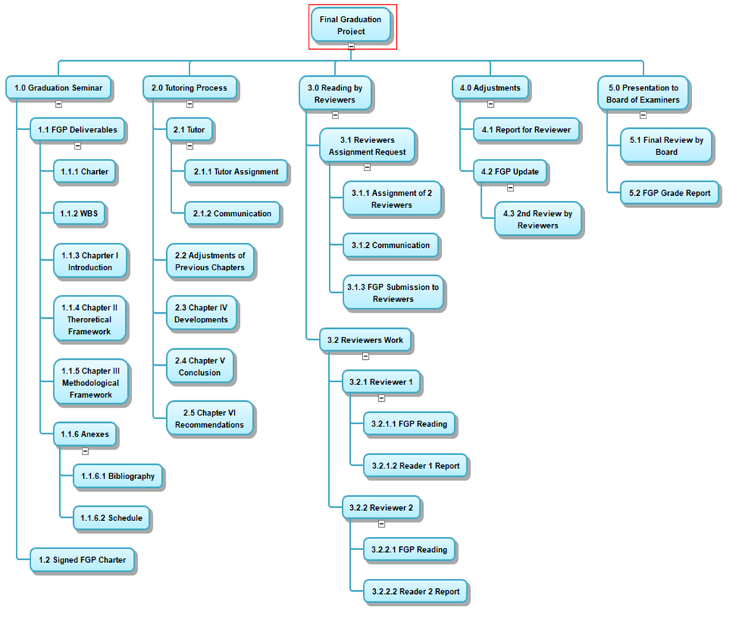

## Appendix 3: FGP Schedule

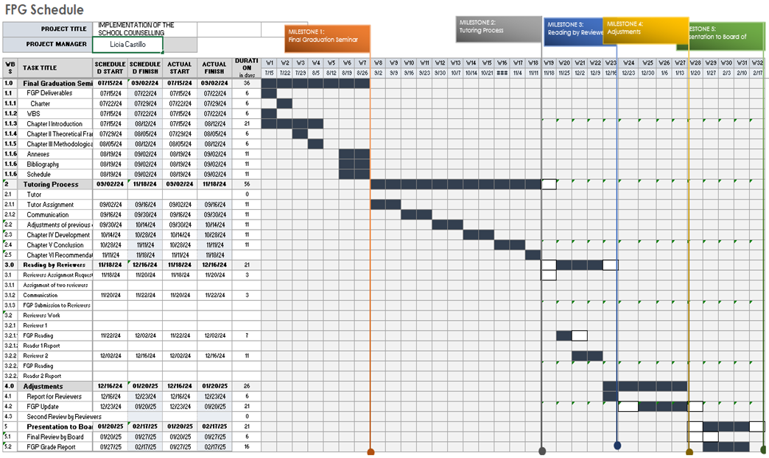

## Appendix 4: Preliminary bibliographical research

Amat, S. (2019). Guidance and counselling in schools. *Proceedings of the 3rd International Conference on Current Issues in Education (ICCIE 2018)*. https://doi.org/10.2991/iccie-18.2019.3

*This paper emphasizes the need for counselling services in schools. It underscores that guidance and counselling are integral to the school system, serving not only students with disciplinary issues but also promoting positive individual development.

American Project Management Institute. (2021). *A Guide to the Project Management Body of Knowledge*, (PMBOK® Guide) - Seventh Edition, Project Management Institute, Inc., 2021.

American School Counselor Association. (2019). *ASCA National Model Implementation Guide: Manage and Assess 2nd: 9781929289608*. https://booksrun.com/9781929289608-asca-national-model-implementation-guide-2nd-edition

*This book offers a guide into applying knowledge of the ASCA National Model in implementing a comprehensive school counselling program. It includes definitions and descriptions of the various components of a comprehensive model, templates and examples.

American School Counselor Association. (2019). *The ASCA national model: A framework for school counseling programs* (4th ed.). Author.

*This book is an essential resource for school counsellors whose goal is to enhance the effectiveness and accountability of school counselling programs, also, outlining a framework designed to guarantee that all students receive the support they need to succeed academically, career-wise, and personally/socially.

Burkard, Alan W.; Gillen, Mark; Martinez, Michael J.; and Skytte, Sarah L.,

*"Implementation Challenges and Training Needs for Comprehensive School Counseling Programs in Wisconsin High Schools"* (2012). College of Education Faculty Research and Publications. 320. <https://epublications.marquette.edu/edu_fac/320>

*This comprehensive investigation aimed to provide a detailed understanding of the current state of comprehensive school counselling program implementation, evaluate training methods, and explore the impact of these programs on student outcomes in Wisconsin.

Camelford, Kellie Giorgio*, "The Relationship Between Implementation of the American*

*School Counselor Association National Model and Professional Secondary School Counselor Burnout"* (2014). University of New Orleans Theses and Dissertations. 1857. <https://scholarworks.uno.edu/td/1857>

*This research has some relevancy because it explored the relationship between the implementation of the ASCA National Model and burnout in secondary school counsellors. The survey results revealed an inverse relationship between model implementation and burnout. When implementing the model, it is important to take into account the emotional state of the school counsellor who is basically the manager of the program.

Kratsa, K. (2019*). Exploring Ecological-Systems Barriers to Implementing a Recognized*

*American School Counselor Association Model Program* (RAMP) (Doctoral dissertation, Duquesne University). Retrieved from https://dsc.duq.edu/etd/1766

Rathbun, Keri Ann. (2017, May 1). *Perceptions of Arkansas School Counselors Regarding the Barriers of Implementing the ASCA National Model.* https://orc.library.atu.edu/cgi/viewcontent.cgi?article=1014&context=etds_2017

* School counsellor experience many obstacles so this study examined what school counsellors perceive to be consistent barriers to implementing a program that follows the ASCA National Model.

Studer, J. R., Diambra, J., Breckner, J. A., & Heidel, R. E. (2011, January). (PDF) *Obstacles and successes in implementing the ASCA National Model In Schools.* https://www.researchgate.net/publication/228839533_Obstacles_and_Successes_in_Implementing_the_ASCA_National_Model_in_Schools

*This paper examines the use and implementation of developmental school counselling programs, particularly focusing on the National Standards and the ASCA National Model, addressing both the obstacles and successes experienced by school counsellors in this process.

Zimmer, D., Laux, J., Liu, Y., Clark, M., & Reynolds, J. (2021, August). (PDF) *Listen to the voices: School Counselors and Comprehensive School Counseling Programs*. https://www.researchgate.net/publication/276189624_Listen_to_the_Voices_School_Counselors_and_Comprehensive_School_Counseling_Programs

*The research study aimed to gather and analyse baseline data on school counsellors’ readiness and progress in implementing comprehensive school counselling programs based on the ASCA National Model.

## Appendix 5: Philologist Review Report

**Tyronie Middleton**

**High School English teacher /ACE Lecturer**

**Certified by Galen University/University of North Carolina**

**December 16th,2024**

Academic Advisor

Master Degree in project Management (MPM)

Universidad para la Cooperacion Internacional (UCI)

Dear Academic Advisor,

Re: **Thorough Review and Proofreading of Final Graduation Project submitted by Licia**

**Castillo in partial fulfillment of the requirements for the Masters in Project**

**Management (MPM) Degree**

I hereby confirm that Licia Castillo has made all the corrections to the Final Graduation Project document as I have advised in my opinion, the document does now meet the literary and linguistic standards expected of a student for a degree at the Masters level.

__T.Middleton_______

**Ms. Tyronie Middleton**

**Master of Education in Secondary Education with a concentration**

**In English**

**High school English teacher/ACE**

**Lecturer**