

Guided Practice

Microsoft Project

Week 1

Create a file with name: First Name-Last Name-Practice W1

# Project Information

Project start date: November 01, 2021.

Apartment building maintenance: The project consists of painting 3 apartments located in a single building.

Each apartment must be prepared, painted, and decorated.

# Define the main characteristics of the project.

On the "Project Information" tab add the project information. In this case, the standard calendar mode will be selected from the start date of the project.

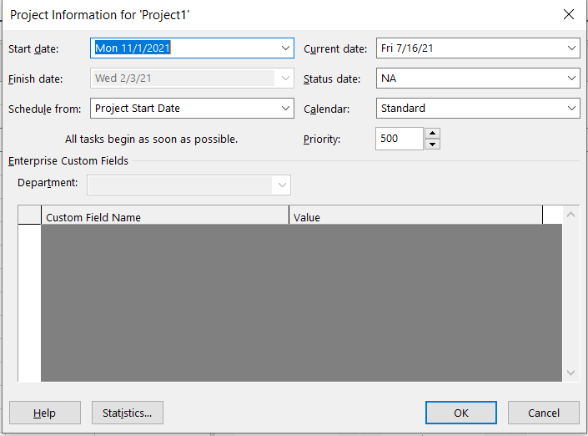

# Define working times

This tab must also set the calendar type of the project. There are three default calendars: The Standard, the Night Shift calendar, and the 24-hour calendar:

* Standard Calendar: set Monday through Friday, 9:00 a.m. to 7:00

p.m. with two hours free at noon. This is the default calendar that the program uses for the project, tasks, and resources.

* Night Shift Calendar: The work schedule is set from 11:00 p.m. to 8:00 a.m. five days a week, with a free time from 3:00 to 4:00 in the morning.
* 24-hour calendar: This is determined for 24-hour periods every day of the week, without stopping.

It is recommended that, from the modification of these three default calendars, the user can define their own calendars.

It will work with the standard calendar, so it is required, modify it to include working hours and non-working days for the months of November, December, January, and February.

To do this you must open the "change the work calendar" tab and add the corresponding exceptions.

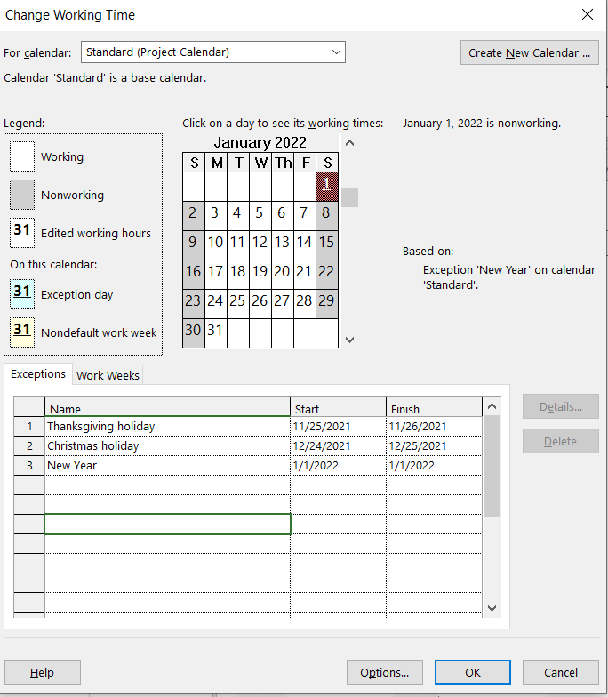

In addition, the third Saturday of each month should be included as a working day in order to conduct lessons learned sessions.

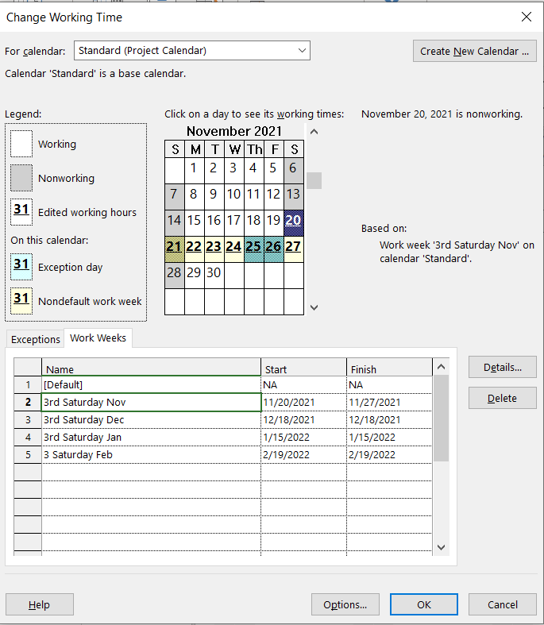

# Create a project task list

To access the Gantt chart view, you must enter the "Task" tab, and select the "Gantt" view from the "view" menu.

To get the MS Project to schedule the start and end dates, in accordance with the scheduling restrictions set on your project, activate the "auto schedule" option in the horizontal bar located at the bottom of the screen.

Enter the tasks in the "Task Name" column.

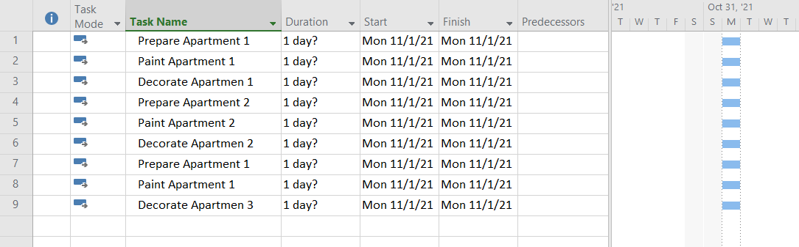

# Organize tasks by deliverable

To organize tasks hierarchically, by deliverables, tasks, and subtasks, indentations must be applied. When you indent a certain group of tasks, these will depend on the top task, which is called a "summary task”, for which it is necessary to add the name of the summary task.

If applied from a WBS, the process of naming summary tasks would already have been done.

A Start Finish Task are added, these tasks are of zero duration, so we have two milestones.

The appearance of your schedule should look similar to the following image:

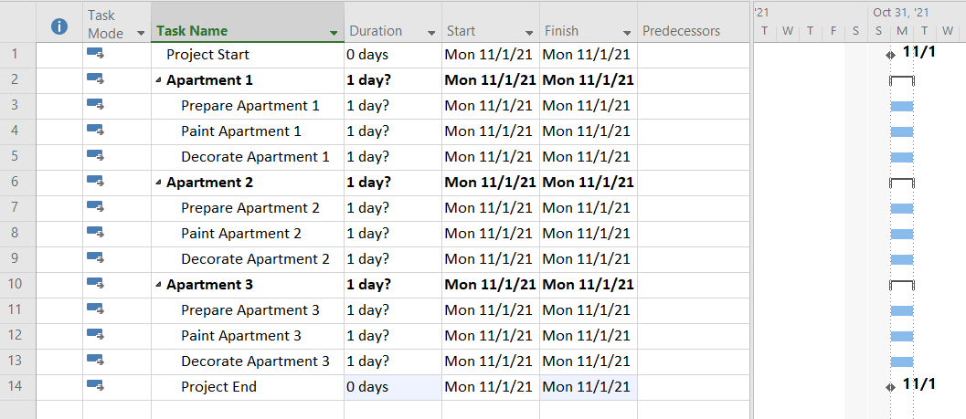

# Schedule tasks

Assign duration: For this there are two options:

* Write directly to the "Duration" column in the Gantt view,
* Double-click on the task name to open the "Task Information" dialog box.

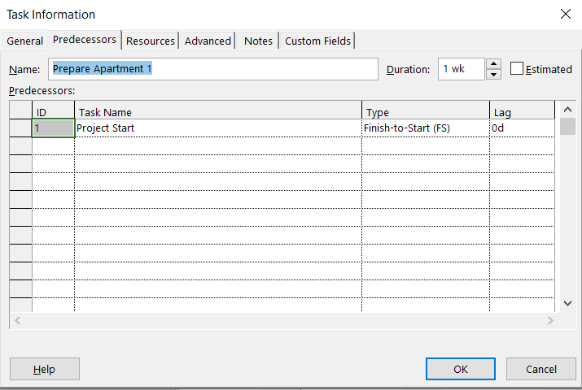

When entering the durations, you can indicate if they are days (5d) weeks (1w) or hours (40h).

Establish dependency relationships: To define precedences there are three options:

* In the Gantt chart, click on the bar corresponding to the preceding task and drag to the successor task bar:



* Open the task dialog box (by double clicking on the "task name" and in the "Predecessors" tab indicate the preceding activities:
* In the Predecessors column, enter the identifier (id) corresponding to the predecessor task(s):

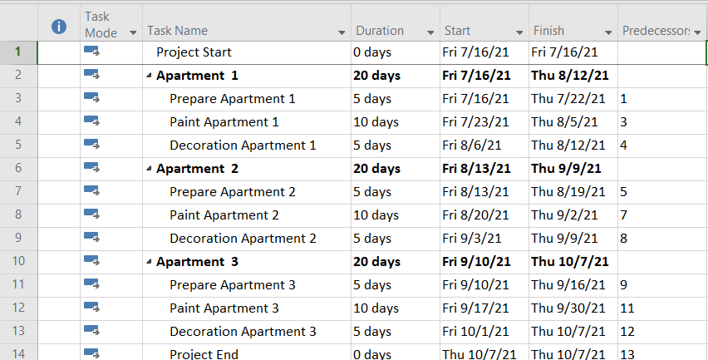

To configure precedence relationships, that is, to indicate the type of precedence, as well as delays (delays) and advances (negative delays), there are two options:

* Double-click on the precedence relation in the Gantt chart. The following window appears:

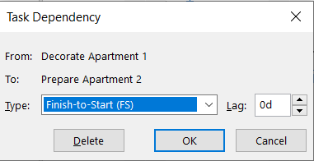

* Double-click on the task name to open the task dialog box. Then, on the Predecessors tab, indicate the type of precedence and, if there are advances or delays, also indicate their value in the Postposition field.

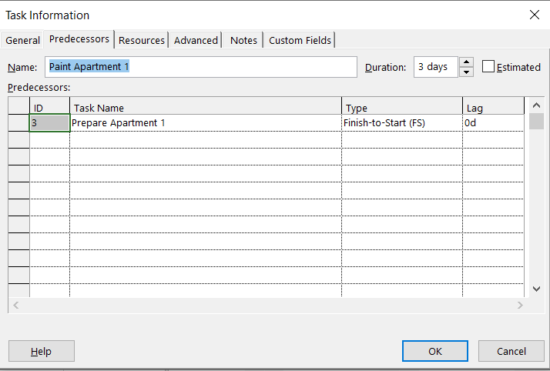

# Viewing the schedule

To display the Gantt as required, go to the "View" tab, select the Zoom menu. You can also vary the timescale of the Gantt chart by using the mouse while holding down the keyboard control key.

To redesign the presentation of the Gantt chart: put vertical bars, or change the color of the lines, go to the "Format" tab, "Format" menu, "Grid" option.

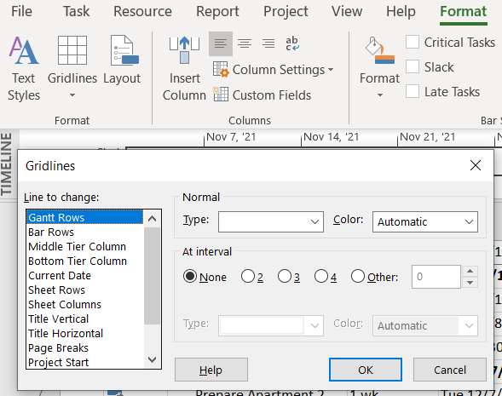

# See the Critical Path

To see critical path, go to the "Format" tab and in the "Bar Styles" menu, check the "Critical tasks" box.

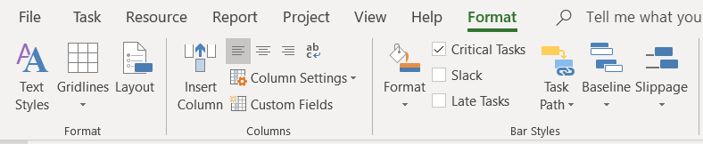

# Clearances

To review the slack information for project critical tasks, in the Gantt Chart view, add a new column to the right of the table. Select the "Total Slack" field, which is the name by which MS Project refers to the total slack of a task.

Verify that critical tasks do indeed correspond to tasks that they have

total clearance equal to zero.

At this point in practice, the Gantt chart obtained should be similar to the one shown in the following figure:

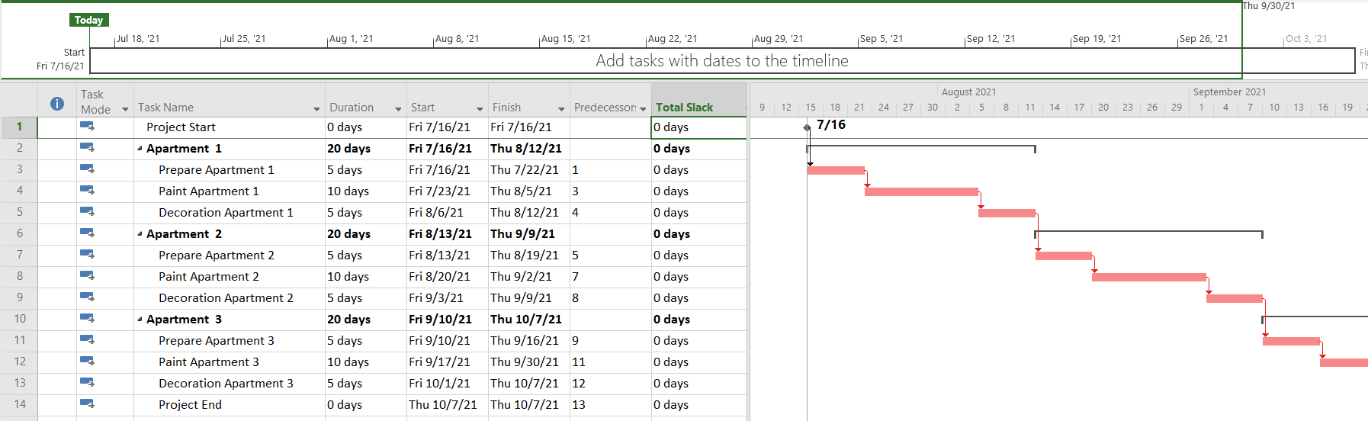

To view the project statistics, go to the Project tab, option "Project Information" at the bottom of this tab, click on the statistics button.

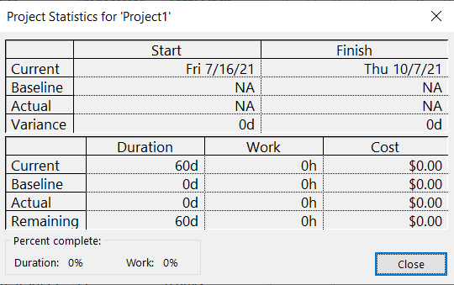

# Add information to the task

To add notes to tasks, double-click on the task name, select the "Notes" tab... and enter as appropriate.

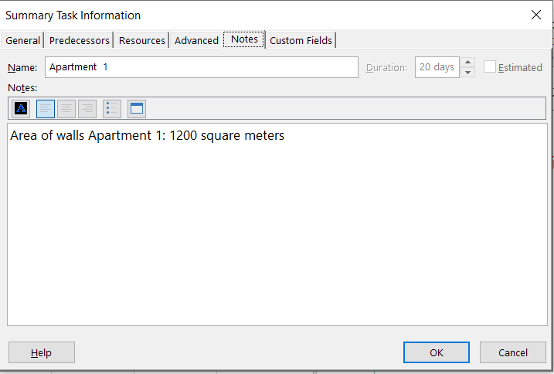

# Adding Columns with Custom Information (WBS)

Display the EBS code in the Gantt view. The WBS code uniquely identifies deliverables and activities. Modify the code to read from the following format: ABC-letter-number.

To view the EDT code: add more columns to the view: Click on the rightmost column header in the gantt chart view table (Add New Column) and from the drop-down list select EDT.

To modify the EDT code so that it remains of the asj-letter-number form: on the Project tab, click on the "EDT" button and select "Define code". You must get:

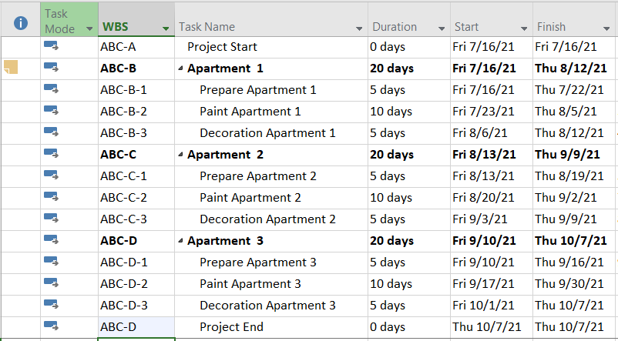

Delimiting tasks

To delimit the task the MS Project establishes three types of restriction: As soon as possible, As late as possible, do not start before...

To delimit tasks, open the task dialog box: double-click on the task. The "Task Information" dialog appears. Select the Advanced tab.

Set the task type

There are three types of tasks ("Task Type" option which are: Fixed Units, Fixed Work, and Fixed Duration.

In all cases the "Units" refers to assigned resource units, work refers to effort.

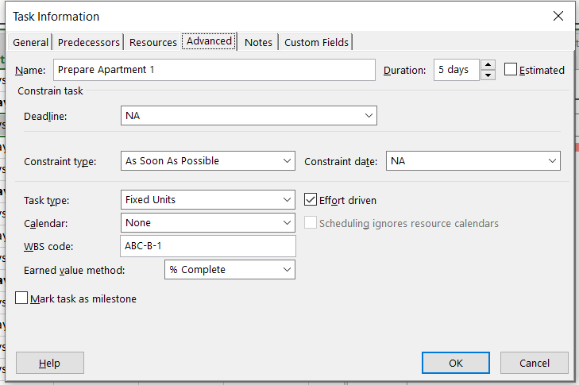

For all tasks, after assigning a resource (resources: people, equipment, and material that are used to complete tasks in a project.) the task is scheduled according to the formula [Duration = Work/Units].

For any task, you can choose the member of the equation that Project calculates by setting the task type (fixed duration, fixed units, or fixed work). If you want the above relationship to have no effect, delete the Effort Conditioned selection (do this for fixed-duration tasks). Fixed effort tasks (in the statement) are set to "fixed work".

At this point, the result of the first part of the practice should look similar to the following figure:

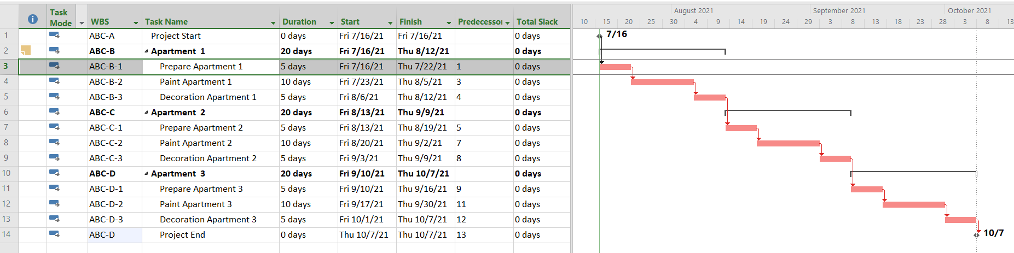

End of first practice.