**Guided Practice - Week 2**

Microsoft Project

Save the file with the name: Name-Surname-Practice W2

1. **Allocation of resources to project activities**

Specify the resources available to the company to perform the tasks and costs

associated with each resource.

In this case, the resources available are 1 painter ($2000 / hour) and 2 assistants

($750 / hour). To deposit the rubble at the selected site: Truck

($7000 / trip).

To specify the characteristics of the resources, the definition view must be displayed

of resources, for this you must go to the tab "Task", Group "View", option "Resource Sheet".

It is important to consider the following attributes of resources:

• Type: Work, Material, Cost.

• Maximum capacity: available resources. If you have multiple units of

resource: for example, 5 workers equal a maximum capacity of 500%.

Standard rate: cost of using one resource unit per hour.

• Overtime rate: cost of using a resource unit when working

extra hours.

• Cost / use: cost of using a resource unit when this cost is

regardless of how long it is used.

• Calendar: all resources are associated with a calendar of use in the project,

so, while most would fit the standard calendar, it is possible to

specify a different calendar for each resource.

To allocate resources to project activities, the resources are considered to be

available for the project, with which we could do it in the fastest way

possible.

To perform the “resource leveling” there are several alternative options:

• View the "Task information", by double clicking on any of the Task columns in the Gantt chart. Select the tab "Resources". You must indicate the resources and the allocation. (Example: if 5 resources to a certain task, the allocation will be 500%)

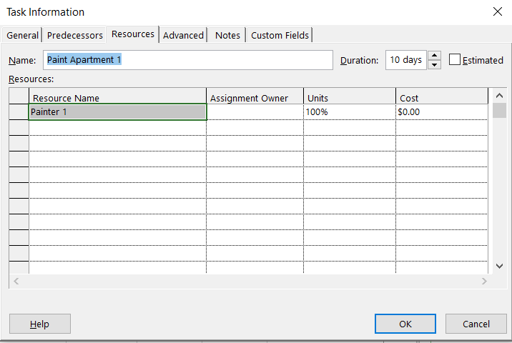

In the "resources" tab, select the task in Gantt chart mode and press the

"Assign resources" button, located in the "Assign"

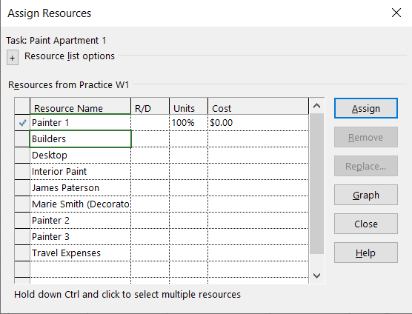

The cost of the tasks will be calculated automatically.

Once you have assigned the resources for all the tasks in the project, view the work (effort) that MS Project has associated with each of the tasks. To do this, add the Resource column: in the Gantt Chart view, click the header of the rightmost column, “Add new column”, and select “Resources Names” from the list that will appear.

The work (effort) associated with each task must be consistent with its duration, the number of resource units that have been assigned and the number of hours that each resource unit participates in the task

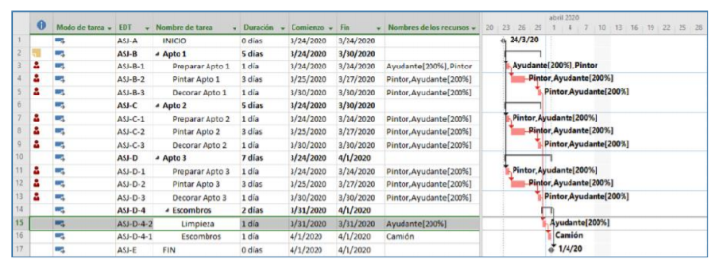

1. **Detect resource conflicts and resolve them**

You will have noticed that, as you assigned the resources to the tasks, there have been Red icons in the information column. These icons appear when it exists resource over-allocation:

To review resource conflicts, open the "Resource Graph" view. To do this,

You must go to the logical group “View”, in the “Task” tab or in the “Resource” tab. The view shows only one resource at a time, to see more resources move the scroll bar located at the bottom left of the view.

In this graph you can see the use of each resource over time. If part of the graph appears in red is because at that moment, there is an over-allocation of resources. In other words, the use of more resources than the available.

Display the resource graph in "percentage allocation" mode. To do this, click the right mouse button anywhere on the graph and, in the pop-up window, select Percentage allocation. In between display mode, a higher allocation 100% on a resource indicates that there is over-allocation.

Your screen should look like the one shown in the following figures. In order to compare your results, make sure the timescale of your chart matches the one used in these figures (note that they are showing the assignment day-to-day percentage).

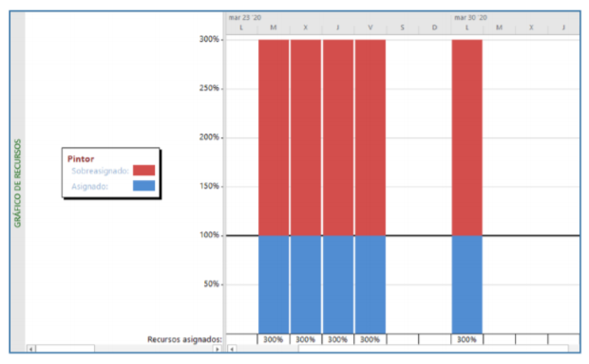

1. **Schedule with resource limitations**

Go back to the Gantt chart view, go to the “Paint Apt 1” task, open your dialog box.

dialog, go to the Advanced tab and change the Bounding Type. Make sure that

"As soon as possible" is selected. This makes it easier to redistribute resources.

In the Resource tab, "Redistribute group", open the "File Options" dialog.

redistribution “(Leveling of resources). When the dialog shown above appears

below, make the selections shown in the figure:

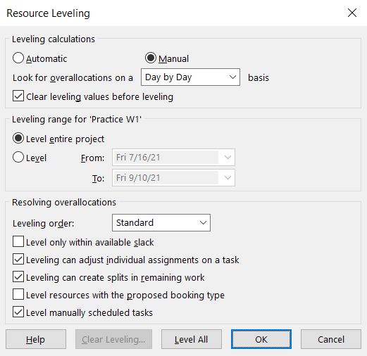

In this course we will always use a manual redistribution of resources, for the purposes of make a first approach to the project scheduling, in which we assume that all the resources necessary to execute each task will be available in the moment each task needs them, a condition that we will call infinite capacity scheduling.

This assumption will lead, in most cases, as in this project, to an over-allocation of resources. Obviously, the over-allocation will cause the programming obtained cannot be carried out in practice. However, this first programming will allow us to know important information for the project, such as, for example: which resources are over-allocated and at what point in the project they are. Once this information is known, a manual redistribution will do that, at the time we want, Project redistribute or level all the resources to resolve any over-allocation that have occurred, so that scheduling can be put into practice.

However, as of the moment “Level All” is selected, Project will resolve possible resource over-allocations immediately, as resources are assigned to tasks. Although this redistribution method Interestingly, the fact that the MS Project always avoids over-allocation of resources will make information important to the project (minimum project duration, over-allocated resources, over-allocated moments, etc.) are no longer available.

When you have configured the reallocation click “Level all”.

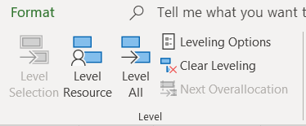

See the effects it has had on Gantt, resource charts, and business statistics.

project (Project tab / Project information / Statistics button).

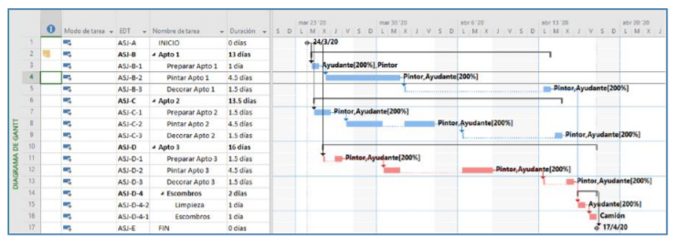

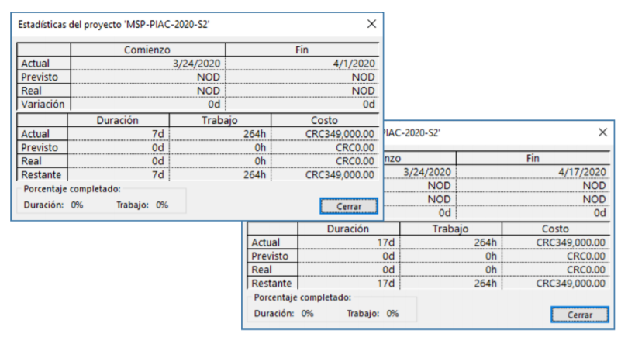

Note the difference between the initial condition and the redistributed one. Duration changed from 7d to 17d, but the amount remains constant. Decisions can be made in practice that affect costs.

If for some reason you want to undo the redistribution of resources that the MS Project has generated, you can use the button "Delete redistribution" that, in the same way, it is located in the "Resource" tab / Redistribute logical group / "Clear redistribution" button.

1. **Make manual changes to improve scheduling**

In the Gantt chart view, open the dialog for the task you want to reschedule, go to the Resources tab, and change for example the worker assignment and then redistribute resources.

See the effect it has had on the Gantt chart. Notice the change in duration and in the project statistics.

If any of the activities runs through the weekend it can be forced to start, for example, Monday.

Redistribute again and observe the results.

End of the second week.