# **Guided Practice**

Microsoft Project

Week 3

Save the file with the name: FirstName-Last-Practice S3

# 1. Update the status date according to the date when the update is made:

To set the status date, you need to go to the Project / Status Logical Group / Status Date tab.

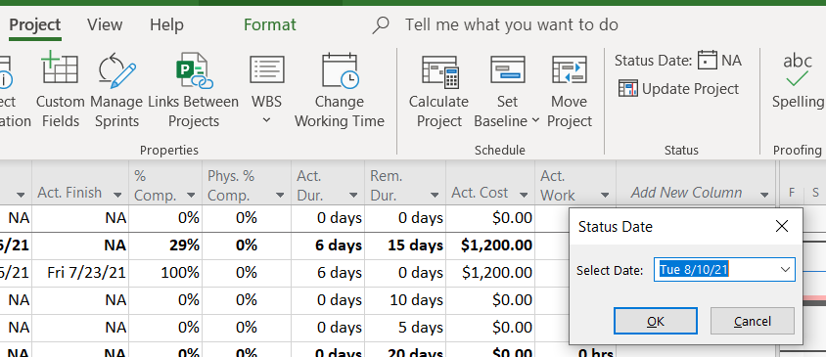

It is important to set the date on which the "update" or follow-up report is made prior to saving the project baseline.

# 2. Save the plan for comparison with later versions

Set the current plan as "baseline". The baseline is a reference schedule that will be used later, during the execution of the project, to compare its actual situation, at any given time, with the schedule planned for that time.

To set baseline: "Project" tab / logical group "Schedule"/ "Set Baseline".

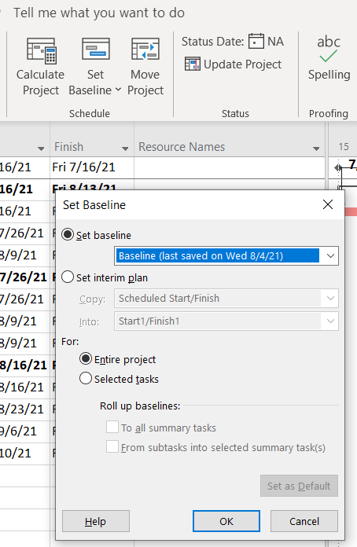

# 3. Incorporate information on the actual status of the project on a given date during its execution

On Tuesday 03/04/2020, first thing in the morning, a control of the project is carried out from which it is deduced that all the tasks have been executed as planned except the task "Painting of Apt2"of which only 20% has been executed. Enter this data in your project.

1. Update the completed work of the project up to the time of completion of the control:
2. To indicate to MS Project that all operations have been executed as expected up to the time of control, go to the tab "Project"/ logical group "Status"/ "Update Project". We must enter a date for the update of the project that makes Project update the completed work until the day 02/04/2020 (included), since the control we are doing on 03/04/2020 first thing in the morning:

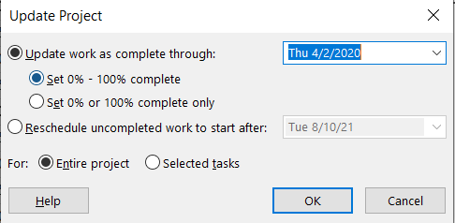

Notice the progress bars that have appeared within the bars of the Gantt chart. Since we control the project early on Tuesday, the progress bars should include the full Monday, but not reach Tuesday (since that day is not done early on Tuesday, there are several hours left to complete Wednesday’s work. Notice the green line in the following figure, a line that marks the date of the update:

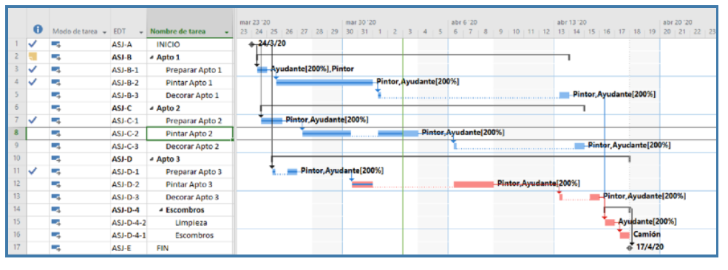

2) Indicate the actual percentage completed of a task:

To tell MS Project the progress (actual percent complete) of a task, you can proceed in two ways:

• Add a new column: %completed. Project will show you the extent to which each task would have been completed if the project run had gone according to plan (ideal scenario).

Notice that the percent complete of the task "Paint Apt 2" figures 72%. This would be the status of this task according to the initial schedule. However, from an observation of the actual state of the project, we conclude that, in reality, this task has only been completed by 20%. To tell this actual project situation to Project, replace 57% with 20%.

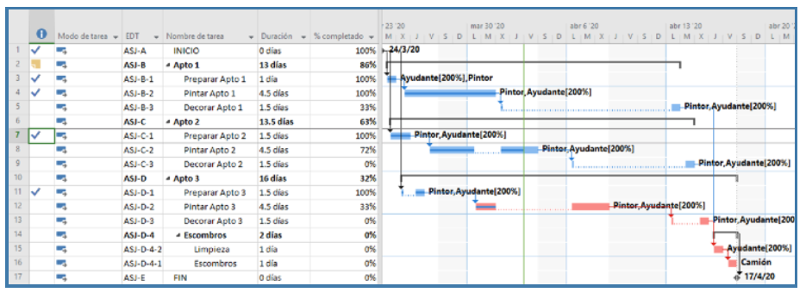

Alternatively, to enter the actual percent complete of a task, you can select the task in the input table, go to the Tasks tab / logical group Schedule / Update Tasks, and indicate the percent complete. In the 'Paint Apt 2' task, replace %completed 70% with 20%.

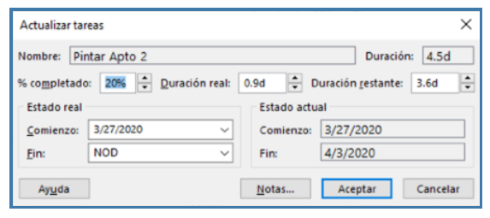

3) Make changes to the project

To reschedule the remaining work go to the Project tab / logical group Status / Update Project button select "Reschedule remaining work to start after" and click OK. After rescheduling you may need to redistribute resources or make other changes.

